Appendix A

Statistical Analysis
Socioeconomic and Geopolitical consideration in COVID-19 Pandemic Response

Table of Contents
1. Introduction 7
2. Data description and pre-processing 7
2.1. Description of dataset 7
2.2. Data pre-processing 8
2.2.1. Covid_19 variables 8
2.2.2. Categorical variables 8
2.2.3. Missing and irrelevant data 9
2.2.4. Test of Normality 9
3. Descriptive analysis 10
3.1. Covid-19 dependent variables 10
3.2. Country related variables 14
3.2.1. Country Climate 14
3.2.2. Country area 20
3.2.3. Country urbanization 21
3.3. Politics related variables 22
3.3.1. Government type 22
3.3.2. Leader education 34
3.3.3. Leader sex 43
3.3.4. Country war conflict 48
3.4. Economics related variables 51
3.4.1. GDP total (Billion) 51
3.4.2. GDP per capita 52
3.4.3. Population growth 52
3.5. Demographic related variables 53
3.5.1. Religion 53
3.5.2. Literacy 60
3.5.3. Life expectancy (years) 60
3.5.4. Population density /km² 60
3.5.5. Population (million) 61
3.5.6. Male percentage 61
3.5.7. Female percentage 62
3.5.8. Age distribution 62
3.6. Health care related variables 69
3.6.1. Health expenditure 69
3.6.2. Hospital beds per 1000 69
3.6.3. Physicians per 1000 69
3.6.4. Nurses per 1000 70
3.6.5. Infant mortality per 1000 70
3.7. Precautions related variables 71
3.7.1. Stay at home 71
3.7.2. Facial covering 79
3.7.3. Restriction on gatherings 89
3.7.4. School closer 99
3.7.5. Testing policies 109
3.7.6. International travel control 118
4. Test of associations 128
4.1. Country related variables 129
4.2. Politics related variables 130
4.3. Economics related variables 136
4.4. Demographic related variables 138
4.5. Health care related variables 141
4.6. Precautions related variables 143
4.7. Summary 151

Table of Figures
Figure 1. Radar chart of Covid-19 variables 13
Figure 2. Cumulative cases vs. climate types 15
Figure 3. Cumulative deaths vs. climate types 16
Figure 4. Population positive cases vs. climate types 18
Figure 5. Population positive deaths vs. climate types 19
Figure 6. Death of infection vs. climate types 20
Figure 7. Country land area (km²) vs. cumulative cases 21
Figure 8. Country urbanization vs. cumulative cases 21
Figure 9. Cumulative Covid-19 cases vs. government type. 25
Figure 10. Cumulative Covid-19 deaths vs. government type. 26
Figure 11. Covid-19 population cases vs. Government type. 30
Figure 12. Covid-19 population deaths vs. Government type. 31
Figure 13. Covid-19 death of infections vs. Government type. 33
Figure 14. Cumulative Covid-19 cases vs. Leader education. 36
Figure 15. Cumulative Covid-19 deaths vs. Leader education. 37
Figure 16. Covid-19 population positive cases vs. Leader education. 40
Figure 17. Covid-19 population deaths vs. Leader education. 41
Figure 18. Covid-19 death of infection vs. Leader education. 42
Figure 19. Cumulative Covid-19 cases vs. leader sex. 44
Figure 20. Cumulative Covid-19 deaths vs. leader sex. 45
Figure 21. Covid-19 population positive cases vs. leader sex. 46
Figure 22. Covid-19 population deaths vs. leader sex. 47
Figure 23. Covid-19 death of infections vs. leader sex. 48
Figure 24. GPD (Billion) vs. cumulative cases heatmap. 51
Figure 25. Top 5 high GDP countries vs. cumulative Covid-19 cases. 51
Figure 26. GPD per capita vs. cumulative deaths heatmap. 52
Figure 27. Top 5 high GDP countries vs. cumulative Covid-19 deaths. 52
Figure 28. Population growth rate vs. cumulative cases heatmap. 53
Figure 29. Countr literacy vs. Covid-19 cumulative cases. 60
Figure 30. Life expectancy heatmap vs. Covid-19 cumulative cases. 60
Figure 31. Population density Km² vs. Covid-19 cumulative cases. 61
Figure 32. Population in millions vs. Covid-19 cumulative cases. 61
Figure 33. Percentage of male population vs. Covid-19 cumulative cases. 62
Figure 34. Percentage of female population vs. Covid-19 cumulative cases. 62
Figure 35. Health expenditure vs Covid-19 cumulative cases. 69
Figure 36. Hospital beds/1000 vs. Covid-19 cumulative cases. 69
Figure 37. Physicians/1000 vs. Covid-19 cumulative cases. 70
Figure 38. Nurses/1000 vs. Covid-19 cumulative cases. 70
Figure 39. Infant mortality/1000 vs. Covid-19 cumulative cases. 71
Figure 40. Covid-19 cumulative cases vs. stay at home policies. 73
Figure 41. Covid-19 cumulative deaths vs. stay at home policies. 74
Figure 42. Covid-19 population positive cases vs. stay at home policies. 76
Figure 43. Covid-19 population deaths vs. stay at home policies 77
Figure 44. Covid-19 death of infection vs. stay at home policies 79
Figure 45. Covid-19 cumulative cases vs. facial covering policies. 81
Figure 46. Covid-19 cumulative deaths vs. facial covering policies. 83
Figure 47. Covid-19 population positive vs. facial covering policies. 85
Figure 48. Covid-19 population deaths vs. facial covering policies. 87
Figure 49. Covid-19 death of infection vs. facial covering policies. 89
Figure 50. Covid-19 cumulative cases vs. restriction on gatherings policies. 91
Figure 51. Covid-19 cumulative deaths vs. restriction on gatherings policies. 93
Figure 52. Covid-19 population positive cases vs. restriction on gatherings policies. 95
Figure 53. Covid-19 population deaths vs. restriction on gatherings policies. 97
Figure 54. Covid-19 death of infection vs. restriction on gatherings policies. 99
Figure 55. Covid-19 cumulative cases vs. school closure policies 101
Figure 56. Covid-19 cumulative deaths vs. school closure policies 103
Figure 57. Covid-19 population positive cases vs. school closure policies 105
Figure 58. Covid-19 population deaths vs. school closure policies. 107
Figure 59. Covid-19 death of infection vs. school closure policies. 109
Figure 60. Covid-19 cumulative cases vs. testing policies. 111
Figure 61. Covid-19 cumulative deaths vs. testing policies. 112
Figure 62. Covid-19 population positive cases vs. testing policies. 114
Figure 63. Covid-19 population positive deaths vs. testing policies. 116
Figure 64. Covid-19 death of infection vs. testing policies. 118
Figure 65. Covid-19 cumulative cases vs. international travel control policies 120
Figure 66. Covid-19 cumulative deaths vs. international travel control policies 121
Figure 67. Covid-19 population positive cases vs. international travel control policies 123
Figure 68. Covid-19 population positive deaths vs. international travel control policies 125
Figure 69. Covid-19 death of infection vs. international travel control policies. 127

Introduction
The scope of this report is to analyze five measures related to the recent Covid-19 pandemic based on a data set collected from 235 countries. The results of the analysis will give an insight into the relationships between Covid-19 and various factors related to domains such as country Geography, Economics, Politics, Demographics, Health care, and Precaution procedures. The analysis consists of three parts. Part one is a description of the dataset with data pre-processing. Part two is the descriptive analysis and visualization of the data variables. Part three is the test of association between the Covid-19 measures and the remaining factors in the dataset.

Data description and pre-processing

Description of dataset
The dataset used in this report was collected from 235 countries. Each country represents a single entry. Each entry contains a group of parameters divided into subgroups related to the following categories:
- Covid-19 variables (dependent variables): cumulative cases, cumulative deaths, population positive cases, population covid deaths, death of infection. (5 variables).
- Country: name, climate, area, urbanization, latitude. (5 variables)
- Politics: government type, leader education, leader gender, leader age, leader employment type, war conflict. (6 variables)
- Economy: GDP total, GDP per capita, population growth, urbanization. (4 variables)
- Demographics: religion, literacy, life expectancy, population density/km², population in millions, male percentage, female percentage, age distribution. (8 variables)
- Health care: health expenditure, hospital beds per 1000, physicians per 1000, nurses per 1000, infant mortality per 1000. (5 variables)
- Precautions: stay at home, facial covering, restriction on gathering, school closer, testing policies, international travel control. (6 variables)

Data pre-processing

Covid_19 variables
There are five parameters that represent Covid-19 measures in the dataset (dependent variables). All these variables are quantitative/scale as they represent counts or percentages. These five variables are grouped in clusters to give a clear insight into the distribution of the Covid-19 within the studied factors. Besides, the clusters will be used to test their associations with the categorical variables. The categories of each variable were assigned to match the original trend of the data. The correlation between the original scales and the new categories was tested to ensure the relativity of the variables. The new categories of the Covid-19 dependent variables are given as follows:
Table 1. Categorization of dependent variables
Cumulative cases (thousands) | Cumulative deaths (thousands) | Population positive cases | Population Covid deaths | Death of infection
0-1  1-10  10-100  100-200  200-300  300-400  400-500  500-600  Above 600 | 0-1  1-5  5-10  10-20  20-50  50-100  Above 100 | 0% - 0.1 %  0.1% - 0.5%  0.5% - 1%  1%- 2%  2% - 3%  3% - 4%  4% - 5%  5% - 6%  6% - 7%  7% - 8%  Above 10% | 0‰ - 1‰  1‰ - 5‰  5‰ - 10‰  10‰ - 50‰  50‰ - 100‰  Above 100‰ | 0‰ - 5‰  5‰ - 10‰  10‰ - 20‰  20‰ - 30‰  30‰ - 40‰  40‰ - 50‰  50‰ - 60‰  60‰ - 70‰  70‰ - 80‰  80‰ - 90‰  Above 100‰

Categorical variables
There are four parameters allow for multiple choices in the dataset described as follows:
- Country climate: 4 subgroups. A country with multiple climate types is considered to have a mixed climate. New keycode ‘mix climate’ is added to represent the diversity.
- A country under war status: 4 subgroups. The 4 subgroups were all combined to a binary variable that indicates whether a country suffers from a single or multiple forms of war conflicts as ‘Yes’ or ‘No’ entry.
- Population age distribution: 3 subgroups. The subgroups of this parameter describe the highest 3 age groups in each country. A new key code entry was added to represent these three groups combined.
- Religion: 3 subgroups. The subgroups of this parameter describe the highest spread religions in a certain country. However, the data related to the second and third religion was either missing or unreported for most countries. Therefore, the analysis was performed only on the first religion of each country.
- The Leader employment variable was analysed using a helper index column. Each employment type that is repeated less than 4 times was ignored. The remaining types will be used for association tests with dependent variables.
- The leader employment variable will not be analysed using crosstabs (not enough frequent data in groups). Only test of association will be performed.

Missing and irrelevant data
There are 15 countries that reported having ‘zero’ Covid-19 cases by the collection date of the dataset (American Samoa, Cook Islands, Democratic People's Republic of Korea, Kiribati, Micronesia, Nauru, Niue, Palau, Pitcairn Islands, Saint Helena, Samoa, Tokelau, Tonga, Turkmenistan, Tuvalu). The ‘zero’ cases countries were removed from the analysis as irrelevant entries.
Missing values in all variables are replaced with (0) and indicated as an ‘unknown’ entry for all categorical variables. However, when the missing values were too many to be replaced the entire variable was removed from the analysis (religion 2 and religion 3).

Test of Normality
Kolmogorov-Smirnov test was conducted to test the normality of the data. The null hypothesis assumes that a certain variable is following the normal distribution. While the alternative hypothesis indicates that the distribution of the variable is not normal. The null hypothesis will be accepted if the p-value of the test is greater than 0.05. All the variables except for ‘Leader age’ were found to not follow the normal distribution as the p-value of all the tests was found less than 0.05. Therefore, non-parametric tests were used to produce the results presented in this report.

Descriptive analysis
The descriptive analysis in this report refers to the following:
- Finding frequency tables for all categorical parameters.
- Calculating the mean, standard error, and trimmed 5% mean for each column category. (Check the definition of 5% mean in the following paragraph).
- Crosstabulation for dependent variables against all categorical variables.
- Visualization of all studied variables.
The frequency tables and percentages are all calculated to illustrate the effect of the study factors on the covid-19 variables. Therefore, the term ‘N (%)’ indicates the number (percentage) of countries that fall in the criteria of the column.
The trimmed 5% mean gives the average of the variable after removing the highest 5% and the lowest 5% of data from the calculations. In this case, the mean that is based on 90% of the variable will be less affected by extreme values.
The descriptive analysis in this report will be presented based on the categories suggested in section 2.1 as follows.

Covid-19 dependent variables
The frequencies of the dependent variables are presented with the percentage of prevalence in each country as given in Table 2.
Table 2. Frequency and percentage of Covid-19 variables in countries.
Cumulative cases (Thousands) |  | N (%) |  | Cumulative deaths (Thousands) |  |  | N (%)
0 - 1 |  | 44 (20%) |  | 0 - 1 |  |  | 135 (61.4%)
1 - 10 |  | 47 (21.4%) |  | 1 - 5 |  |  | 45 (20.5%)
10 - 100 |  | 53 (24.1%) |  | 5 - 10 |  |  | 12 (5.5%)
100 - 200 |  | 27 (12.3%) |  | 10 - 20 |  |  | 10 (4.5%)
200 - 300 |  | 11 (5%) |  | 20 - 50 |  |  | 8 (3.6%)
300 - 400 |  | 4 (1.8%) |  | 50 - 100 |  |  | 6 (2.7%)
400 - 500 |  | 7 (3.2%) |  | Above 100 |  |  | 4 (1.8%)
500 - 600 |  | 3 (1.4%)
Above 600 |  | 24 (10.9%)
Population positive cases | N (%) |  | Population COVID deaths |  | N (%) | Death of infection |  | N (%)
0% - 0.1% | 50 (22.7%) |  | 0‰ - 1‰ |  | 55 (25%) | 0‰ - 5‰ |  | 38 (17.3%)
0.1% - 0.5% | 48 (21.8%) |  | 1‰ - 5‰ |  | 38 (17.3%) | 5‰ - 10‰ |  | 31 (14.1%)
0.5% - 1% | 18 (8.2%) |  | 5‰ - 10‰ |  | 22 (10%) | 10‰ - 20‰ |  | 78 (35.5%)
1%- 2% | 27 (12.3%) |  | 10‰ - 50‰ |  | 61 (27.7%) | 20‰ - 30‰ |  | 41 (18.6%)
2% - 3% | 28 (12.7%) |  | 50‰ - 100‰ |  | 29 (13.2%) | 30‰ - 40‰ |  | 15 (6.8%)
3% - 4% | 20 (9.1%) |  | Above 100‰ |  | 15 (6.8%) | 40‰ - 50‰ |  | 8 (3.6%)
4% - 5% | 10 (4.5%) |  |  |  |  | 50‰ - 60‰ |  | 2 (0.9%)
5% - 6% | 12 (5.5%) |  |  |  |  | 60‰ - 70‰ |  | 4 (1.8%)
6% - 7% | 3 (1.4%) |  |  |  |  | 70‰ - 80‰ |  | 1 (0.5%)
7% - 8% | 3 (1.4%) |  |  |  |  | 80‰ - 90‰ |  | 1 (0.5%)
10% and above | 1 (0.5%) |  |  |  |  | Above 100‰ |  | 1 (0.5%)
There are 24 countries (10.9% of the countries) that have cumulative Covid-19 cases that exceed 600 thousand. On the contrary, 77% of the countries have a cumulative Covid-19 cases of less than 200 thousand.
A group of 61.4% of the countries has recorded less than 1000 Covid-19 death cases. Only 1.8% have more than 100 thousand deaths due to Covid-19.
Around 50% of the countries (116 countries) have less than 1% of the population infected with Covid-19. While only 6 counties have an infection rate between 6%-8% of the population, and only one country diagnosed more than 10% of the population as positive Covid-19 cases.
The population death rate due to Covid-19 did not exceed 10 per 1000 humans in about 50.3% of the countries. Only 15 countries (6.8%) reported a death rate of more than 100‰.
The death rate of covid-19 patients did not exceed 20 deaths in every 1000 infected cases in around 85.5% of the countries. Three counties (1.5% of the sample) reported more than 70 deaths in every 1000 infected cases of Covid-19.
The visualization of covid-19 dependent variables is illustrated in Figure 1.

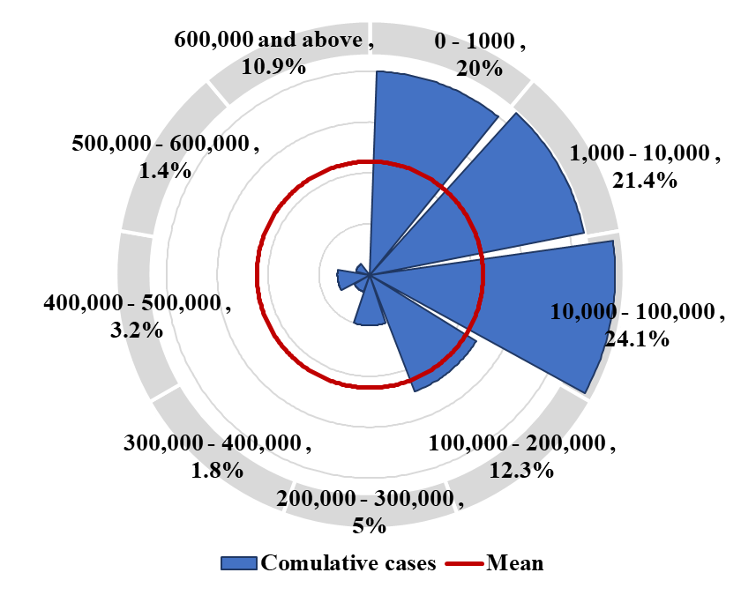 | 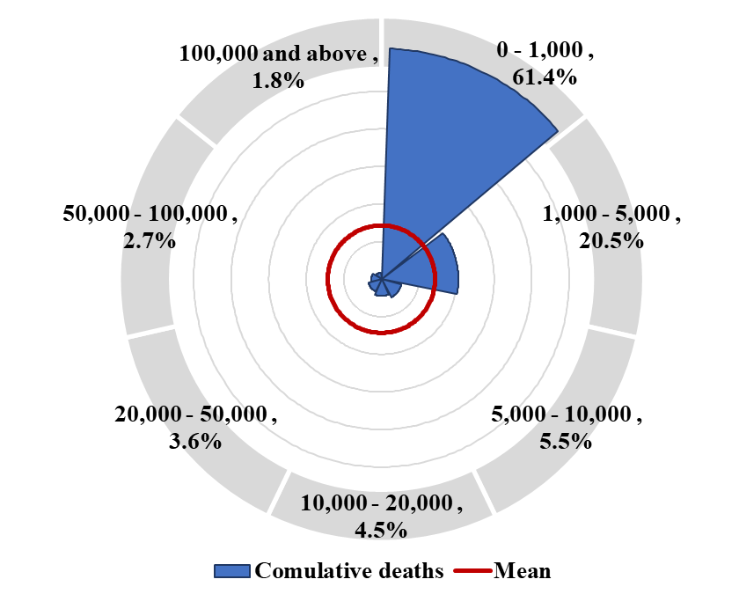 | 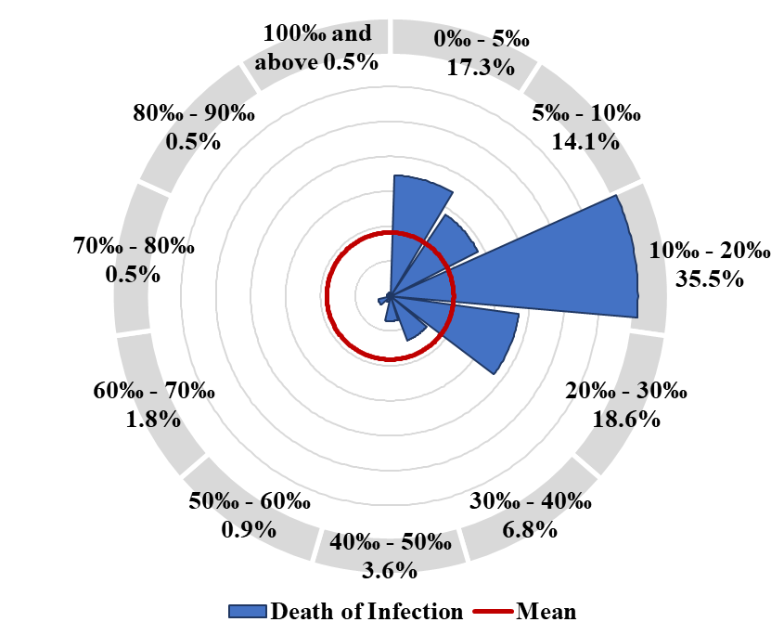
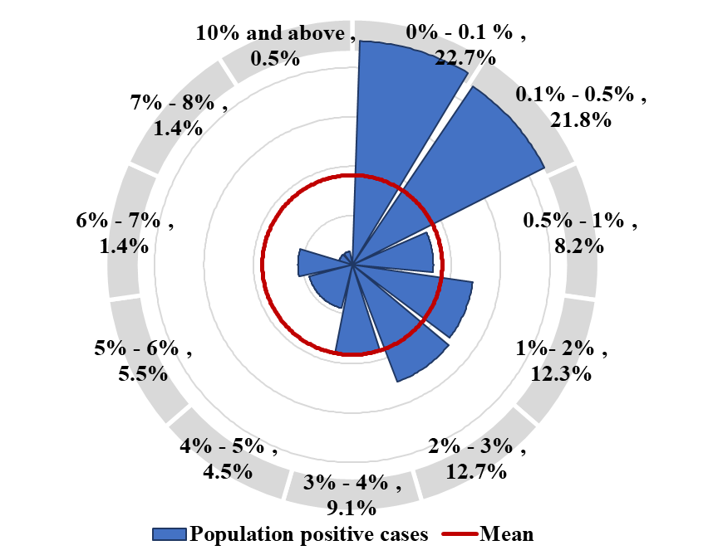 | 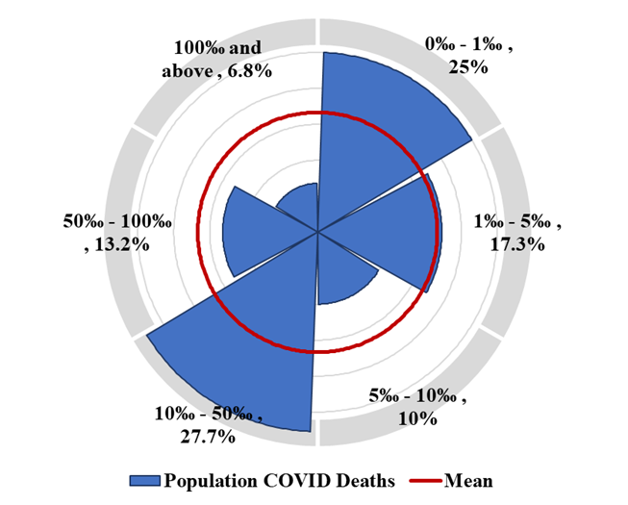
Figure 1. Radar chart of Covid-19 variables

Country related variables

Country Climate
There are 5 climate classes reported in this study. Each country was reported to have a single or multiple types of climates. A country with more than one type of climate is considered to have a mixed climate. The distribution of climate types within the countries is given in
Table 3.
Table 3. Climate distribution among countries.
Climate | N (%)
Tropical | 105 (47.7%)
Dry | 24 (10.9%)
Temperate | 52 (23.6%)
Cold Continental | 6 (2.7%)
Polar | 1 (0.5%)
Mix climate | 32 (14.5%)
There are 105 countries reported to have Tropical climate (47.7% of the counties). 10.9% of the countries have a Dry climate. Countries with Temperate climate are 23.6% of the studied sample. Only 1 country was reported to have a Polar climate. And 32 countries (14.5%) were reported to have mixed climates.
The distribution of Covid-19 cumulative cases within different climate types is given in Table 4.
Table 4. Cumulative cases vs. climate types
Cumulative cases (Thousands) | Tropical | Dry | Temperate | Cold Continental | Polar | Mix climate
0 – 1 | 15 (14.3%) | 6 (25%) | 12 (23.1%) | 1 (16.7%) | 0 (0%) | 10 (31.3%)
1 – 10 | 18 (17.1%) | 10 (41.7%) | 13 (25%) | 0 (0%) | 0 (0%) | 6 (18.8%)
10 – 100 | 29 (27.6%) | 3 (12.5%) | 13 (25%) | 2 (33.3%) | 1 (100%) | 5 (15.6%)
100 – 200 | 16 (15.2%) | 2 (8.3%) | 2 (3.8%) | 1 (16.7%) | 0 (0%) | 6 (18.8%)
200 – 300 | 3 (2.9%) | 2 (8.3%) | 5 (9.6%) | 0 (0%) | 0 (0%) | 1 (3.1%)
300 – 400 | 3 (2.9%) | 0 (0%) | 0 (0%) | 1 (16.7%) | 0 (0%) | 0 (0%)
400 – 500 | 6 (5.7%) | 0 (0%) | 0 (0%) | 1 (16.7%) | 0 (0%) | 0 (0%)
500 – 600 | 1 (1%) | 0 (0%) | 2 (3.8%) | 0 (0%) | 0 (0%) | 0 (0%)
Above 600 | 14 (13.3%) | 1 (4.2%) | 5 (9.6%) | 0 (0%) | 0 (0%) | 4 (12.5%)
Mean cases | 277168.62 | 111811.71 | 502714.75 | 157834.33 | - | 738624.38
Std. Err. | 54699.77 | 68307.9515 | 247934.316 | 76938.28 | - | 609528.88
Mean 95% | 181582.66 | 45763.63 | 141753.53 | 152001.43 | - | 115239.31
Around 75% of the countries with Tropical climate have less than 200 thousand cases of Covid-19. Only 13.3% of the tropical countries (14 countries) have more than 600 thousand Covid-19 cases.
Around 67% of Dry climate countries registered less than 10 thousand Covid-19 cases. While 13% of the countries with Temperate climate registered more than 500 thousand cases. Half of the countries with Mixed climate registered less than 10 thousand cases of Covid-19.
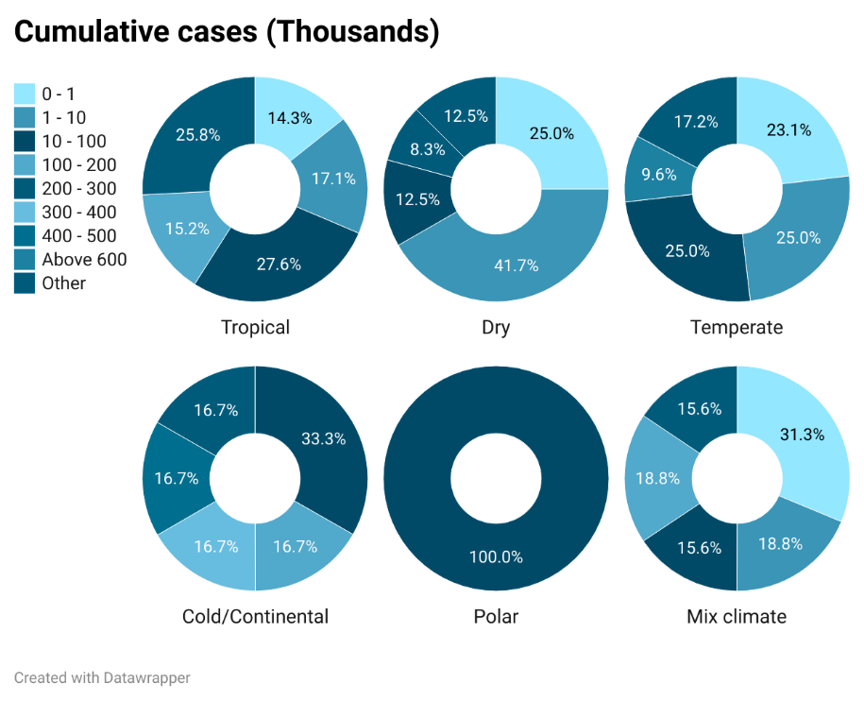
Figure 2. Cumulative cases vs. climate types

Table 5. Cumulative deaths vs. climate types
Cumulative deaths (Thousands) | Tropical | Dry | Temperate | Cold Continental | Polar | Mix climate
0 - 1 | 56 (53.3%) | 20 (83.3%) | 37 (71.2%) | 3 (50%) | 1 (100%) | 18 (56.3%)
1 - 5 | 26 (24.8%) | 3 (12.5%) | 6 (11.5%) | 1 (16.7%) | 0 (0%) | 9 (28.1%)
5 - 10 | 7 (6.7%) | 0 (0%) | 2 (3.8%) | 2 (33.3%) | 0 (0%) | 1 (3.1%)
10 - 20 | 7 (6.7%) | 0 (0%) | 2 (3.8%) | 0 (0%) | 0 (0%) | 1 (3.1%)
20 - 50 | 4 (3.8%) | 1 (4.2%) | 2 (3.8%) | 0 (0%) | 0 (0%) | 1 (3.1%)
50 - 100 | 4 (3.8%) | 0 (0%) | 1 (1.9%) | 0 (0%) | 0 (0%) | 1 (3.1%)
Above 100 | 1 (1%) | 0 (0%) | 2 (3.8%) | 0 (0%) | 0 (0%) | 1 (3.1%)
Mean deaths | 6788.77 | 2145.92 | 10840.25 | 3058.83 | - | 14733.81
Std. Err. | 1710.04 | 1790.53 | 4894.73 | 1341.10 | - | 10647.22
Mean 95% | 3503.41 | 361.38 | 3740.41 | 3011.37 | - | 3428.12

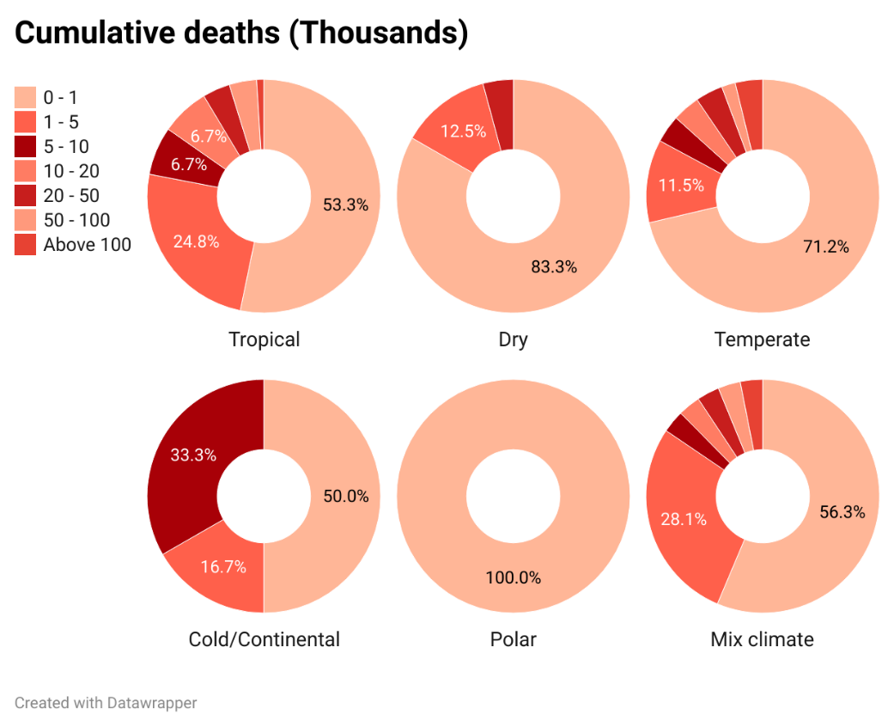
Figure 3. Cumulative deaths vs. climate types

Table 6. Population positive cases vs. climate types
Population positive cases | Tropical | Dry | Temperate | Cold Continental | Polar | Mix climate
0% - 0.1 % | 15 (14.3%) | 9 (37.5%) | 14 (26.9%) | 1 (16.7%) | 0 (0%) | 11 (34.4%)
0.1% - 0.5% | 19 (18.1%) | 5 (20.8%) | 13 (25%) | 2 (33.3%) | 1 (100%) | 8 (25%)
0.5% - 1% | 7 (6.7%) | 4 (16.7%) | 5 (9.6%) | 1 (16.7%) | 0 (0%) | 1 (3.1%)
1%- 2% | 17 (16.2%) | 3 (12.5%) | 4 (7.7%) | 0 (0%) | 0 (0%) | 3 (9.4%)
2% - 3% | 19 (18.1%) | 1 (4.2%) | 7 (13.5%) | 0 (0%) | 0 (0%) | 1 (3.1%)
3% - 4% | 12 (11.4%) | 1 (4.2%) | 6 (11.5%) | 0 (0%) | 0 (0%) | 1 (3.1%)
4% - 5% | 5 (4.8%) | 1 (4.2%) | 0 (0%) | 2 (33.3%) | 0 (0%) | 2 (6.3%)
5% - 6% | 5 (4.8%) | 0 (0%) | 2 (3.8%) | 0 (0%) | 0 (0%) | 5 (15.6%)
6% - 7% | 2 (1.9%) | 0 (0%) | 1 (1.9%) | 0 (0%) | 0 (0%) | 0 (0%)
7% - 8% | 3 (2.9%) | 0 (0%) | 0 (0%) | 0 (0%) | 0 (0%) | 0 (0%)
10% and above | 1 (1%) | 0 (0%) | 0 (0%) | 0 (0%) | 0 (0%) | 0 (0%)
Mean cases | 2.06 | 0.77 | 1.31 | 1.59 | - | 1.56
Std. Err. | 0.21 | 0.24 | 0.23 | 0.79 | - | 0.38
Mean 95% | 1.85 | 0.59 | 1.14 | 1.53 | - | 1.41

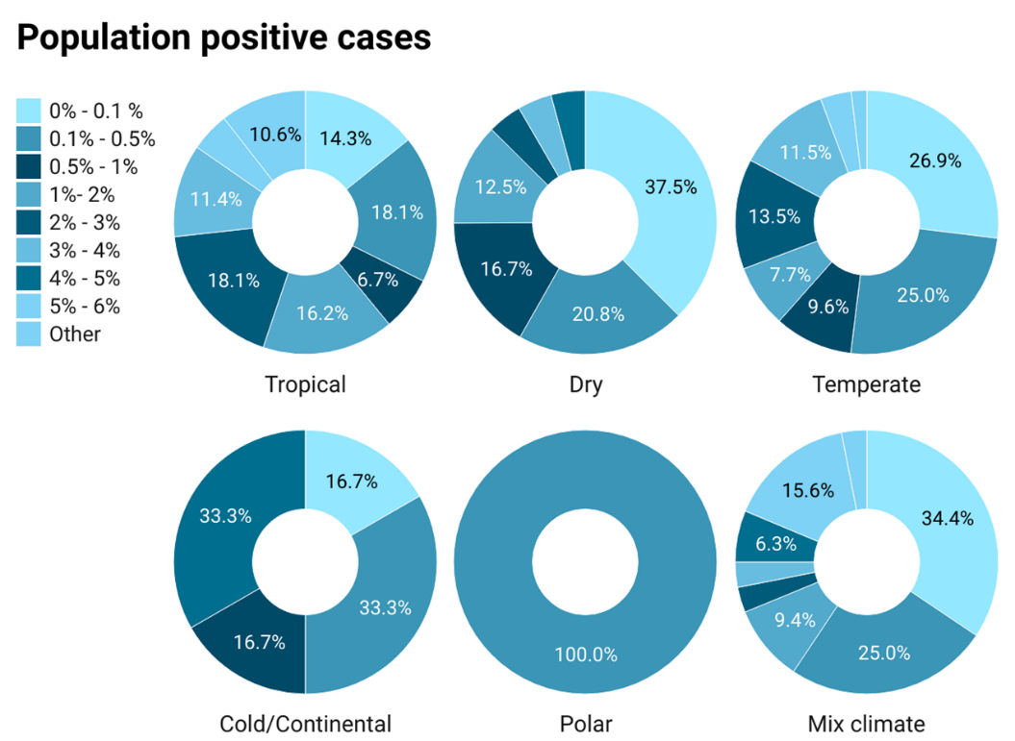
Figure 4. Population positive cases vs. climate types

Table 7. Population positive deaths vs. climate types
Population Covid deaths | Tropical | Dry | Temperate | Cold Continental | Polar | Mix climate
0‰ - 1‰ | 16 (15.2%) | 11 (45.8%) | 16 (30.8%) | 2 (33.3%) | 0 (0%) | 10 (31.3%)
1‰ - 5‰ | 14 (13.3%) | 6 (25%) | 11 (21.2%) | 0 (0%) | 1 (100%) | 6 (18.8%)
5‰ - 10‰ | 11 (10.5%) | 4 (16.7%) | 3 (5.8%) | 0 (0%) | 0 (0%) | 4 (12.5%)
10‰ - 50‰ | 42 (40%) | 2 (8.3%) | 11 (21.2%) | 2 (33.3%) | 0 (0%) | 4 (12.5%)
50‰ - 100‰ | 13 (12.4%) | 1 (4.2%) | 8 (15.4%) | 2 (33.3%) | 0 (0%) | 5 (15.6%)
above 100‰ | 9 (8.6%) | 0 (0%) | 3 (5.8%) | 0 (0%) | 0 (0%) | 3 (9.4%)
Mean deaths | 0.034 | 0.007 | 0.025 | 0.029 | - | 0.029
Std. Err. | 0.004 | 0.004 | 0.005 | 0.013 | - | 0.008
Mean 95% | 0.030 | 0.004 | 0.022 | 0.029 | - | 0.024

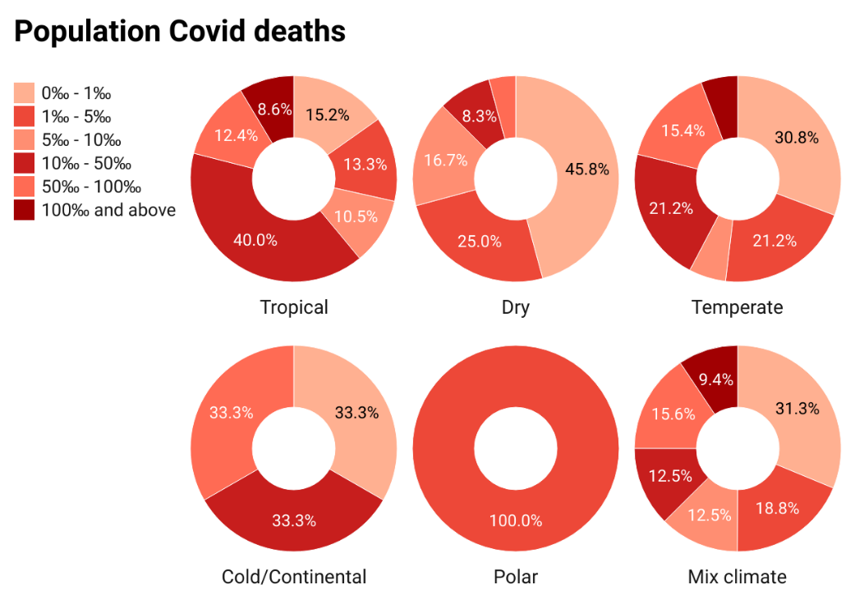
Figure 5. Population positive deaths vs. climate types

Table 8. Death of infection vs. climate types
Death of infection | Tropical | Dry | Temperate | Cold Continental | Polar | Mix climate
0‰ - 5‰ | 12 (11.4%) | 9 (37.5%) | 10 (19.2%) | 1 (16.7%) | 0 (0%) | 6 (18.8%)
5‰ - 10‰ | 16 (15.2%) | 3 (12.5%) | 6 (11.5%) | 1 (16.7%) | 0 (0%) | 5 (15.6%)
10‰ - 20‰ | 41 (39%) | 7 (29.2%) | 18 (34.6%) | 2 (33.3%) | 1 (100%) | 9 (28.1%)
20‰ - 30‰ | 21 (20%) | 3 (12.5%) | 11 (21.2%) | 1 (16.7%) | 0 (0%) | 5 (15.6%)
30‰ - 40‰ | 6 (5.7%) | 1 (4.2%) | 3 (5.8%) | 1 (16.7%) | 0 (0%) | 4 (12.5%)
40‰ - 50‰ | 4 (3.8%) | 1 (4.2%) | 1 (1.9%) | 0 (0%) | 0 (0%) | 2 (6.3%)
50‰ - 60‰ | 1 (1%) | 0 (0%) | 0 (0%) | 0 (0%) | 0 (0%) | 1 (3.1%)
60‰ - 70‰ | 2 (1.9%) | 0 (0%) | 2 (3.8%) | 0 (0%) | 0 (0%) | 0 (0%)
70‰ - 80‰ | 1 (1%) | 0 (0%) | 0 (0%) | 0 (0%) | 0 (0%) | 0 (0%)
80‰ - 90‰ | 1 (1%) | 0 (0%) | 0 (0%) | 0 (0%) | 0 (0%) | 0 (0%)
above 100‰ | 0 (0%) | 0 (0%) | 1 (1.9%) | 0 (0%) | 0 (0%) | 0 (0%)
Mean Death | 0.019 | 0.012 | 0.023 | 0.016 | - | 0.019
Std. Err. | 0.001 | 0.003 | 0.006 | 0.005 | - | 0.003
Mean 95% | 0.018 | 0.011 | 0.017 | 0.016 | - | 0.018

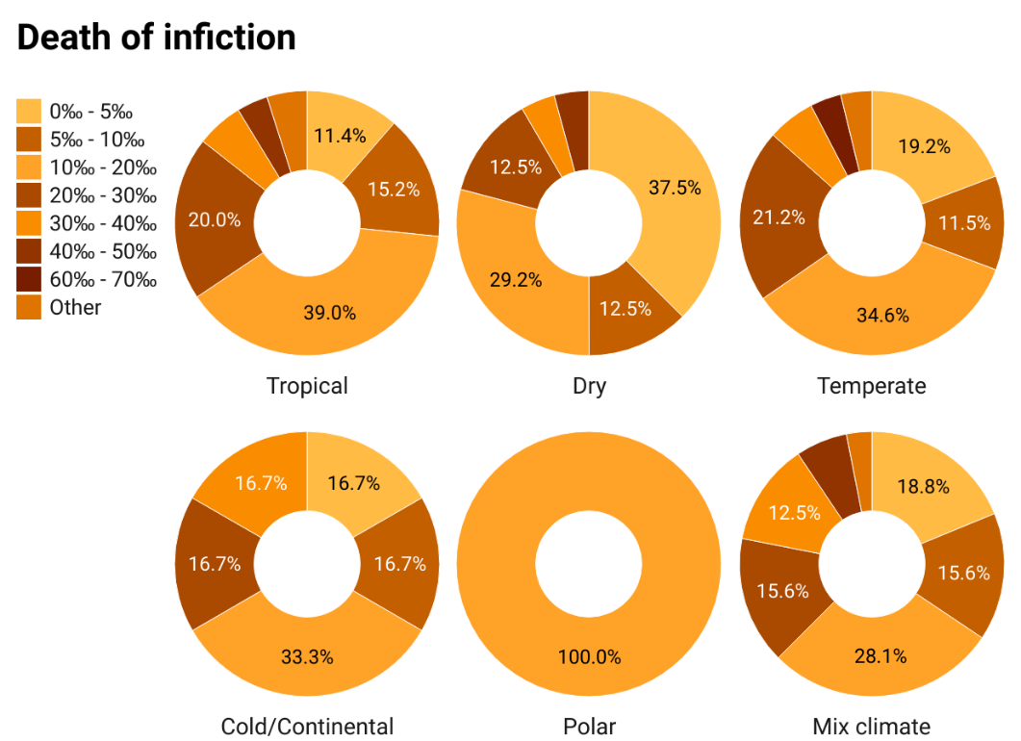
Figure 6. Death of infection vs. climate types

Country area
The country land area is a scale variable that represents the area of a certain country in square kilometres (Km²). The distribution of Covid-19 cumulative cases in the world is presented as a heat map from low to high cases. The land area is presented in a heat map from large to small as well. The combination between the two heat scales represents the distribution of covid-19 cumulative cases in different land areas as depicted in Figure 7.
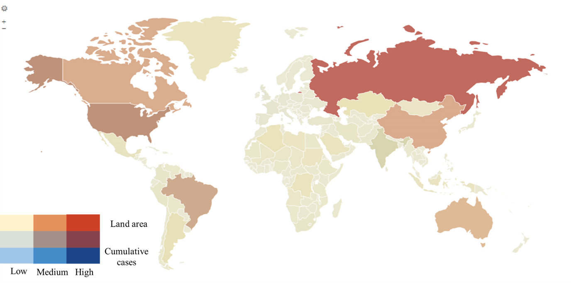
Figure 7. Country land area (km²) vs. cumulative cases

Country urbanization
The urbanization variable is a scale variable that describes the percentage of the country's urbanization. The highly urbanized countries are illustrated in a bivariate heat map with cumulative Covid-19 cases in Figure 8.
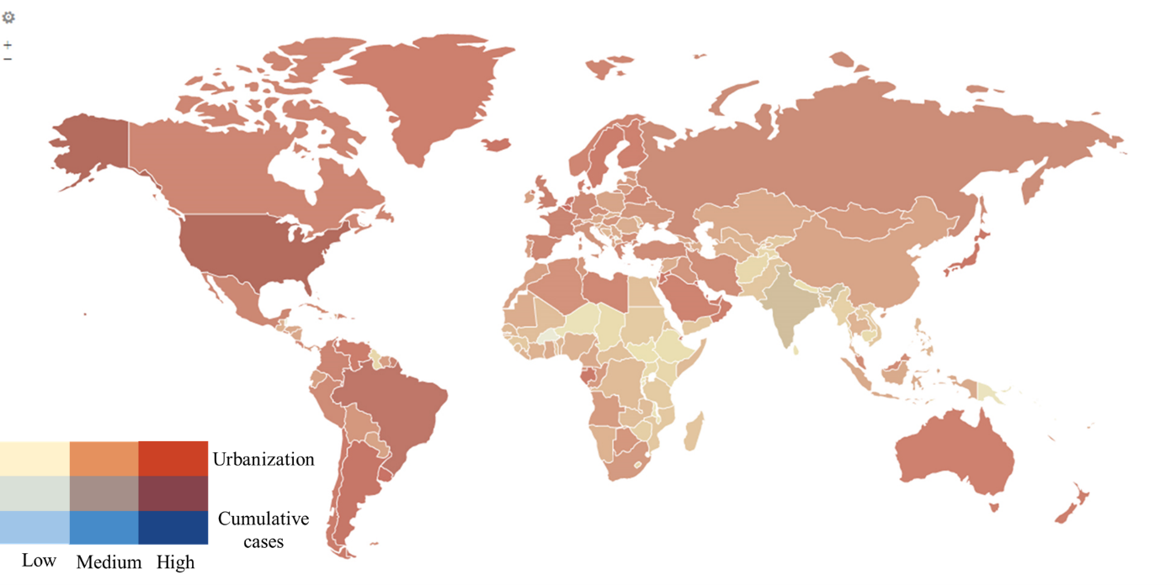
Figure 8. Country urbanization vs. cumulative cases

Politics related variables

Government type
Table 9. Cumulative Covid-19 cases/deaths vs. Government type.
Cumulative cases (Thousands) | Full Presidential Republic |  | Semi-Presidential Republic | Parliamentary Republic |  |  | Parliamentary Constitutional Monarchy | Parliamentary Democracy |  | Constitutional Monarchy |  | Absolute Monarchy |  | One Party State Dictatorship
0 - 1 | 4 (5.5%) |  | 5 (20%) | 6 (11.1%) |  |  | 1 (7.1%) | 23 (63.9%) |  | 2 (25%) |  | 2 (33.3%) |  | 1 (25%)
1 - 10 | 20 (27.4%) |  | 8 (32%) | 6 (11.1%) |  |  | 1 (7.1%) | 8 (22.2%) |  | 2 (25%) |  | 1 (16.7%) |  | 1 (25%)
10 - 100 | 26 (35.6%) |  | 4 (16%) | 14 (25.9%) |  |  | 2 (14.3%) | 3 (8.3%) |  | 2 (25%) |  | 0 (0%) |  | 2 (50%)
100 - 200 | 9 (12.3%) |  | 2 (8%) | 10 (18.5%) |  |  | 2 (14.3%) | 1 (2.8%) |  | 1 (12.5%) |  | 2 (33.3%) |  | 0 (0%)
200 - 300 | 4 (5.5%) |  | 1 (4%) | 3 (5.6%) |  |  | 2 (14.3%) | 0 (0%) |  | 1 (12.5%) |  | 0 (0%) |  | 0 (0%)
300 - 400 | 0 (0%) |  | 0 (0%) | 3 (5.6%) |  |  | 0 (0%) | 0 (0%) |  | 0 (0%) |  | 1 (16.7%) |  | 0 (0%)
400 - 500 | 1 (1.4%) |  | 1 (4%) | 2 (3.7%) |  |  | 2 (14.3%) | 1 (2.8%) |  | 0 (0%) |  | 0 (0%) |  | 0 (0%)
500 - 600 | 0 (0%) |  | 0 (0%) | 3 (5.6%) |  |  | 0 (0%) | 0 (0%) |  | 0 (0%) |  | 0 (0%) |  | 0 (0%)
Above 600 | 9 (12.3%) |  | 4 (16%) | 7 (13%) |  |  | 4 (28.6%) | 0 (0%) |  | 0 (0%) |  | 0 (0%) |  | 0 (0%)
Mean cases | 540984.82 |  | 342551.84 | 461552.07 |  |  | 546052.50 | 18937.31 |  | 63903.88 |  | 107553.83 |  | 27600.00
Std. Err. | 286978.39 |  | 163042.47 | 195467.27 |  |  | 203210.90 | 12435.84 |  | 28327.95 |  | 57652.95 |  | 23231.33
Mean 95% | 145154.56 |  | 208987.48 | 231684.42 |  |  | 465477.89 | 3986.90 |  | 59317.25 |  | 99342.93 |  | 25285.00
Cumulative deaths (Thousands) | Full Presidential Republic | Semi-Presidential Republic |  |  | Parliamentary Republic | Parliamentary Constitutional Monarchy |  |  | Parliamentary Democracy |  | Constitutional Monarchy |  | Absolute Monarchy | One Party State Dictatorship
0 - 1 | 43 (58.9%) | 17 (68%) |  |  | 21 (38.9%) | 5 (35.7%) |  |  | 34 (94.4%) |  | 8 (100%) |  | 4 (66.7%) | 3 (75%)
1 - 5 | 17 (23.3%) | 3 (12%) |  |  | 18 (33.3%) | 3 (21.4%) |  |  | 2 (5.6%) |  | 0 (0%) |  | 1 (16.7%) | 1 (25%)
5 - 10 | 3 (4.1%) | 1 (4%) |  |  | 5 (9.3%) | 2 (14.3%) |  |  | 0 (0%) |  | 0 (0%) |  | 1 (16.7%) | 0 (0%)
10 - 20 | 2 (2.7%) | 2 (8%) |  |  | 4 (7.4%) | 2 (14.3%) |  |  | 0 (0%) |  | 0 (0%) |  | 0 (0%) | 0 (0%)
20 - 50 | 5 (6.8%) | 0 (0%) |  |  | 3 (5.6%) | 0 (0%) |  |  | 0 (0%) |  | 0 (0%) |  | 0 (0%) | 0 (0%)
50 - 100 | 0 (0%) | 2 (8%) |  |  | 2 (3.7%) | 2 (14.3%) |  |  | 0 (0%) |  | 0 (0%) |  | 0 (0%) | 0 (0%)
Above 100 | 3 (4.1%) | 0 (0%) |  |  | 1 (1.9%) | 0 (0%) |  |  | 0 (0%) |  | 0 (0%) |  | 0 (0%) | 0 (0%)
Mean deaths | 12762.22 | 6861.00 |  |  | 9448.00 | 12980.86 |  |  | 221.92 |  | 319.88 |  | 1363.83 | 1242.75
Std. Err. | 5588.48 | 3414.60 |  |  | 3236.50 | 5910.08 |  |  | 120.46 |  | 125.91 |  | 1000.04 | 1182.83
Mean 95% | 3701.99 | 4117.22 |  |  | 5095.00 | 10305.12 |  |  | 73.97 |  | 303.42 |  | 1169.26 | 1114.72

There are 8 government types presented in the studied dataset. The distribution of world countries within the different government types is given in Table 10.
Table 10. Government type distribution among countries.
Government type | N (%)
Full Presidential Republic | 73 (33.2%)
Semi-Presidential Republic | 25 (11.4%)
Parliamentary Republic | 54 (24.5%)
Parliamentary Constitutional Monarchy | 14 (6.4%)
Parliamentary Democracy | 36 (16.4%)
Constitutional Monarchy | 8 (3.6%)
Absolute Monarchy | 6 (2.7%)
One Party State/Dictatorship | 4 (1.8%)
There are 73 counties reported to have a Full presidential republic system. That is 33.2% of the studied countries.
The distribution of the cumulative Covid-19 cases groups within the different government types is illustrated in Figure 9.
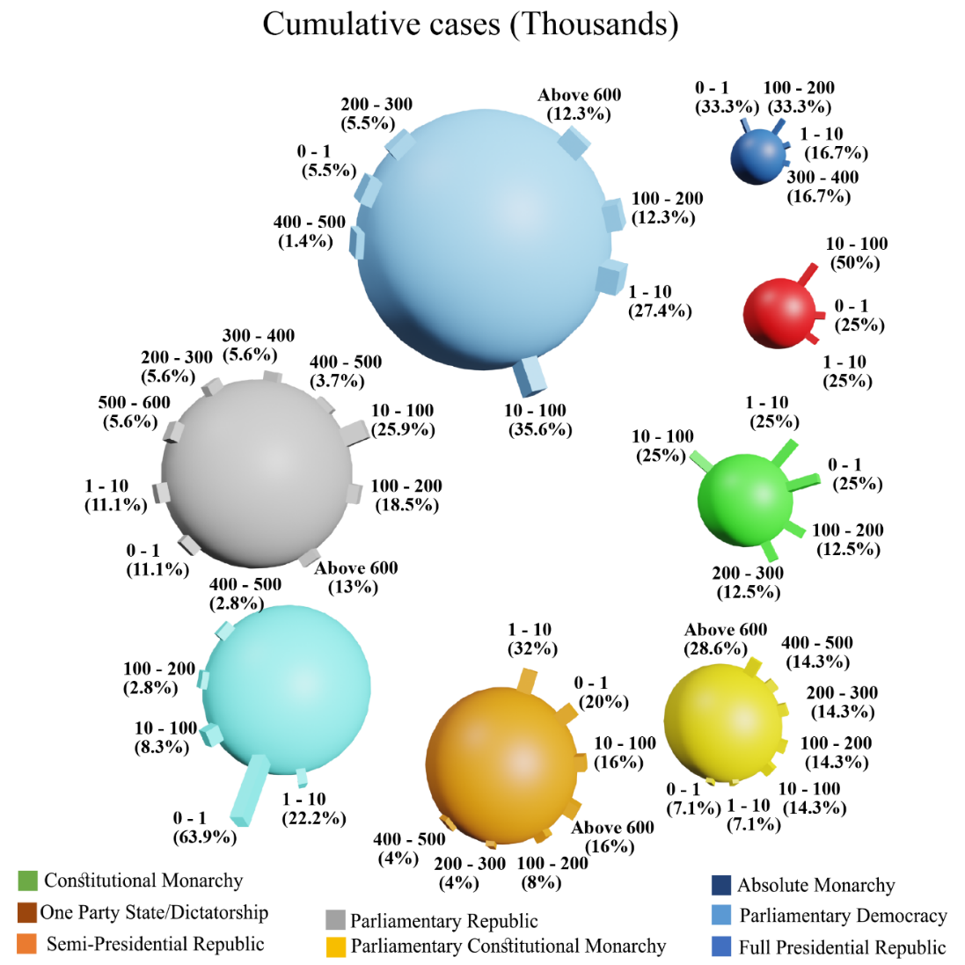
Figure 9. Cumulative Covid-19 cases vs. government type.

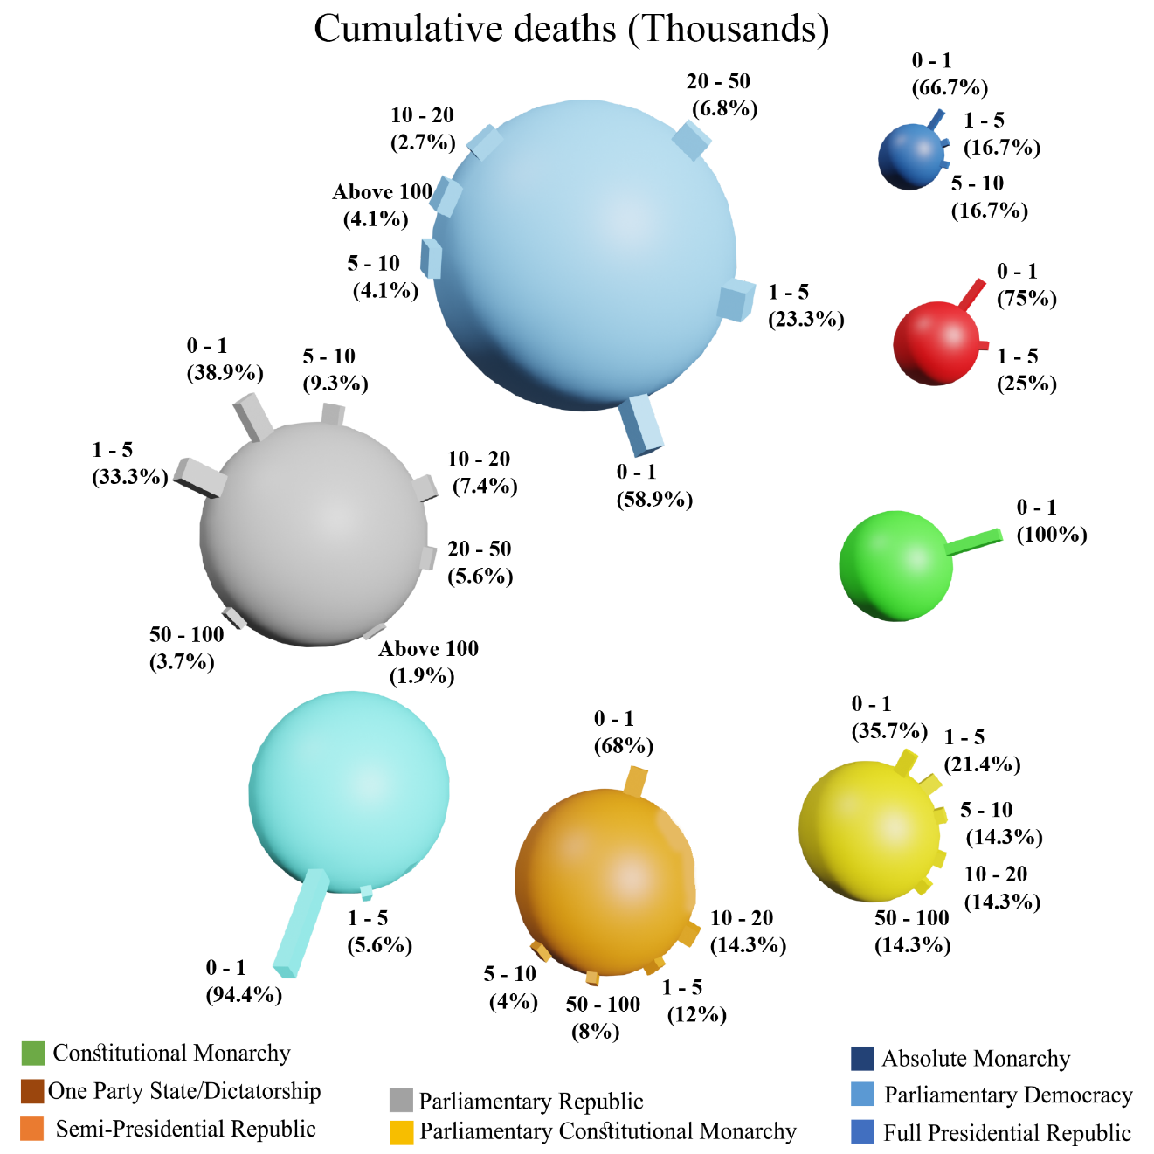
Figure 10. Cumulative Covid-19 deaths vs. government type.

Table 11. Covid-19 population cases/deaths vs. Government type.
Population positive cases | Full Presidential Republic | Semi-Presidential Republic | Parliamentary Republic | Parliamentary Constitutional Monarchy | Parliamentary Democracy | Constitutional Monarchy | Absolute Monarchy | One Party State Dictatorship
0% - 0.1 % | 21 (28.8%) | 8 (32%) | 7 (13%) | 1 (7.1%) | 7 (19.4%) | 2 (25%) | 1 (16.7%) | 3 (75%)
0.1% - 0.5% | 23 (31.5%) | 3 (12%) | 6 (11.1%) | 3 (21.4%) | 12 (33.3%) | 0 (0%) | 0 (0%) | 1 (25%)
0.5% - 1% | 5 (6.8%) | 0 (0%) | 6 (11.1%) | 1 (7.1%) | 5 (13.9%) | 0 (0%) | 1 (16.7%) | 0 (0%)
1%- 2% | 11 (15.1%) | 2 (8%) | 11 (20.4%) | 1 (7.1%) | 1 (2.8%) | 0 (0%) | 1 (16.7%) | 0 (0%)
2% - 3% | 4 (5.5%) | 5 (20%) | 9 (16.7%) | 3 (21.4%) | 4 (11.1%) | 2 (25%) | 1 (16.7%) | 0 (0%)
3% - 4% | 6 (8.2%) | 3 (12%) | 7 (13%) | 1 (7.1%) | 1 (2.8%) | 1 (12.5%) | 1 (16.7%) | 0 (0%)
4% - 5% | 1 (1.4%) | 2 (8%) | 2 (3.7%) | 3 (21.4%) | 1 (2.8%) | 0 (0%) | 1 (16.7%) | 0 (0%)
5% - 6% | 2 (2.7%) | 2 (8%) | 3 (5.6%) | 1 (7.1%) | 2 (5.6%) | 2 (25%) | 0 (0%) | 0 (0%)
6% - 7% | 0 (0%) | 0 (0%) | 1 (1.9%) | 0 (0%) | 2 (5.6%) | 0 (0%) | 0 (0%) | 0 (0%)
7% - 8% | 0 (0%) | 0 (0%) | 2 (3.7%) | 0 (0%) | 0 (0%) | 1 (12.5%) | 0 (0%) | 0 (0%)
above 10% | 0 (0%) | 0 (0%) | 0 (0%) | 0 (0%) | 1 (2.8%) | 0 (0%) | 0 (0%) | 0 (0%)
Mean positive | 0.97 | 1.82 | 2.12 | 2.40 | 1.64 | 3.35 | 2.11 | 0.03
Std. Err. | 0.16 | 0.37 | 0.27 | 0.51 | 0.40 | 0.97 | 0.75 | 0.03
Mean 95% | 0.80 | 1.71 | 1.95 | 2.36 | 1.35 | 3.30 | 2.06 | 0.03
Population Covid deaths | Full Presidential Republic | Semi-Presidential Republic | Parliamentary Republic | Parliamentary Constitutional Monarchy | Parliamentary Democracy | Constitutional Monarchy | Absolute Monarchy | One Party State Dictatorship
0‰ - 1‰ | 17 (23.3%) | 8 (32%) | 9 (16.7%) | 1 (7.1%) | 13 (36.1%) | 2 (25%) | 2 (33.3%) | 3 (75%)
1‰ - 5‰ | 19 (26%) | 4 (16%) | 6 (11.1%) | 3 (21.4%) | 5 (13.9%) | 0 (0%) | 0 (0%) | 1 (25%)
5‰ - 10‰ | 12 (16.4%) | 1 (4%) | 3 (5.6%) | 1 (7.1%) | 2 (5.6%) | 2 (25%) | 1 (16.7%) | 0 (0%)
10‰ - 50‰ | 13 (17.8%) | 7 (28%) | 20 (37%) | 3 (21.4%) | 13 (36.1%) | 2 (25%) | 3 (50%) | 0 (0%)
50‰ - 100‰ | 10 (13.7%) | 5 (20%) | 7 (13%) | 3 (21.4%) | 2 (5.6%) | 2 (25%) | 0 (0%) | 0 (0%)
above 100‰ | 2 (2.7%) | 0 (0%) | 9 (16.7%) | 3 (21.4%) | 1 (2.8%) | 0 (0%) | 0 (0%) | 0 (0%)
Mean deaths | 0.0205 | 0.0248 | 0.0432 | 0.0498 | 0.0181 | 0.0280 | 0.0124 | 0.0004
Std. Err. | 0.0037 | 0.0060 | 0.0061 | 0.0140 | 0.0044 | 0.0124 | 0.0047 | 0.0003
Mean 95% | 0.0170 | 0.0223 | 0.0398 | 0.0460 | 0.0144 | 0.0263 | 0.0121 | 0.0004

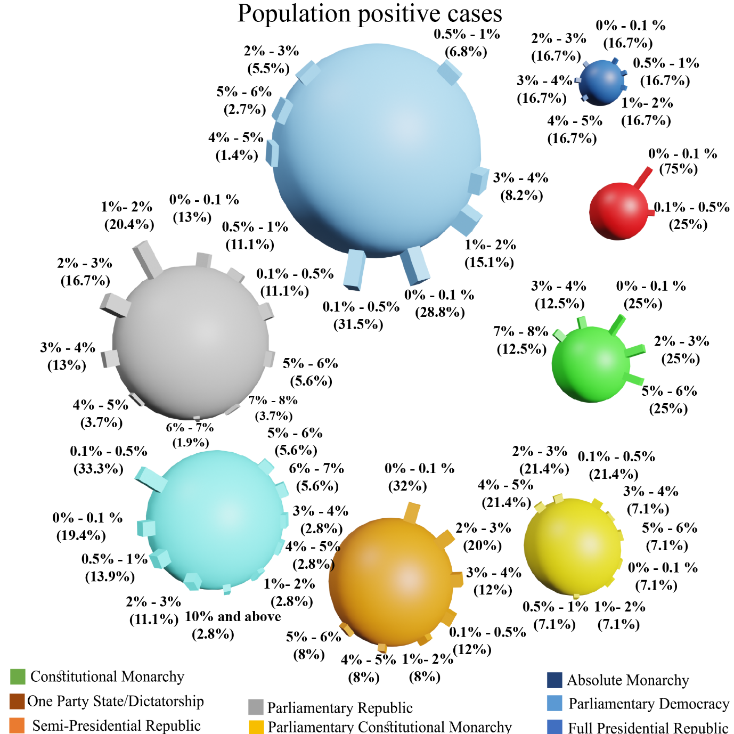
Figure 11. Covid-19 population cases vs. Government type.

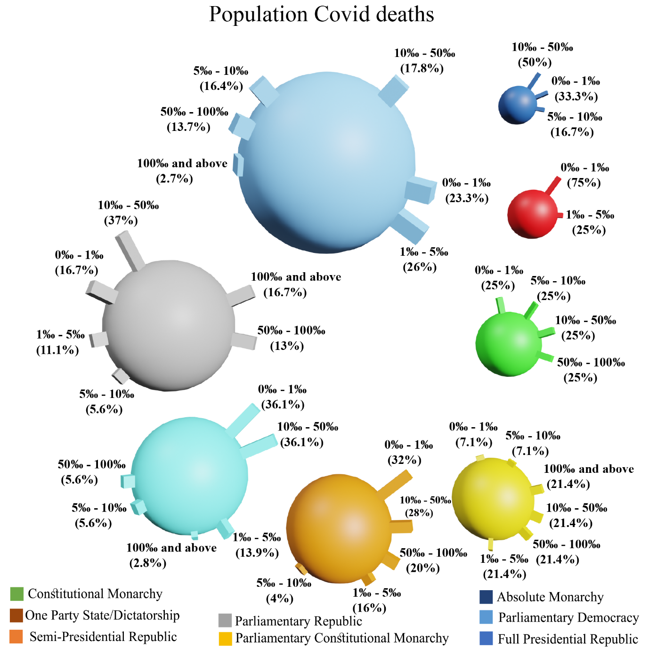
Figure 12. Covid-19 population deaths vs. Government type.

Table 12. Covid-19 death of infections vs. Government type.
Death of infection | Full Presidential Republic | Semi-Presidential Republic | Parliamentary Republic | Parliamentary Constitutional Monarchy | Parliamentary Democracy | Constitutional Monarchy | Absolute Monarchy | One Party State Dictatorship
0‰ - 5‰ | 4 (5.5%) | 6 (24%) | 6 (11.1%) | 2 (14.3%) | 13 (36.1%) | 4 (50%) | 2 (33.3%) | 1 (25%)
5‰ - 10‰ | 13 (17.8%) | 3 (12%) | 6 (11.1%) | 2 (14.3%) | 5 (13.9%) | 2 (25%) | 0 (0%) | 0 (0%)
10‰ - 20‰ | 28 (38.4%) | 10 (40%) | 17 (31.5%) | 6 (42.9%) | 11 (30.6%) | 2 (25%) | 3 (50%) | 1 (25%)
20‰ - 30‰ | 15 (20.5%) | 3 (12%) | 16 (29.6%) | 3 (21.4%) | 2 (5.6%) | 0 (0%) | 1 (16.7%) | 1 (25%)
30‰ - 40‰ | 4 (5.5%) | 3 (12%) | 5 (9.3%) | 1 (7.1%) | 2 (5.6%) | 0 (0%) | 0 (0%) | 0 (0%)
40‰ - 50‰ | 3 (4.1%) | 0 (0%) | 3 (5.6%) | 0 (0%) | 1 (2.8%) | 0 (0%) | 0 (0%) | 1 (25%)
50‰ - 60‰ | 2 (2.7%) | 0 (0%) | 0 (0%) | 0 (0%) | 0 (0%) | 0 (0%) | 0 (0%) | 0 (0%)
60‰ - 70‰ | 3 (4.1%) | 0 (0%) | 0 (0%) | 0 (0%) | 1 (2.8%) | 0 (0%) | 0 (0%) | 0 (0%)
70‰ - 80‰ | 0 (0%) | 0 (0%) | 0 (0%) | 0 (0%) | 1 (2.8%) | 0 (0%) | 0 (0%) | 0 (0%)
80‰ - 90‰ | 1 (1.4%) | 0 (0%) | 0 (0%) | 0 (0%) | 0 (0%) | 0 (0%) | 0 (0%) | 0 (0%)
above 100 | 0 (0%) | 0 (0%) | 1 (1.9%) | 0 (0%) | 0 (0%) | 0 (0%) | 0 (0%) | 0 (0%)
Mean Death | 0.022 | 0.014 | 0.024 | 0.016 | 0.014 | 0.006 | 0.012 | 0.021
Std. Err. | 0.002 | 0.002 | 0.005 | 0.002 | 0.003 | 0.002 | 0.004 | 0.011
Mean 95% | 0.020 | 0.014 | 0.020 | 0.016 | 0.012 | 0.006 | 0.012 | 0.021

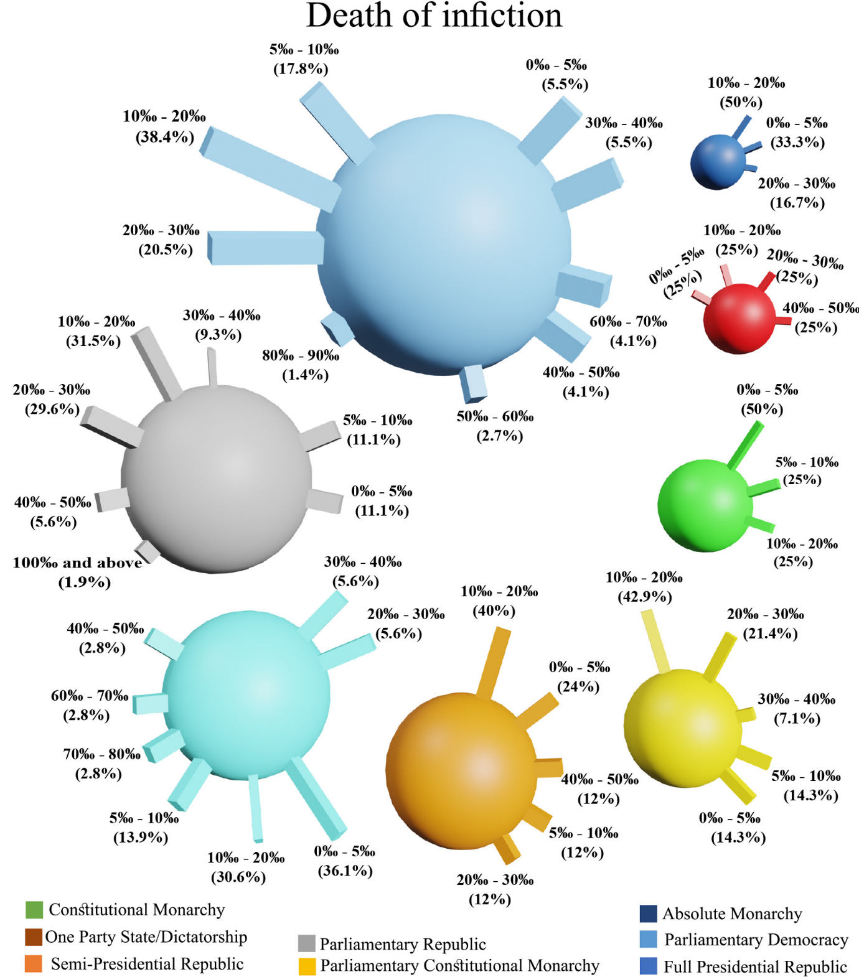
Figure 13. Covid-19 death of infections vs. Government type.

Leader education
There are 4 education levels of country leaders. Table 13 shows the distribution of leader’s degrees within world countries.
Table 13. Distribution of leader education degree within countries.
Leader Education | N (%)
Bachelor | 83 (37.7%)
Masters | 53 (24.1%)
Doctorate | 33 (15%)
None | 35 (15.9%)
Unknown | 16 (7.3%)

There are 37.7% of the leaders who have only a bachelor’s degree. While 39% have a higher educational degree. On the contrary, 15.9% of world leaders have no educational degree at all.
Table 14. Cumulative Covid-19 cases/deaths vs. Leader education.
Cumulative cases (Thousands) | Bachelor | Masters | Doctorate | None | Unknown
0 - 1 | 17 (20.5%) | 10 (18.9%) | 4 (12.1%) | 5 (14.3%) | 8 (50%)
1 - 10 | 13 (15.7%) | 13 (24.5%) | 8 (24.2%) | 12 (34.3%) | 1 (6.3%)
10 - 100 | 22 (26.5%) | 15 (28.3%) | 9 (27.3%) | 5 (14.3%) | 2 (12.5%)
100 - 200 | 12 (14.5%) | 6 (11.3%) | 3 (9.1%) | 4 (11.4%) | 2 (12.5%)
200 - 300 | 4 (4.8%) | 1 (1.9%) | 3 (9.1%) | 3 (8.6%) | 0 (0%)
300 - 400 | 0 (0%) | 2 (3.8%) | 0 (0%) | 1 (2.9%) | 1 (6.3%)
400 - 500 | 2 (2.4%) | 1 (1.9%) | 2 (6.1%) | 2 (5.7%) | 0 (0%)
500 - 600 | 1 (1.2%) | 0 (0%) | 0 (0%) | 1 (2.9%) | 1 (6.3%)
Above 600 | 12 (14.5%) | 5 (9.4%) | 4 (12.1%) | 2 (5.7%) | 1 (6.3%)
Mean cases | 503210.29 | 355778.30 | 215055.18 | 350358.51 | 161928.69
Std. Err. | 241494.88 | 200358.74 | 71007.52 | 219387.68 | 91127.37
Mean 95% | 187684.82 | 102452.07 | 151112.87 | 116283.47 | 101780.88
Cumulative deaths (Thousands) | Bachelor | Masters | Doctorate | None | Unknown
0 - 1 | 47 (56.6%) | 36 (67.9%) | 18 (54.5%) | 22 (62.9%) | 12 (75%)
1 - 5 | 19 (22.9%) | 11 (20.8%) | 9 (27.3%) | 5 (14.3%) | 1 (6.3%)
5 - 10 | 2 (2.4%) | 1 (1.9%) | 2 (6.1%) | 5 (14.3%) | 2 (12.5%)
10 - 20 | 6 (7.2%) | 2 (3.8%) | 1 (3%) | 1 (2.9%) | 0 (0%)
20 - 50 | 3 (3.6%) | 1 (1.9%) | 3 (9.1%) | 0 (0%) | 1 (6.3%)
50 - 100 | 4 (4.8%) | 1 (1.9%) | 0 (0%) | 1 (2.9%) | 0 (0%)
Above 100 | 2 (2.4%) | 1 (1.9%) | 0 (0%) | 1 (2.9%) | 0 (0%)
Mean deaths | 11795.54 | 6247.08 | 4829.12 | 8923.63 | 2311.25
Std. Err. | 4557.00 | 3124.91 | 1715.37 | 5705.90 | 1381.47
Mean 95% | 4768.76 | 1874.25 | 3353.77 | 2408.74 | 1396.22

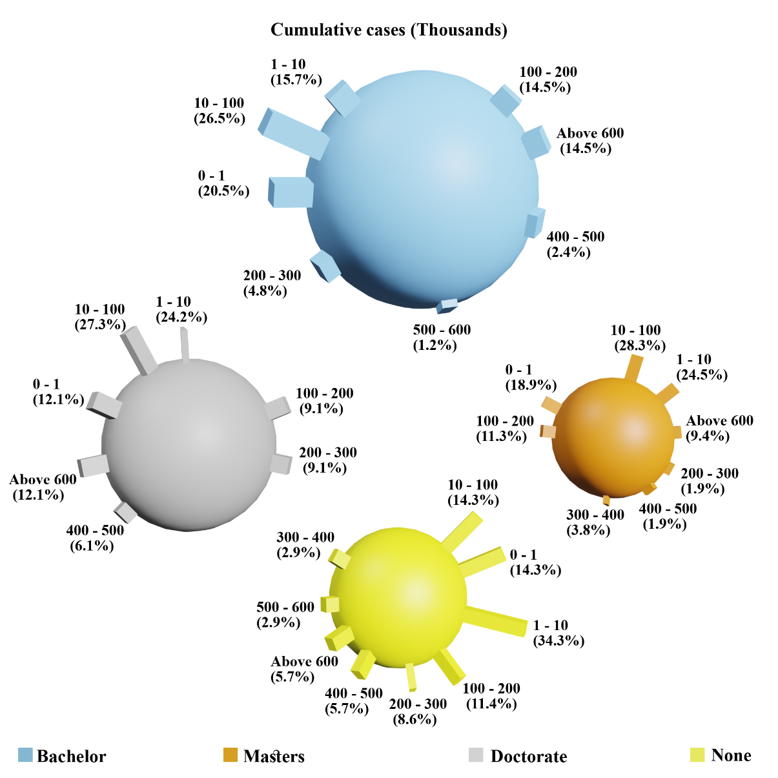
Figure 14. Cumulative Covid-19 cases vs. Leader education.

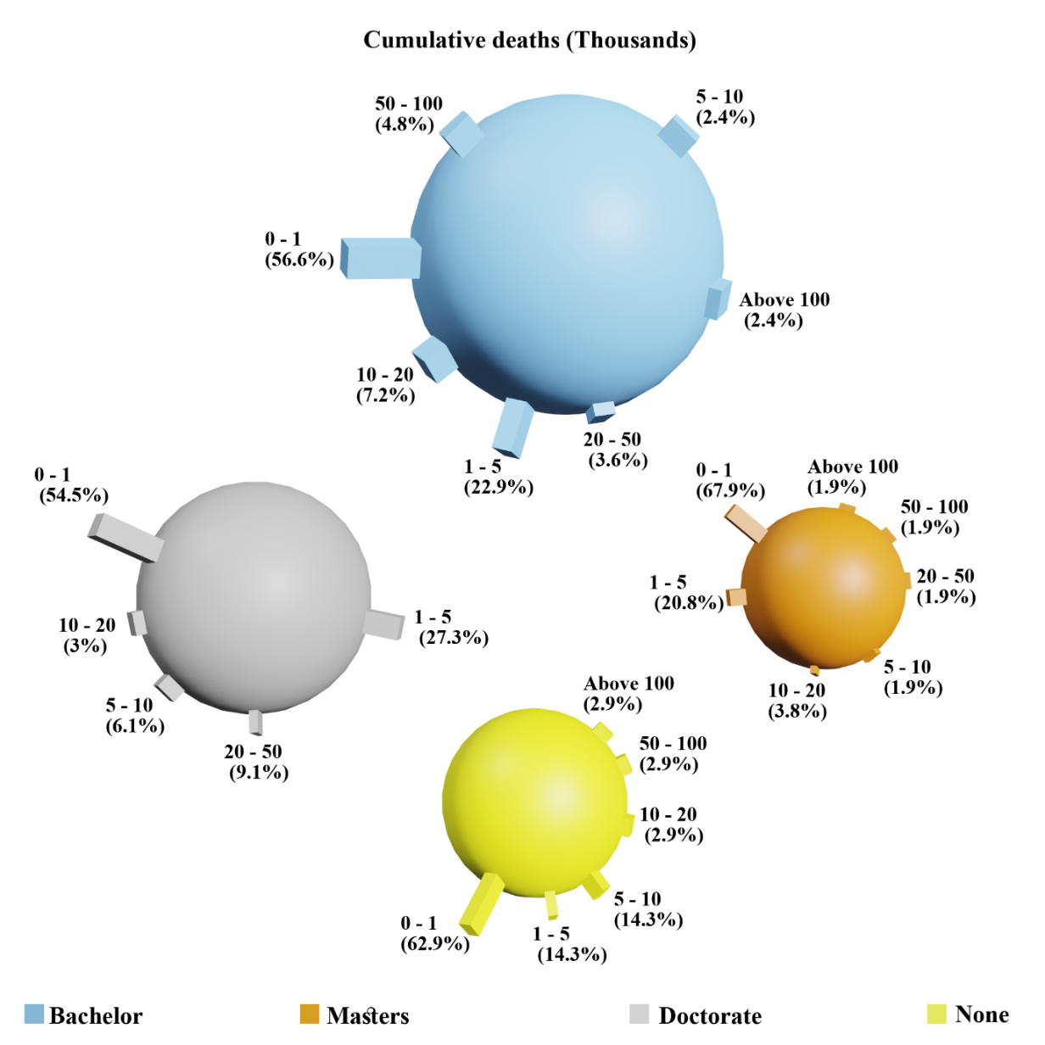
Figure 15. Cumulative Covid-19 deaths vs. Leader education.

Table 15. Covid-19 population cases/deaths and death of infection vs. Leader education.
Population positive cases | Bachelor | Masters | Doctorate | None | Unknown
0% - 0.1 % | 15 (18.1%) | 6 (11.3%) | 7 (21.2%) | 15 (42.9%) | 7 (43.8%)
0.1% - 0.5% | 24 (28.9%) | 8 (15.1%) | 7 (21.2%) | 6 (17.1%) | 3 (18.8%)
0.5% - 1% | 5 (6%) | 7 (13.2%) | 3 (9.1%) | 3 (8.6%) | 0 (0%)
1%- 2% | 11 (13.3%) | 10 (18.9%) | 1 (3%) | 3 (8.6%) | 2 (12.5%)
2% - 3% | 9 (10.8%) | 7 (13.2%) | 7 (21.2%) | 3 (8.6%) | 2 (12.5%)
3% - 4% | 8 (9.6%) | 6 (11.3%) | 4 (12.1%) | 1 (2.9%) | 1 (6.3%)
4% - 5% | 2 (2.4%) | 4 (7.5%) | 1 (3%) | 2 (5.7%) | 1 (6.3%)
5% - 6% | 6 (7.2%) | 3 (5.7%) | 1 (3%) | 2 (5.7%) | 0 (0%)
6% - 7% | 2 (2.4%) | 1 (1.9%) | 0 (0%) | 0 (0%) | 0 (0%)
7% - 8% | 1 (1.2%) | 0 (0%) | 2 (6.1%) | 0 (0%) | 0 (0%)
10% and above | 0 (0%) | 1 (1.9%) | 0 (0%) | 0 (0%) | 0 (0%)
Mean cases | 1.6 | 2.1 | 1.8 | 1.1 | 1.1
Std. Err. | 0.2 | 0.3 | 0.4 | 0.3 | 0.4
Mean 95% | 1.5 | 1.9 | 1.6 | 0.9 | 0.9
Population Covid deaths | Bachelor | Masters | Doctorate | None | Unknown
0‰ - 1‰ | 17 (20.5%) | 11 (20.8%) | 7 (21.2%) | 11 (31.4%) | 9 (56.3%)
1‰ - 5‰ | 18 (21.7%) | 6 (11.3%) | 6 (18.2%) | 7 (20%) | 1 (6.3%)
5‰ - 10‰ | 6 (7.2%) | 5 (9.4%) | 2 (6.1%) | 6 (17.1%) | 3 (18.8%)
10‰ - 50‰ | 23 (27.7%) | 21 (39.6%) | 10 (30.3%) | 4 (11.4%) | 3 (18.8%)
50‰ - 100‰ | 11 (13.3%) | 6 (11.3%) | 6 (18.2%) | 6 (17.1%) | 0 (0%)
above 100‰ | 8 (9.6%) | 4 (7.5%) | 2 (6.1%) | 1 (2.9%) | 0 (0%)
Mean deaths | 0.032 | 0.029 | 0.032 | 0.021 | 0.006
Std. Err. | 0.005 | 0.005 | 0.006 | 0.006 | 0.002
Mean 95% | 0.028 | 0.025 | 0.030 | 0.018 | 0.006
Death of infection | Bachelor | Masters | Doctorate | None | Unknown
0‰ - 5‰ | 10 (12%) | 11 (20.8%) | 4 (12.1%) | 5 (14.3%) | 8 (50%)
5‰ - 10‰ | 9 (10.8%) | 14 (26.4%) | 3 (9.1%) | 5 (14.3%) | 0 (0%)
10‰ - 20‰ | 29 (34.9%) | 16 (30.2%) | 14 (42.4%) | 12 (34.3%) | 7 (43.8%)
20‰ - 30‰ | 20 (24.1%) | 8 (15.1%) | 7 (21.2%) | 6 (17.1%) | 0 (0%)
30‰ - 40‰ | 6 (7.2%) | 4 (7.5%) | 2 (6.1%) | 3 (8.6%) | 0 (0%)
40‰ - 50‰ | 4 (4.8%) | 0 (0%) | 1 (3%) | 2 (5.7%) | 1 (6.3%)
50‰ - 60‰ | 1 (1.2%) | 0 (0%) | 0 (0%) | 1 (2.9%) | 0 (0%)
60‰ - 70‰ | 2 (2.4%) | 0 (0%) | 2 (6.1%) | 0 (0%) | 0 (0%)
70‰ - 80‰ | 1 (1.2%) | 0 (0%) | 0 (0%) | 0 (0%) | 0 (0%)
80‰ - 90‰ | 1 (1.2%) | 0 (0%) | 0 (0%) | 0 (0%) | 0 (0%)
above 100‰ | 0 (0%) | 0 (0%) | 0 (0%) | 1 (2.9%) | 0 (0%)
Mean Death | 0.021 | 0.013 | 0.020 | 0.027 | 0.009
Std. Err. | 0.002 | 0.001 | 0.003 | 0.008 | 0.003
Mean 95% | 0.020 | 0.013 | 0.019 | 0.019 | 0.008
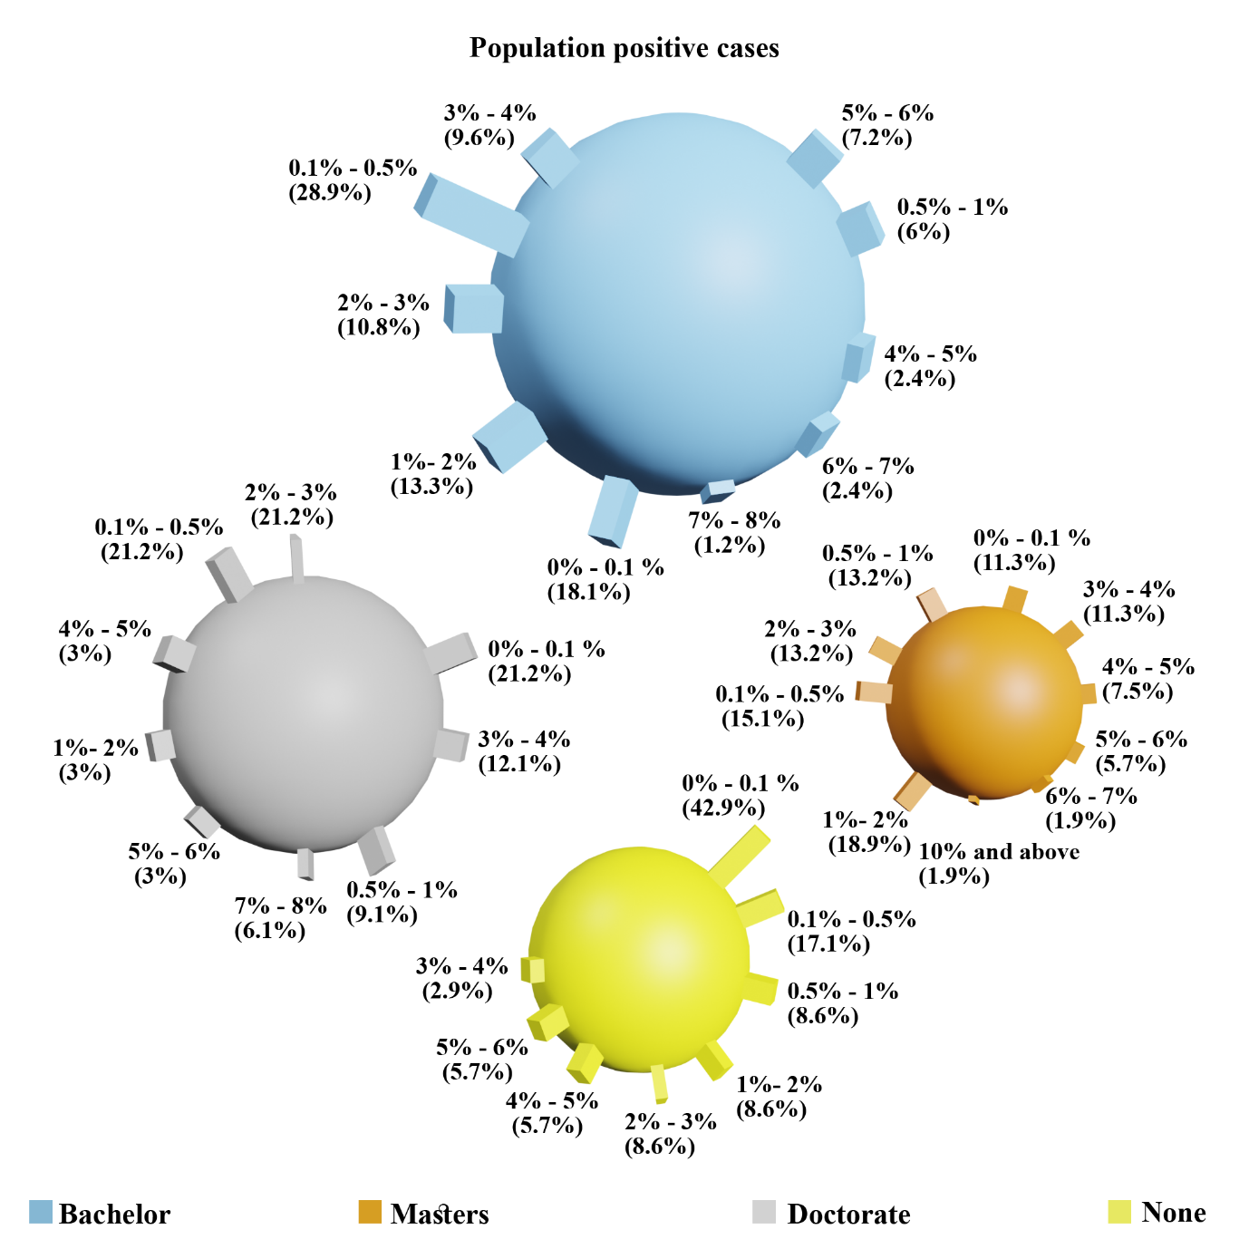
Figure 16. Covid-19 population positive cases vs. Leader education.

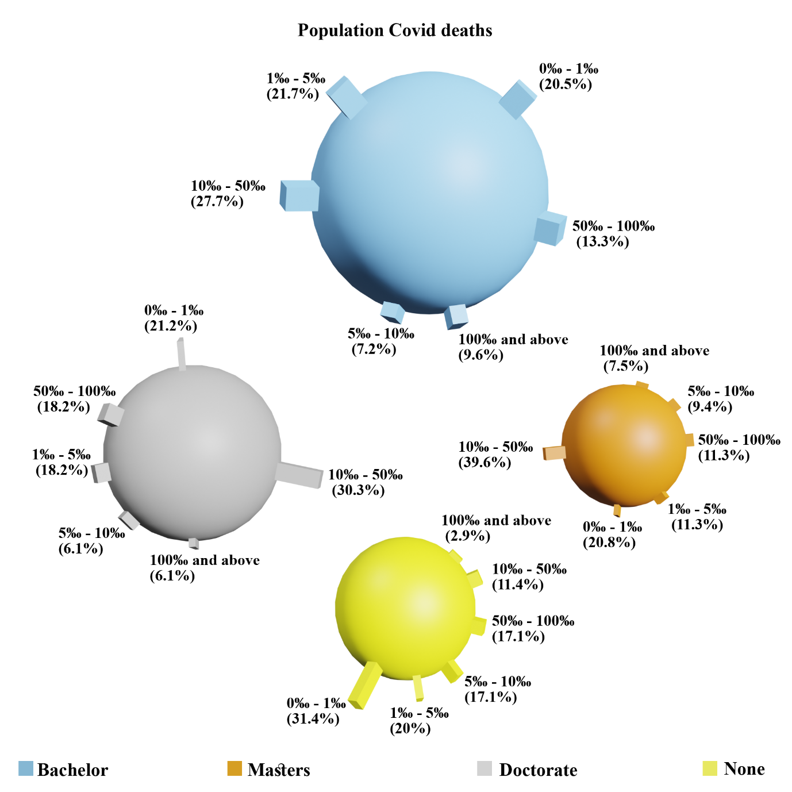
Figure 17. Covid-19 population deaths vs. Leader education.

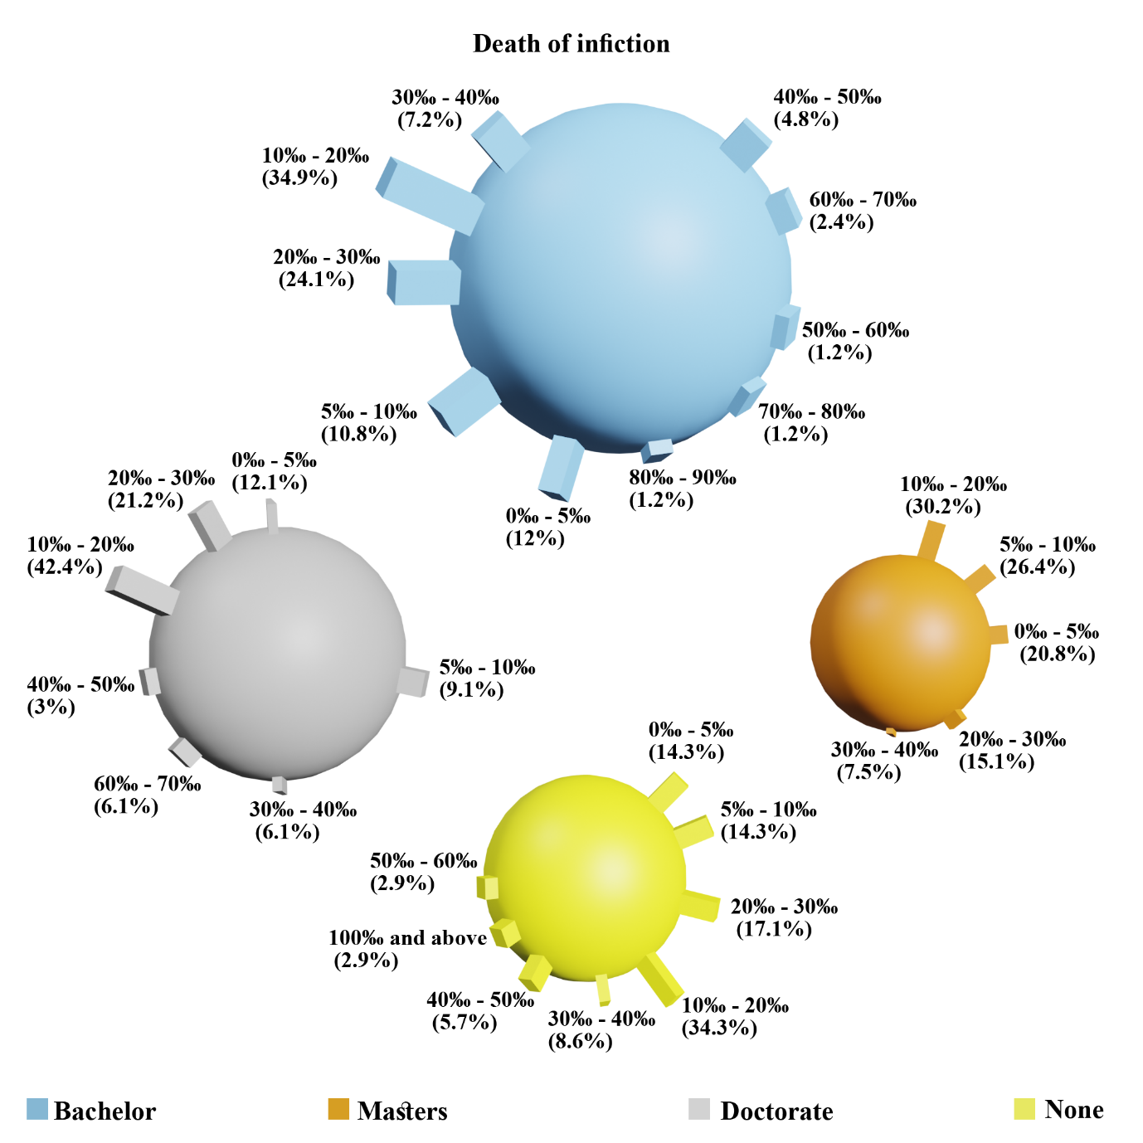
Figure 18. Covid-19 death of infection vs. Leader education.

Leader sex
World leaders are divided based on gender into 93.6% males and 6.4% females, (206 countries with male leaders and 14 countries with female leaders).
Table 16. Distribution of leader sex within countries.
Leader Sex | N (%)
Male | 206 (93.6%)
Female | 14 (6.4%)

The distribution of Covid-19 cumulative cases on leaders’ gender is presented in Table 17.
Table 17. Cumulative Covid-19 cases vs. leader sex.
Cumulative cases (Thousands) | Male | Female
0 - 1 | 42 (20.4%) | 2 (14.3%)
1 - 10 | 44 (21.4%) | 3 (21.4%)
10 - 100 | 51 (24.8%) | 2 (14.3%)
100 - 200 | 24 (11.7%) | 3 (21.4%)
200 - 300 | 11 (5.3%) | 0 (0%)
300 - 400 | 3 (1.5%) | 1 (7.1%)
400 - 500 | 6 (2.9%) | 1 (7.1%)
500 - 600 | 2 (1%) | 1 (7.1%)
Above 600 | 23 (11.2%) | 1 (7.1%)
Mean Cumulative cases | 357211.58 | 259226.6
Std. Err. | 108671.69 | 124065
Mean 95% | 121899.58 | 190508.6

Around 41% of the countries with male leaders reported less than 10 thousand Covid-19 cases. While only 35% of the countries with female leaders reported less than 10 thousand cases. On the contrary, 11.2% of the countries with male leaders reported more than 600 thousand cases, while only 7.1% of countries leaded by females reported the same category of infections.
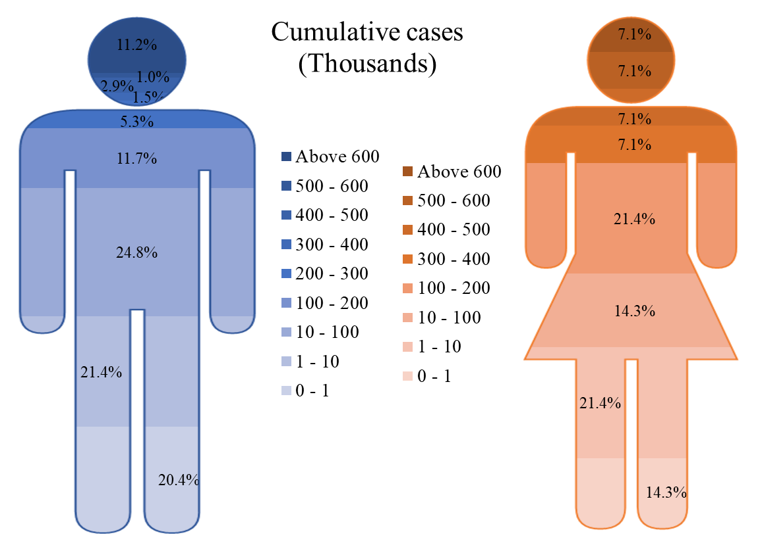
Figure 19. Cumulative Covid-19 cases vs. leader sex.

Table 18. Cumulative Covid-19 deaths vs. leader sex.
Cumulative deaths (Thousands) | Male | Female
0 - 1 | 128 (62.1%) | 7 (50%)
1 - 5 | 42 (20.4%) | 3 (21.4%)
5 - 10 | 9 (4.4%) | 3 (21.4%)
10 - 20 | 10 (4.9%) | 0 (0%)
20 - 50 | 7 (3.4%) | 1 (7.1%)
50 - 100 | 6 (2.9%) | 0 (0%)
Above 100 | 4 (1.9%) | 0 (0%)
Mean Cumulative deaths | 7935.52 | 4645.93
Std. Err. | 2090.79 | 2410.60
Mean 95% | 2623.96 | 3275.48

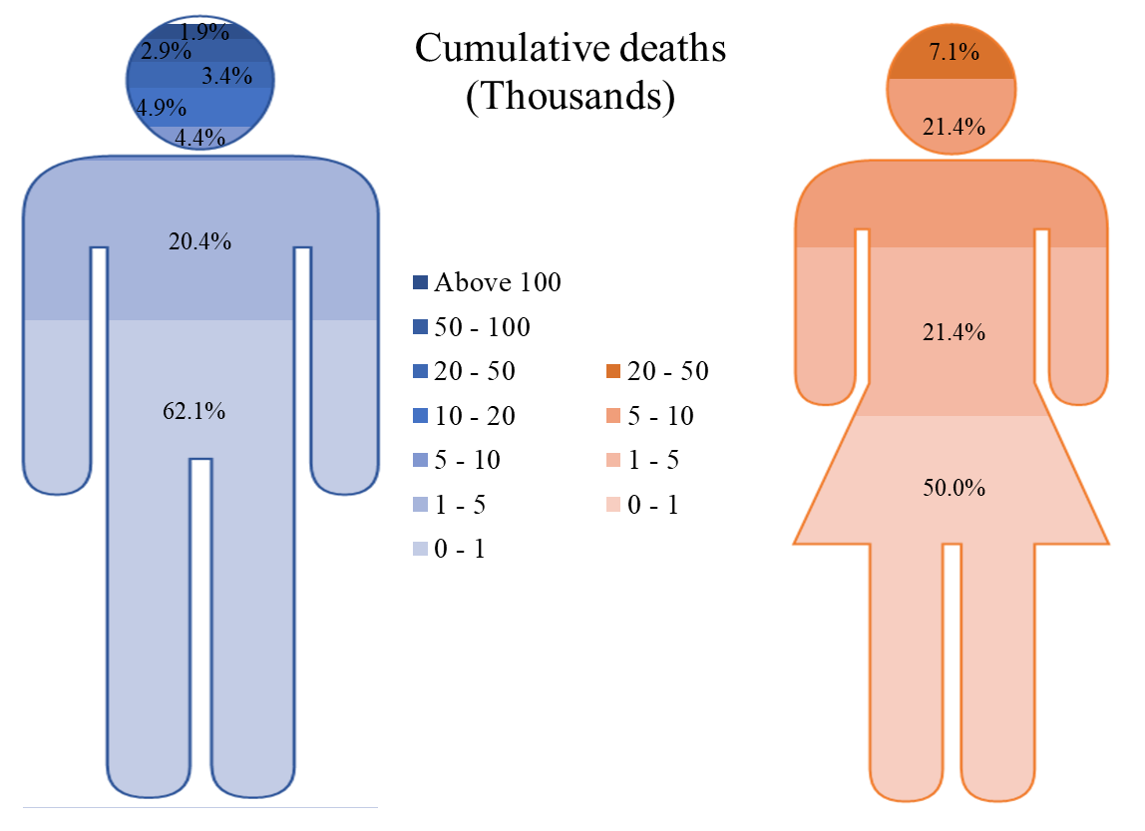
Figure 20. Cumulative Covid-19 deaths vs. leader sex.

Table 19. Covid-19 population positive cases vs. leader sex.
Population positive cases | Male | Female
0% - 0.1 % | 48 (23.3%) | 2 (14.3%)
0.1% - 0.5% | 46 (22.3%) | 2 (14.3%)
0.5% - 1% | 16 (7.8%) | 2 (14.3%)
1%- 2% | 25 (12.1%) | 2 (14.3%)
2% - 3% | 26 (12.6%) | 2 (14.3%)
3% - 4% | 19 (9.2%) | 1 (7.1%)
4% - 5% | 10 (4.9%) | 0 (0%)
5% - 6% | 9 (4.4%) | 3 (21.4%)
6% - 7% | 3 (1.5%) | 0 (0%)
7% - 8% | 3 (1.5%) | 0 (0%)
10% and above | 1 (0.5%) | 0 (0%)
Mean Population positive | 1.51 | 2.12
Std. Err. | 0.13 | 0.54
Mean 95% | 1.29 | 2.05

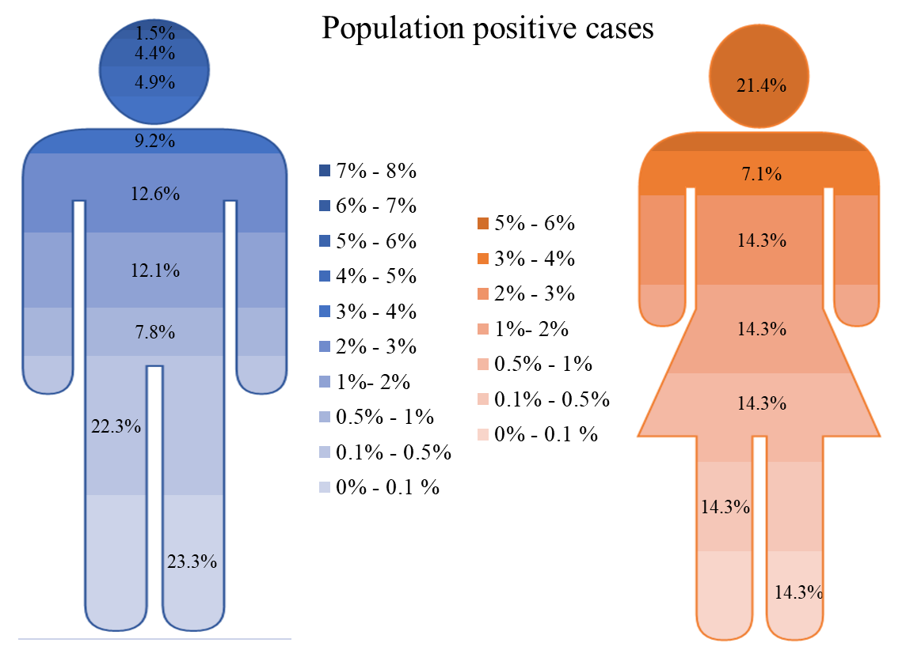
Figure 21. Covid-19 population positive cases vs. leader sex.
Table 20. Covid-19 population deaths vs. leader sex.
Population Covid deaths | Male | Female
0‰ - 1‰ | 53 (25.7%) | 2 (14.3%)
1‰ - 5‰ | 36 (17.5%) | 2 (14.3%)
5‰ - 10‰ | 20 (9.7%) | 2 (14.3%)
10‰ - 50‰ | 56 (27.2%) | 5 (35.7%)
50‰ - 100‰ | 26 (12.6%) | 3 (21.4%)
100‰ and above | 15 (7.3%) | 0 (0%)
Mean Population Covid | 0.026 | 0.029
Std. Err. | 0.002 | 0.008
Mean 95% | 0.022 | 0.027

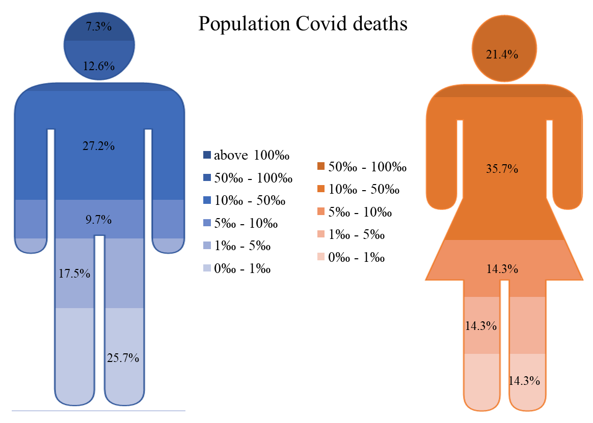
Figure 22. Covid-19 population deaths vs. leader sex.

Table 21. Covid-19 death of infections vs. leader sex.
Death of infection | Male | Female
0‰ - 5‰ | 37 (18%) | 1 (7.1%)
5‰ - 10‰ | 26 (12.6%) | 5 (35.7%)
10‰ - 20‰ | 71 (34.5%) | 7 (50%)
20‰ - 30‰ | 41 (19.9%) | 0 (0%)
30‰ - 40‰ | 15 (7.3%) | 0 (0%)
40‰ - 50‰ | 8 (3.9%) | 0 (0%)
50‰ - 60‰ | 1 (0.5%) | 1 (7.1%)
60‰ - 70‰ | 4 (1.9%) | 0 (0%)
70‰ - 80‰ | 1 (0.5%) | 0 (0%)
80‰ - 90‰ | 1 (0.5%) | 0 (0%)
100‰ and above | 1 (0.5%) | 0 (0%)
Mean Death of infection | 0.018 | 0.015
Std. Err. | 0.002 | 0.004
Mean 95% | 0.016 | 0.013

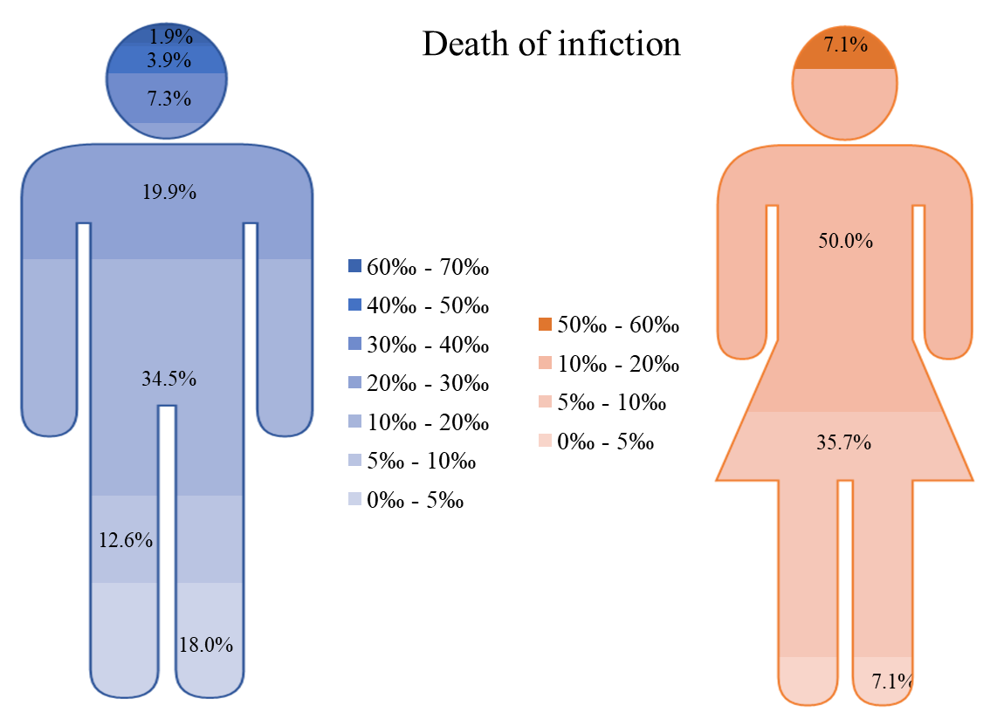
Figure 23. Covid-19 death of infections vs. leader sex.

Country war conflict
There are 84 countries that suffer from a sort of war conflict. That is 38.2% of the countries around the world. The remaining 61.8% have no type of instability.
Table 22. Distribution of war conflict around the countries.
War conflict | N (%)
NO | 136 (61.8%)
YES | 84 (38.2%)

Table 23. Cumulative Covid-19 cases vs. war conflict status.
Cumulative cases (Thousands) | NO | YES
0 - 1 | 41 (30.1%) | 3 (3.6%)
1 - 10 | 28 (20.6%) | 19 (22.6%)
10 - 100 | 28 (20.6%) | 25 (29.8%)
100 - 200 | 15 (11%) | 12 (14.3%)
200 - 300 | 7 (5.1%) | 4 (4.8%)
300 - 400 | 3 (2.2%) | 1 (1.2%)
400 - 500 | 2 (1.5%) | 5 (6%)
500 - 600 | 0 (0%) | 3 (3.6%)
Above 600 | 12 (8.8%) | 12 (14.3%)
Mean Cumulative cases | 155543.37 | 696957.95
Std. Err. | 33033.11 | 274197.48
Mean 95% | 77438.46 | 233102.30
Half of the countries that have no war conflict reported less than 10 thousand cases of Covid-19. While 8.8% of the stable countries reported more than 600 thousand infections.
Table 24. Cumulative Covid-19 deaths vs. war conflict status.
Cumulative deaths (Thousands) | Male | Female
0 - 1 | 96 (70.6%) | 39 (46.4%)
1 - 5 | 22 (16.2%) | 23 (27.4%)
5 - 10 | 6 (4.4%) | 6 (7.1%)
10 - 20 | 4 (2.9%) | 6 (7.1%)
20 - 50 | 5 (3.7%) | 3 (3.6%)
50 - 100 | 3 (2.2%) | 3 (3.6%)
Above 100 | 0 (0%) | 4 (4.8%)
Mean Cumulative deaths | 3566.43 | 15103.86
Std. Err. | 895.29 | 5139.53
Mean 95% | 1387.69 | 5957.69

Table 25. Covid-19 population positive cases vs. war conflict status.
Population positive cases | Male | Female
0% - 0.1 % | 25 (18.4%) | 25 (29.8%)
0.1% - 0.5% | 24 (17.6%) | 24 (28.6%)
0.5% - 1% | 14 (10.3%) | 4 (4.8%)
1%- 2% | 13 (9.6%) | 14 (16.7%)
2% - 3% | 20 (14.7%) | 8 (9.5%)
3% - 4% | 15 (11%) | 5 (6%)
4% - 5% | 8 (5.9%) | 2 (2.4%)
5% - 6% | 10 (7.4%) | 2 (2.4%)
6% - 7% | 3 (2.2%) | 0 (0%)
7% - 8% | 3 (2.2%) | 0 (0%)
10% and above | 1 (0.7%) | 0 (0%)
Mean Population positive | 1.86 | 0.99
Std. Err. | 0.17 | 0.15
Mean 95% | 1.66 | 0.82

Table 26. Covid-19 population deaths vs. war conflict status.
Population Covid deaths | Male | Female
0‰ - 1‰ | 35 (25.7%) | 20 (23.8%)
1‰ - 5‰ | 16 (11.8%) | 22 (26.2%)
5‰ - 10‰ | 12 (8.8%) | 10 (11.9%)
10‰ - 50‰ | 41 (30.1%) | 20 (23.8%)
50‰ - 100‰ | 19 (14%) | 10 (11.9%)
100‰ and above | 13 (9.6%) | 2 (2.4%)
Mean Population Covid | 0.029 | 0.021
Std. Err. | 0.003 | 0.003
Mean 95% | 0.024 | 0.018

Table 27. Covid-19 death of infection vs. war conflict status.
Death of infection | Male | Female
0‰ - 5‰ | 34 (25%) | 4 (4.8%)
5‰ - 10‰ | 22 (16.2%) | 9 (10.7%)
10‰ - 20‰ | 51 (37.5%) | 27 (32.1%)
20‰ - 30‰ | 17 (12.5%) | 24 (28.6%)
30‰ - 40‰ | 6 (4.4%) | 9 (10.7%)
40‰ - 50‰ | 3 (2.2%) | 5 (6%)
50‰ - 60‰ | 1 (0.7%) | 1 (1.2%)
60‰ - 70‰ | 1 (0.7%) | 3 (3.6%)
70‰ - 80‰ | 1 (0.7%) | 0 (0%)
80‰ - 90‰ | 0 (0%) | 1 (1.2%)
100‰ and above | 0 (0%) | 1 (1.2%)
Mean Death of infection | 0.013 | 0.027
Std. Err. | 0.001 | 0.004
Mean 95% | 0.012 | 0.023

Economics related variables

GDP total (Billion)
The GDP of world countries estimated in billions combined with Covid-19 cumulative cases is illustrated in the heat map depicted in Figure 24.
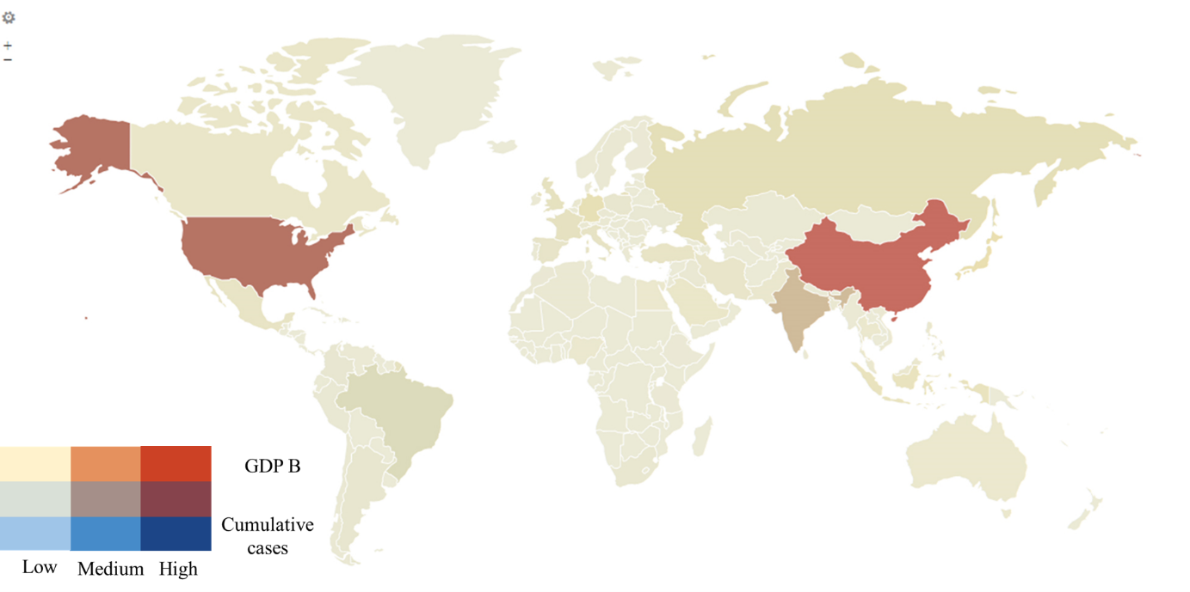
Figure 24. GPD (Billion) vs. cumulative cases heatmap.
Countries with dark heat spots have high GDP with high Covid-19 cumulative cases as well.
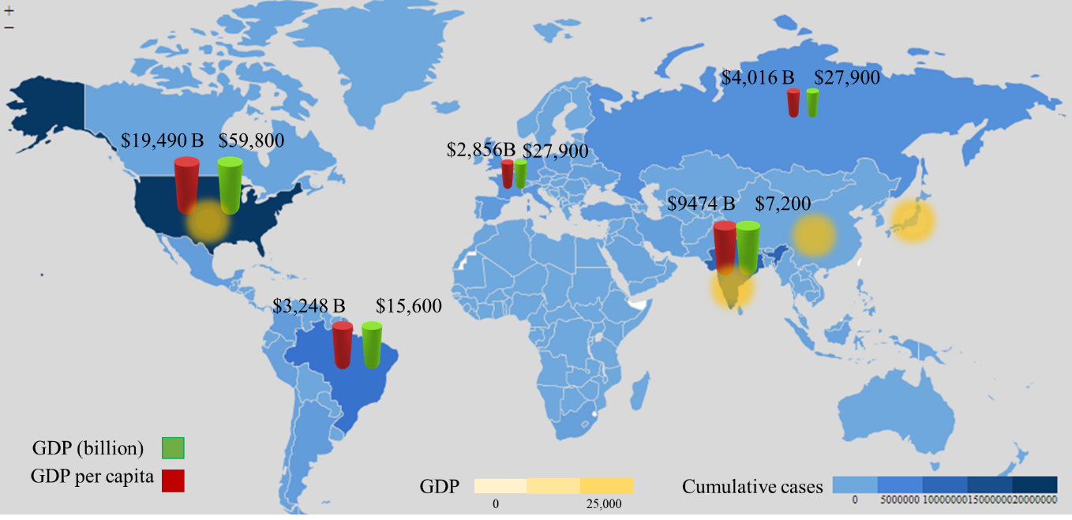
Figure 25. Top 5 high GDP countries vs. cumulative Covid-19 cases.
It is shown in Figure 25 that the top 5 countries with the highest GDP (yellow heat spots) do not have the same Covid-19 cumulative cases.

GDP per capita
The GDP per capita of world countries combined with Covid-19 cumulative cases is illustrated in the heat map depicted in Figure 26.
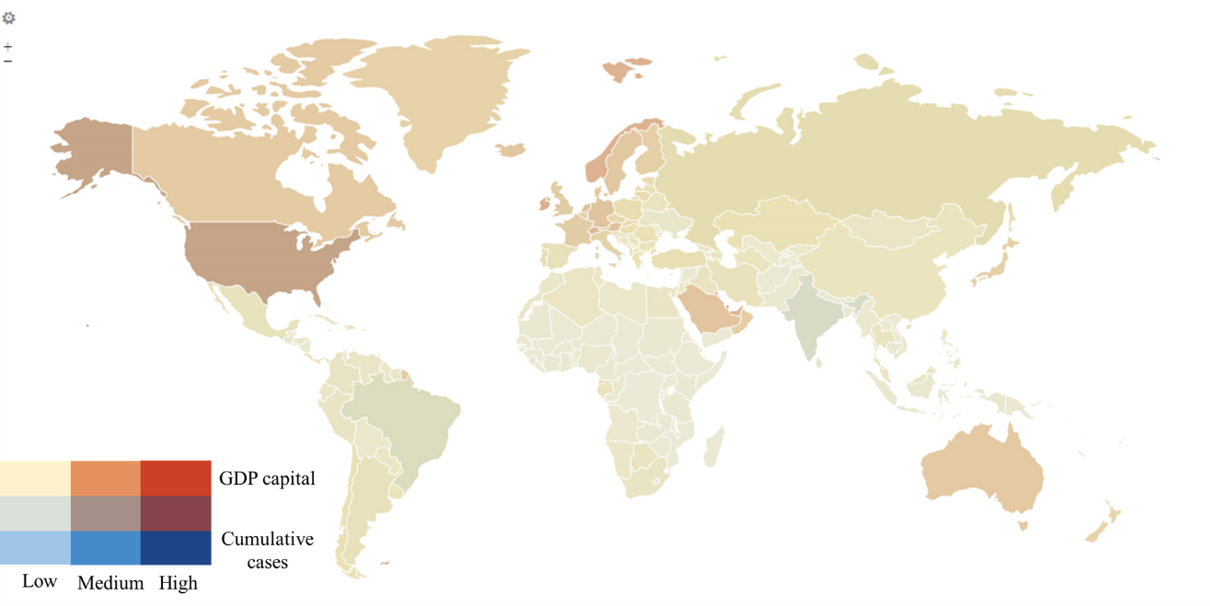
Figure 26. GPD per capita vs. cumulative deaths heatmap.

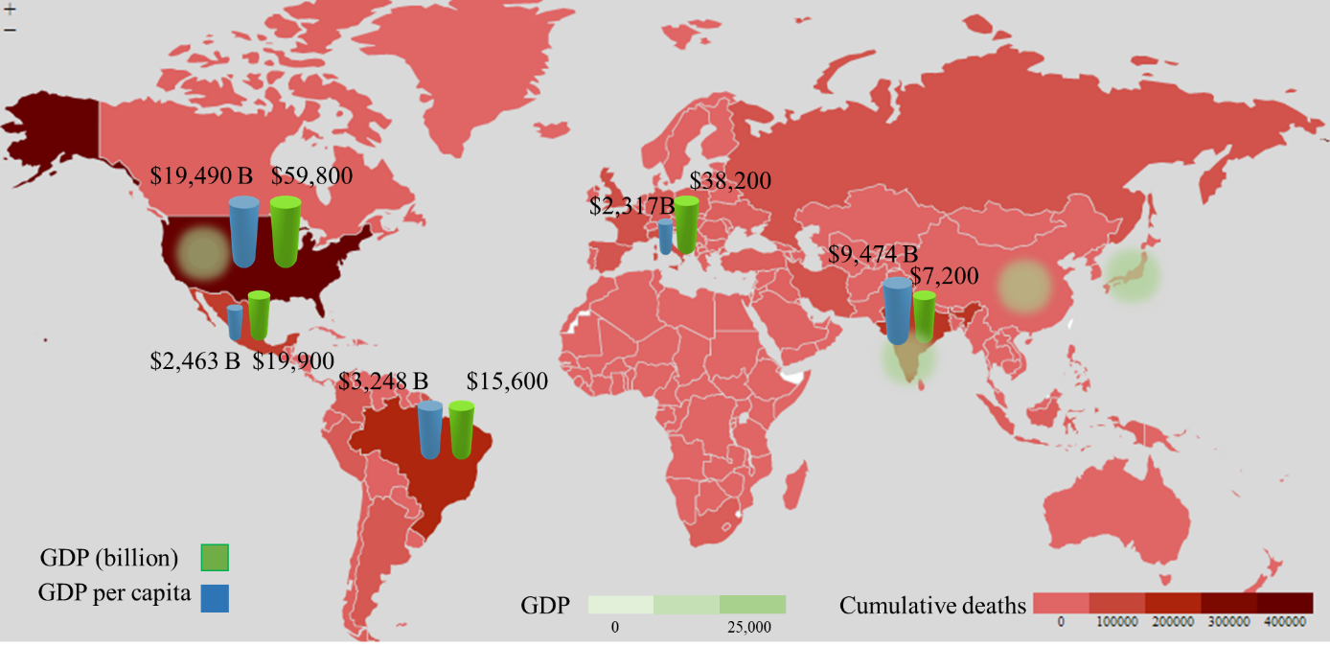
Figure 27. Top 5 high GDP countries vs. cumulative Covid-19 deaths.

Population growth
The percentage of population growth rate is combined with the distribution of Covid-19 cumulative cases in the heatmap presented in Figure 28.
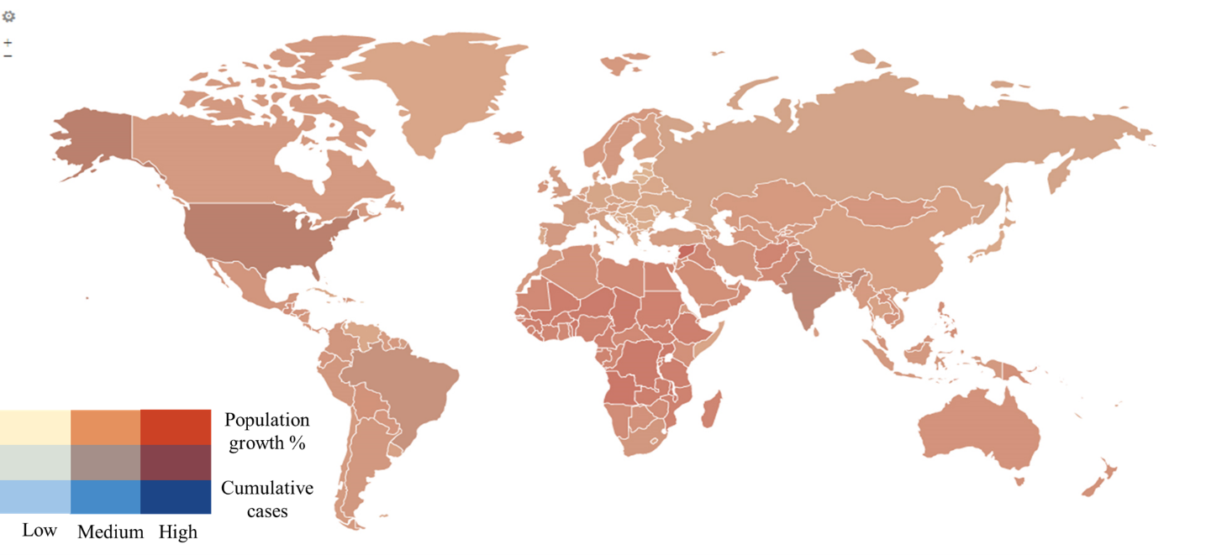
Figure 28. Population growth rate vs. cumulative cases heatmap.

Demographic related variables

Religion
Religion variable is a combined variable of the first three religions in a certain country. However, the second and third religions are reported as unknown for most countries. Therefore, only the first religion was considered for the between groups comparison. The distribution of a certain religion as the first major religion around the world is detailed in Table 28.
Table 28. Distribution of the first/major religion within countries.
Religion | N (%)
Christianity | 145 (65.9%)
Islam | 51 (23.2%)
Judaism | 1 (0.5%)
Hinduism | 3 (1.4%)
Buddhism | 8 (3.6%)
Unspecified | 6 (2.7%)
None/Atheist | 5 (2.3%)
Shintoism | 1 (0.5%)
Almost 65% of the world countries have Christianity as their first religion. While Islam is the first religion in 32.2% of the countries around the world.
The distribution of Covid-19 cumulative cases, deaths, population cases, population deaths, and death of infections among countries with different first religion is given in
Table 29 to Table 33.

Table 29. Covid-19 cumulative cases vs. first religion.
Cumulative cases (Thousands) | Christianity | Islam | Judaism | Hinduism | Buddhism | Unspecified | None/Atheist | Shintoism
0 - 1 | 35 (24.1%) | 2 (3.9%) | 0 (0%) | 1 (33.3%) | 3 (37.5%) | 3 (50%) | 0 (0%) | 0 (0%)
1 - 10 | 31 (21.4%) | 11 (21.6%) | 0 (0%) | 0 (0%) | 2 (25%) | 1 (16.7%) | 2 (40%) | 0 (0%)
10 - 100 | 32 (22.1%) | 16 (31.4%) | 0 (0%) | 0 (0%) | 2 (25%) | 1 (16.7%) | 2 (40%) | 0 (0%)
100 - 200 | 16 (11%) | 10 (19.6%) | 0 (0%) | 0 (0%) | 1 (12.5%) | 0 (0%) | 0 (0%) | 0 (0%)
200 - 300 | 5 (3.4%) | 4 (7.8%) | 0 (0%) | 1 (33.3%) | 0 (0%) | 0 (0%) | 0 (0%) | 1 (100%)
300 - 400 | 3 (2.1%) | 1 (2%) | 0 (0%) | 0 (0%) | 0 (0%) | 0 (0%) | 0 (0%) | 0 (0%)
400 - 500 | 4 (2.8%) | 2 (3.9%) | 1 (100%) | 0 (0%) | 0 (0%) | 0 (0%) | 0 (0%) | 0 (0%)
500 - 600 | 1 (0.7%) | 2 (3.9%) | 0 (0%) | 0 (0%) | 0 (0%) | 0 (0%) | 0 (0%) | 0 (0%)
Above 600 | 18 (12.4%) | 3 (5.9%) | 0 (0%) | 1 (33.3%) | 0 (0%) | 1 (16.7%) | 1 (20%) | 0 (0%)
Mean cases | 417236.0 | 173800.3 | - | 3522444.7 | 29628.8 | 140258.2 | 180078.6 | -
Std. Err. | 149622.2 | 40397.3 | - | 3392505.2 | 15828.0 | 120046.9 | 156814.1 | -
Mean 95% | 156573.7 | 126592.5 | - |  | 25971.2 | 114982.7 | 155242.6 | -

Table 30. Covid-19 cumulative deaths vs. first religion.
Cumulative deaths (Thousands) | Christianity | Islam | Judaism | Hinduism | Buddhism | Unspecified | None/Atheist | Shintoism
0 - 1 | 93 (64.1%) | 26 (51%) | 0 (0%) | 1 (33.3%) | 7 (87.5%) | 4 (66.7%) | 4 (80%) | 0 (0%)
1 - 5 | 24 (16.6%) | 16 (31.4%) | 1 (100%) | 1 (33.3%) | 1 (12.5%) | 1 (16.7%) | 0 (0%) | 1 (100%)
5 - 10 | 8 (5.5%) | 4 (7.8%) | 0 (0%) | 0 (0%) | 0 (0%) | 0 (0%) | 0 (0%) | 0 (0%)
10 - 20 | 6 (4.1%) | 2 (3.9%) | 0 (0%) | 0 (0%) | 0 (0%) | 1 (16.7%) | 1 (20%) | 0 (0%)
20 - 50 | 6 (4.1%) | 2 (3.9%) | 0 (0%) | 0 (0%) | 0 (0%) | 0 (0%) | 0 (0%) | 0 (0%)
50 - 100 | 5 (3.4%) | 1 (2%) | 0 (0%) | 0 (0%) | 0 (0%) | 0 (0%) | 0 (0%) | 0 (0%)
Above 100 | 3 (2.1%) | 0 (0%) | 0 (0%) | 1 (33.3%) | 0 (0%) | 0 (0%) | 0 (0%) | 0 (0%)
Mean deaths | 9898.6 | 3786.8 | - | 50364.0 | 374.1 | 2776.5 | 2556.0 | -
Std. Err. | 2988.0 | 1229.6 | - | 49429.9 | 332.8 | 1971.2 | 2251.5 | -
Mean 95% | 3764.3 | 2261.9 | - | - | 265.9 | 2427.9 | 2197.7 | -
Table 31. Covid-19 population positive vs. first religion.
Population positive cases | Christianity | Islam | Judaism | Hinduism | Buddhism | Unspecified | None/Atheist | Shintoism
0% - 0.1 % | 28 (19.3%) | 13 (25.5%) | 0 (0%) | 1 (33.3%) | 5 (62.5%) | 1 (16.7%) | 2 (40%) | 0 (0%)
0.1% - 0.5% | 29 (20%) | 14 (27.5%) | 0 (0%) | 0 (0%) | 2 (25%) | 1 (16.7%) | 1 (20%) | 1 (100%)
0.5% - 1% | 14 (9.7%) | 1 (2%) | 0 (0%) | 2 (66.7%) | 0 (0%) | 1 (16.7%) | 0 (0%) | 0 (0%)
1%- 2% | 15 (10.3%) | 9 (17.6%) | 0 (0%) | 0 (0%) | 1 (12.5%) | 2 (33.3%) | 0 (0%) | 0 (0%)
2% - 3% | 18 (12.4%) | 9 (17.6%) | 0 (0%) | 0 (0%) | 0 (0%) | 0 (0%) | 1 (20%) | 0 (0%)
3% - 4% | 17 (11.7%) | 3 (5.9%) | 0 (0%) | 0 (0%) | 0 (0%) | 0 (0%) | 0 (0%) | 0 (0%)
4% - 5% | 7 (4.8%) | 1 (2%) | 1 (100%) | 0 (0%) | 0 (0%) | 0 (0%) | 1 (20%) | 0 (0%)
5% - 6% | 11 (7.6%) | 1 (2%) | 0 (0%) | 0 (0%) | 0 (0%) | 0 (0%) | 0 (0%) | 0 (0%)
6% - 7% | 2 (1.4%) | 0 (0%) | 0 (0%) | 0 (0%) | 0 (0%) | 1 (16.7%) | 0 (0%) | 0 (0%)
7% - 8% | 3 (2.1%) | 0 (0%) | 0 (0%) | 0 (0%) | 0 (0%) | 0 (0%) | 0 (0%) | 0 (0%)
above 10% | 1 (0.7%) | 0 (0%) | 0 (0%) | 0 (0%) | 0 (0%) | 0 (0%) | 0 (0%) | 0 (0%)
Mean cases | 1.92 | 1.14 | - | 0.56 | 0.20 | 1.78 | 1.41 | -
Std. Err. | 0.17 | 0.19 | - | 0.26 | 0.12 | 1.05 | 0.92 | -
Mean 95% | 1.73 | 1.00 | - | - | 0.16 | 1.59 | 1.30 | -

Table 32. Covid-19 population deaths vs. first religion.
Population Covid deaths | Christianity | Islam | Judaism | Hinduism | Buddhism | Unspecified | None/Atheist | Shintoism
0‰ - 1‰ | 31 (21.4%) | 10 (19.6%) | 0 (0%) | 1 (33.3%) | 7 (87.5%) | 4 (66.7%) | 2 (40%) | 0 (0%)
1‰ - 5‰ | 23 (15.9%) | 11 (21.6%) | 0 (0%) | 0 (0%) | 1 (12.5%) | 1 (16.7%) | 1 (20%) | 1 (100%)
5‰ - 10‰ | 11 (7.6%) | 10 (19.6%) | 0 (0%) | 1 (33.3%) | 0 (0%) | 0 (0%) | 0 (0%) | 0 (0%)
10‰ - 50‰ | 41 (28.3%) | 17 (33.3%) | 1 (100%) | 1 (33.3%) | 0 (0%) | 0 (0%) | 1 (20%) | 0 (0%)
50‰ - 100‰ | 26 (17.9%) | 2 (3.9%) | 0 (0%) | 0 (0%) | 0 (0%) | 0 (0%) | 1 (20%) | 0 (0%)
above 100‰ | 13 (9%) | 1 (2%) | 0 (0%) | 0 (0%) | 0 (0%) | 1 (16.7%) | 0 (0%) | 0 (0%)
Mean deaths | 0.035 | 0.016 | - | 0.006 | 0.001 | 0.019 | 0.018 | -
Std. Err. | 0.003 | 0.003 | - | 0.003 | 0.001 | 0.018 | 0.013 | -
Mean 95% | 0.031 | 0.013 | - | - | 0.001 | 0.015 | 0.016 | -
Table 33. Covid-19 death of infections vs. first religion.
Death of infection | Christianity | Islam | Judaism | Hinduism | Buddhism | Unspecified | None/Atheist | Shintoism
0‰ - 5‰ | 23 (15.9%) | 5 (9.8%) | 0 (0%) | 0 (0%) | 6 (75%) | 4 (66.7%) | 0 (0%) | 0 (0%)
5‰ - 10‰ | 19 (13.1%) | 8 (15.7%) | 1 (100%) | 1 (33.3%) | 1 (12.5%) | 0 (0%) | 1 (20%) | 0 (0%)
10‰ - 20‰ | 55 (37.9%) | 16 (31.4%) | 0 (0%) | 2 (66.7%) | 0 (0%) | 1 (16.7%) | 3 (60%) | 1 (100%)
20‰ - 30‰ | 29 (20%) | 10 (19.6%) | 0 (0%) | 0 (0%) | 1 (12.5%) | 0 (0%) | 1 (20%) | 0 (0%)
30‰ - 40‰ | 10 (6.9%) | 5 (9.8%) | 0 (0%) | 0 (0%) | 0 (0%) | 0 (0%) | 0 (0%) | 0 (0%)
40‰ - 50‰ | 4 (2.8%) | 3 (5.9%) | 0 (0%) | 0 (0%) | 0 (0%) | 1 (16.7%) | 0 (0%) | 0 (0%)
50‰ - 60‰ | 1 (0.7%) | 1 (2%) | 0 (0%) | 0 (0%) | 0 (0%) | 0 (0%) | 0 (0%) | 0 (0%)
60‰ - 70‰ | 2 (1.4%) | 2 (3.9%) | 0 (0%) | 0 (0%) | 0 (0%) | 0 (0%) | 0 (0%) | 0 (0%)
70‰ - 80‰ | 1 (0.7%) | 0 (0%) | 0 (0%) | 0 (0%) | 0 (0%) | 0 (0%) | 0 (0%) | 0 (0%)
80‰ - 90‰ | 1 (0.7%) | 0 (0%) | 0 (0%) | 0 (0%) | 0 (0%) | 0 (0%) | 0 (0%) | 0 (0%)
Above 100‰ | 0 (0%) | 1 (2%) | 0 (0%) | 0 (0%) | 0 (0%) | 0 (0%) | 0 (0%) | 0 (0%)
Mean Deaths | 0.018 | 0.026 | - | 0.014 | 0.004 | 0.012 | 0.015 | -
Std. Err. | 0.001 | 0.006 | - | 0.003 | 0.003 | 0.008 | 0.002 | -
Mean 95% | 0.017 | 0.021 | - | - | 0.004 | 0.010 | 0.015 | -

Literacy
The literacy percentage of world countries against the cumulative Covid-19 cases is depicted in Figure 29.
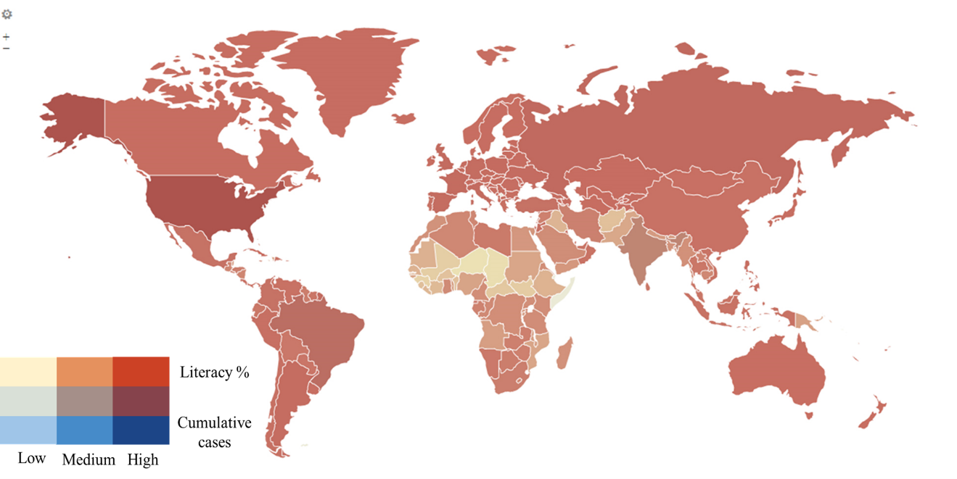
Figure 29. Countr literacy vs. Covid-19 cumulative cases.

Life expectancy (years)
The estimated life expectancy in years around the world is illustrated in Figure 30. Countries with high life expectancy and high Covid-19 cases are illustrated with darker heat spots.
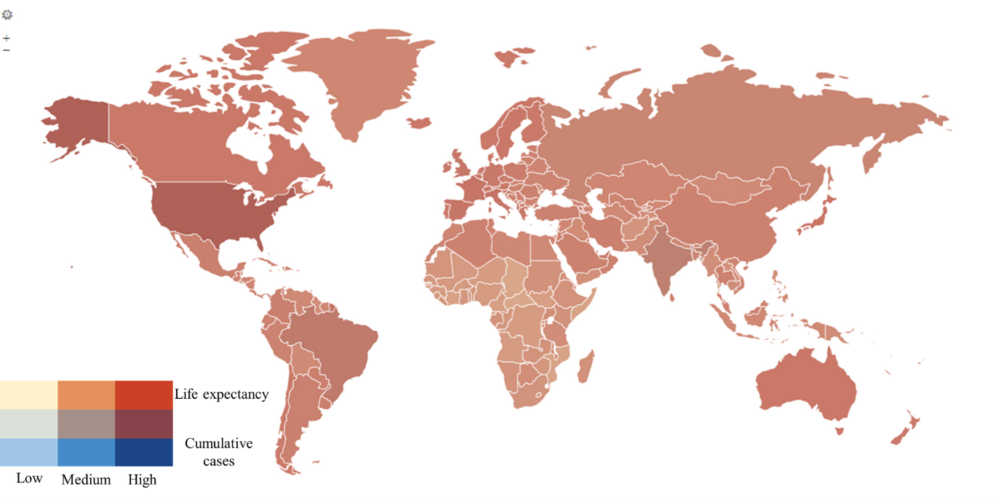
Figure 30. Life expectancy heatmap vs. Covid-19 cumulative cases.

Population density /km²
The population density per square kilometer and the cumulative Covid-19 cases are combined in the heatmap given in Figure 31.
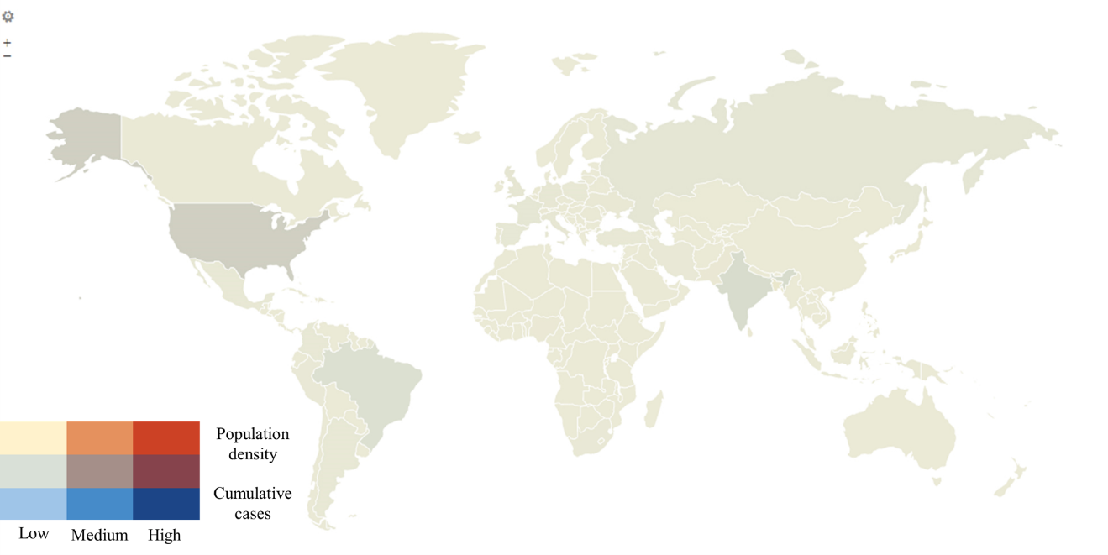
Figure 31. Population density Km² vs. Covid-19 cumulative cases.

Population (million)
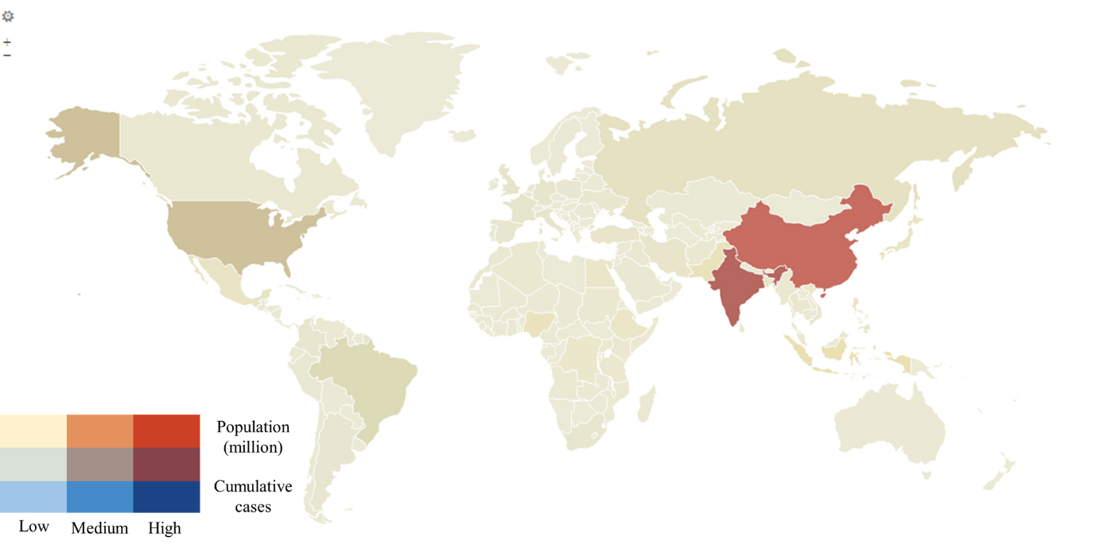
Figure 32. Population in millions vs. Covid-19 cumulative cases.

Male percentage
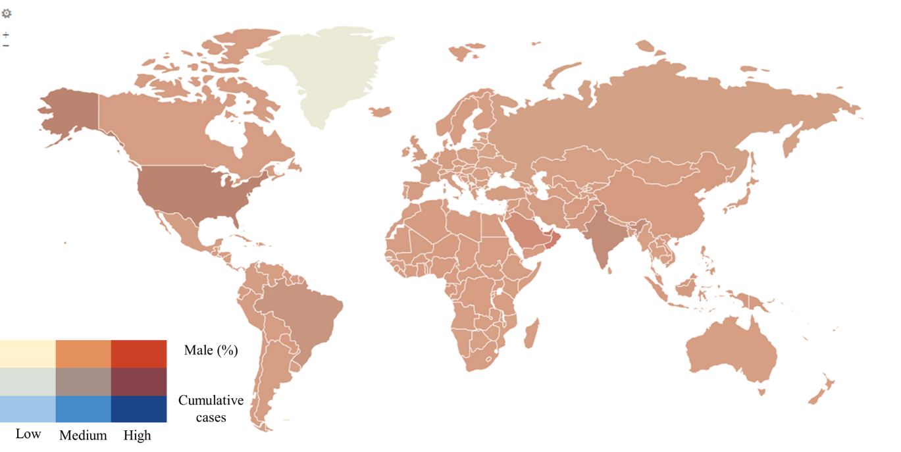
Figure 33. Percentage of male population vs. Covid-19 cumulative cases.

Female percentage

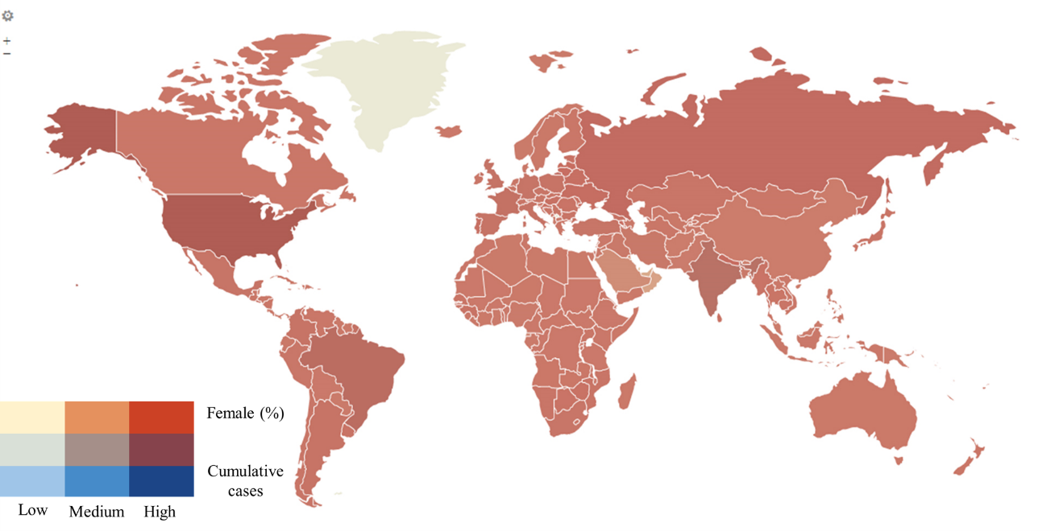
Figure 34. Percentage of female population vs. Covid-19 cumulative cases.

Age distribution

Table 34. Distribution of age groups within countries.
Age groups | N (%)
Unknown | 13 (5.9%)
[0-14], [25-54], [15-24] | 40 (18.2%)
[25-54], [0-14], [15-24] | 97 (44.1%)
[25-54], [0-14], [55-64] | 6 (2.7%)
[25-54], [0-14], [65- ] | 19 (8.6%)
[25-54], [15-24], [0-14] | 3 (1.4%)
[25-54], [65- ], [0-14] | 32 (14.5%)
[25-54], [65- ], [55-64] | 9 (4.1%)
[65- ], [25-54], [55-64] | 1 (0.5%)

Table 35. Covid-19 cumulative cases/deaths among age groups.
Cumulative cases (Thousands) | Unknown |  | [0-14], [25-54], [15-24] |  | [25-54], [0-14], [15-24] |  | [25-54], [0-14], [55-64] |  | [25-54], [0-14], [65- ] |  | [25-54], [15-24], [0-14] |  | [25-54], [65- ],  [0-14] |  | [25-54], [65- ],  [55-64] |  | [65- ],  [25-54], [55-64]
0 - 1 | 1 (7.7%) |  | 4 (10%) |  | 21 (21.6%) |  | 0 (0%) |  | 6 (31.6%) |  | 0 (0%) |  | 11 (34.4%) |  | 1 (11.1%) |  | 0 (0%)
1 - 10 | 1 (7.7%) |  | 12 (30%) |  | 19 (19.6%) |  | 2 (33.3%) |  | 3 (15.8%) |  | 1 (33.3%) |  | 7 (21.9%) |  | 2 (22.2%) |  | 0 (0%)
10 - 100 | 4 (30.8%) |  | 10 (25%) |  | 20 (20.6%) |  | 3 (50%) |  | 5 (26.3%) |  | 0 (0%) |  | 7 (21.9%) |  | 4 (44.4%) |  | 0 (0%)
100 - 200 | 3 (23.1%) |  | 5 (12.5%) |  | 14 (14.4%) |  | 0 (0%) |  | 2 (10.5%) |  | 1 (33.3%) |  | 2 (6.3%) |  | 0 (0%) |  | 0 (0%)
200 - 300 | 1 (7.7%) |  | 3 (7.5%) |  | 4 (4.1%) |  | 0 (0%) |  | 1 (5.3%) |  | 0 (0%) |  | 0 (0%) |  | 1 (11.1%) |  | 1 (100%)
300 - 400 | 1 (7.7%) |  | 0 (0%) |  | 1 (1%) |  | 0 (0%) |  | 1 (5.3%) |  | 0 (0%) |  | 1 (3.1%) |  | 0 (0%) |  | 0 (0%)
400 - 500 | 1 (7.7%) |  | 0 (0%) |  | 5 (5.2%) |  | 0 (0%) |  | 0 (0%) |  | 1 (33.3%) |  | 0 (0%) |  | 0 (0%) |  | 0 (0%)
500 - 600 | 0 (0%) |  | 1 (2.5%) |  | 0 (0%) |  | 0 (0%) |  | 1 (5.3%) |  | 0 (0%) |  | 1 (3.1%) |  | 0 (0%) |  | 0 (0%)
Above 600 | 1 (7.7%) |  | 5 (12.5%) |  | 13 (13.4%) |  | 1 (16.7%) |  | 0 (0%) |  | 0 (0%) |  | 3 (9.4%) |  | 1 (11.1%) |  | 0 (0%)
Mean cases | 172436.8 |  | 219367.1 |  | 472430.8 |  | 152184.8 |  | 81831.7 |  | 200337.0 |  | 655769.8 |  | 160941.4 |  | -
Std. Err. | 54447.8 |  | 69440.7 |  | 208159.4 |  | 117590.8 |  | 34820.9 |  | 142054.3 |  | 394574.3 |  | 109081.2 |  | -
Mean 95% | 156223.7 |  | 149347.9 |  | 184274.9 |  | 128081.5 |  | 59091.0 |  |  |  | 210876.5 |  | 122406.0 |  | -
Cumulative deaths (Thousands) |  | Unknown |  | [0-14], [25-54], [15-24] |  | [25-54], [0-14], [15-24] |  | [25-54], [0-14], [55-64] |  | [25-54], [0-14], [65- ] |  | [25-54], [15-24], [0-14] |  | [25-54], [65- ], [0-14] |  | [25-54], [65- ],  [55-64] |  | [65- ], [25-54], [55-64]
0 - 1 |  | 6 (46.2%) |  | 24 (60%) |  | 56 (57.7%) |  | 4 (66.7%) |  | 13 (68.4%) |  | 1 (33.3%) |  | 24 (75%) |  | 7 (77.8%) |  | 0 (0%)
1 - 5 |  | 5 (38.5%) |  | 10 (25%) |  | 21 (21.6%) |  | 1 (16.7%) |  | 3 (15.8%) |  | 1 (33.3%) |  | 3 (9.4%) |  | 0 (0%) |  | 1 (100%)
5 - 10 |  | 1 (7.7%) |  | 0 (0%) |  | 6 (6.2%) |  | 0 (0%) |  | 2 (10.5%) |  | 1 (33.3%) |  | 2 (6.3%) |  | 0 (0%) |  | 0 (0%)
10 - 20 |  | 1 (7.7%) |  | 2 (5%) |  | 4 (4.1%) |  | 1 (16.7%) |  | 1 (5.3%) |  | 0 (0%) |  | 0 (0%) |  | 1 (11.1%) |  | 0 (0%)
20 - 50 |  | 0 (0%) |  | 3 (7.5%) |  | 3 (3.1%) |  | 0 (0%) |  | 0 (0%) |  | 0 (0%) |  | 1 (3.1%) |  | 1 (11.1%) |  | 0 (0%)
50 - 100 |  | 0 (0%) |  | 1 (2.5%) |  | 5 (5.2%) |  | 0 (0%) |  | 0 (0%) |  | 0 (0%) |  | 0 (0%) |  | 0 (0%) |  | 0 (0%)
Above 100 |  | 0 (0%) |  | 0 (0%) |  | 2 (2.1%) |  | 0 (0%) |  | 0 (0%) |  | 0 (0%) |  | 2 (6.3%) |  | 0 (0%) |  | 0 (0%)
Mean deaths |  | 2873.3 |  | 5587.2 |  | 10600.7 |  | 2570.8 |  | 1954.4 |  | 4149.3 |  | 12773.0 |  | 5930.1 |  | -
Std. Err. |  | 1212.9 |  | 2006.0 |  | 3940.3 |  | 1882.0 |  | 920.0 |  | 2700.1 |  | 7581.9 |  | 4251.5 |  | -
Mean 95% |  | 2311.3 |  | 3470.5 |  | 4117.2 |  | 2197.0 |  | 1312.0 |  | - |  | 4314.5 |  | 4495.3 |  | -

Table 36. Covid-19 population positive cases/deaths among age groups.
Population positive cases |  | Unknown |  | [0-14], [25-54], [15-24] |  | [25-54], [0-14], [15-24] |  | [25-54], [0-14], [55-64] |  | [25-54], [0-14], [65- ] |  | [25-54], [15-24], [0-14] |  | [25-54], [65- ],  [0-14] |  | [25-54], [65- ], [55-64] |  | [65- ], [25-54], [55-64]
0% - 0.1 % |  | 2 (15.4%) |  | 13 (32.5%) |  | 19 (19.6%) |  | 0 (0%) |  | 6 (31.6%) |  | 0 (0%) |  | 7 (21.9%) |  | 3 (33.3%) |  | 0 (0%)
0.1% - 0.5% |  | 3 (23.1%) |  | 4 (10%) |  | 23 (23.7%) |  | 2 (33.3%) |  | 3 (15.8%) |  | 1 (33.3%) |  | 10 (31.3%) |  | 2 (22.2%) |  | 0 (0%)
0.5% - 1% |  | 1 (7.7%) |  | 1 (2.5%) |  | 9 (9.3%) |  | 1 (16.7%) |  | 2 (10.5%) |  | 0 (0%) |  | 4 (12.5%) |  | 0 (0%) |  | 0 (0%)
1%- 2% |  | 0 (0%) |  | 7 (17.5%) |  | 13 (13.4%) |  | 1 (16.7%) |  | 3 (15.8%) |  | 1 (33.3%) |  | 1 (3.1%) |  | 1 (11.1%) |  | 0 (0%)
2% - 3% |  | 2 (15.4%) |  | 7 (17.5%) |  | 10 (10.3%) |  | 1 (16.7%) |  | 2 (10.5%) |  | 0 (0%) |  | 5 (15.6%) |  | 1 (11.1%) |  | 0 (0%)
3% - 4% |  | 3 (23.1%) |  | 3 (7.5%) |  | 9 (9.3%) |  | 0 (0%) |  | 1 (5.3%) |  | 0 (0%) |  | 3 (9.4%) |  | 1 (11.1%) |  | 0 (0%)
4% - 5% |  | 1 (7.7%) |  | 2 (5%) |  | 5 (5.2%) |  | 0 (0%) |  | 0 (0%) |  | 0 (0%) |  | 2 (6.3%) |  | 0 (0%) |  | 0 (0%)
5% - 6% |  | 1 (7.7%) |  | 2 (5%) |  | 6 (6.2%) |  | 0 (0%) |  | 1 (5.3%) |  | 0 (0%) |  | 0 (0%) |  | 1 (11.1%) |  | 1 (100%)
6% - 7% |  | 0 (0%) |  | 0 (0%) |  | 1 (1%) |  | 1 (16.7%) |  | 1 (5.3%) |  | 0 (0%) |  | 0 (0%) |  | 0 (0%) |  | 0 (0%)
7% - 8% |  | 0 (0%) |  | 0 (0%) |  | 2 (2.1%) |  | 0 (0%) |  | 0 (0%) |  | 1 (33.3%) |  | 0 (0%) |  | 0 (0%) |  | 0 (0%)
above 10% |  | 0 (0%) |  | 1 (2.5%) |  | 0 (0%) |  | 0 (0%) |  | 0 (0%) |  | 0 (0%) |  | 0 (0%) |  | 0 (0%) |  | 0 (0%)
Mean cases |  | 2.1 |  | 1.7 |  | 1.7 |  | 2.1 |  | 1.4 |  | 2.9 |  | 1.2 |  | 1.4 |  | -
Std. Err. |  | 0.5 |  | 0.3 |  | 0.2 |  | 1.0 |  | 0.4 |  | 2.1 |  | 0.3 |  | 0.6 |  | -
Mean 95% |  | 2.0 |  | 1.4 |  | 1.5 |  | 1.9 |  | 1.2 |  | - |  | 1.1 |  | 1.2 |  | -
Population Covid deaths | Unknown |  | [0-14], [25-54], [15-24] |  | [25-54], [0-14], [15-24] |  | [25-54], [0-14], [55-64] |  | [25-54], [0-14], [65- ] |  | [25-54], [15-24], [0-14] |  | [25-54], [65- ],  [0-14] |  | [25-54], [65- ], [55-64] |  | [65- ], [25-54], [55-64]
0‰ - 1‰ | 1 (7.7%) |  | 13 (32.5%) |  | 19 (19.6%) |  | 0 (0%) |  | 9 (47.4%) |  | 0 (0%) |  | 10 (31.3%) |  | 3 (33.3%) |  | 0 (0%)
1‰ - 5‰ | 3 (23.1%) |  | 5 (12.5%) |  | 18 (18.6%) |  | 1 (16.7%) |  | 1 (5.3%) |  | 0 (0%) |  | 8 (25%) |  | 2 (22.2%) |  | 0 (0%)
5‰ - 10‰ | 2 (15.4%) |  | 5 (12.5%) |  | 10 (10.3%) |  | 1 (16.7%) |  | 1 (5.3%) |  | 1 (33.3%) |  | 2 (6.3%) |  | 0 (0%) |  | 0 (0%)
10‰ - 50‰ | 3 (23.1%) |  | 9 (22.5%) |  | 30 (30.9%) |  | 3 (50%) |  | 6 (31.6%) |  | 1 (33.3%) |  | 7 (21.9%) |  | 2 (22.2%) |  | 0 (0%)
50‰ - 100‰ | 4 (30.8%) |  | 4 (10%) |  | 13 (13.4%) |  | 0 (0%) |  | 1 (5.3%) |  | 0 (0%) |  | 5 (15.6%) |  | 1 (11.1%) |  | 1 (100%)
above 100‰ | 0 (0%) |  | 4 (10%) |  | 7 (7.2%) |  | 1 (16.7%) |  | 1 (5.3%) |  | 1 (33.3%) |  | 0 (0%) |  | 1 (11.1%) |  | 0 (0%)
Mean deaths | 0.031 |  | 0.030 |  | 0.028 |  | 0.036 |  | 0.020 |  | 0.071 |  | 0.019 |  | 0.028 |  | -
Std. Err. | 0.009 |  | 0.007 |  | 0.004 |  | 0.017 |  | 0.007 |  | 0.052 |  | 0.005 |  | 0.014 |  | -
Mean 95% | 0.030 |  | 0.025 |  | 0.025 |  | 0.034 |  | 0.016 |  | - |  | 0.016 |  | 0.025 |  | -

Table 37. Covid-19 death of infection among age groups.
Death of infection | Unknown | [0-14], [25-54], [15-24] | [25-54], [0-14], [15-24] | [25-54], [0-14], [55-64] | [25-54], [0-14], [65- ] | [25-54], [15-24],  [0-14] | [25-54], [65- ],  [0-14] | [25-54], [65- ],  [55-64] | [65- ], [25-54], [55-64]
0‰ - 5‰ | 0 (0%) | 9 (22.5%) | 14 (14.4%) | 0 (0%) | 6 (31.6%) | 0 (0%) | 8 (25%) | 1 (11.1%) | 0 (0%)
5‰ - 10‰ | 4 (30.8%) | 5 (12.5%) | 10 (10.3%) | 0 (0%) | 6 (31.6%) | 0 (0%) | 4 (12.5%) | 2 (22.2%) | 0 (0%)
10‰ - 20‰ | 3 (23.1%) | 11 (27.5%) | 41 (42.3%) | 4 (66.7%) | 3 (15.8%) | 1 (33.3%) | 10 (31.3%) | 4 (44.4%) | 1 (100%)
20‰ - 30‰ | 4 (30.8%) | 7 (17.5%) | 17 (17.5%) | 2 (33.3%) | 1 (5.3%) | 2 (66.7%) | 8 (25%) | 0 (0%) | 0 (0%)
30‰ - 40‰ | 1 (7.7%) | 4 (10%) | 6 (6.2%) | 0 (0%) | 3 (15.8%) | 0 (0%) | 0 (0%) | 1 (11.1%) | 0 (0%)
40‰ - 50‰ | 1 (7.7%) | 2 (5%) | 4 (4.1%) | 0 (0%) | 0 (0%) | 0 (0%) | 1 (3.1%) | 0 (0%) | 0 (0%)
50‰ - 60‰ | 0 (0%) | 0 (0%) | 2 (2.1%) | 0 (0%) | 0 (0%) | 0 (0%) | 0 (0%) | 0 (0%) | 0 (0%)
60‰ - 70‰ | 0 (0%) | 2 (5%) | 0 (0%) | 0 (0%) | 0 (0%) | 0 (0%) | 1 (3.1%) | 1 (11.1%) | 0 (0%)
70‰ - 80‰ | 0 (0%) | 0 (0%) | 1 (1%) | 0 (0%) | 0 (0%) | 0 (0%) | 0 (0%) | 0 (0%) | 0 (0%)
80‰ - 90‰ | 0 (0%) | 0 (0%) | 1 (1%) | 0 (0%) | 0 (0%) | 0 (0%) | 0 (0%) | 0 (0%) | 0 (0%)
above 100‰ | 0 (0%) | 0 (0%) | 1 (1%) | 0 (0%) | 0 (0%) | 0 (0%) | 0 (0%) | 0 (0%) | 0 (0%)
Mean Death | 0.019 | 0.019 | 0.022 | 0.018 | 0.012 | 0.023 | 0.016 | 0.020 | -
Std. Err. | 0.003 | 0.003 | 0.003 | 0.002 | 0.003 | 0.002 | 0.003 | 0.007 | -
Mean 95% | 0.018 | 0.018 | 0.018 | 0.018 | 0.011 | - | 0.014 | 0.018 | -

Health care related variables

Health expenditure

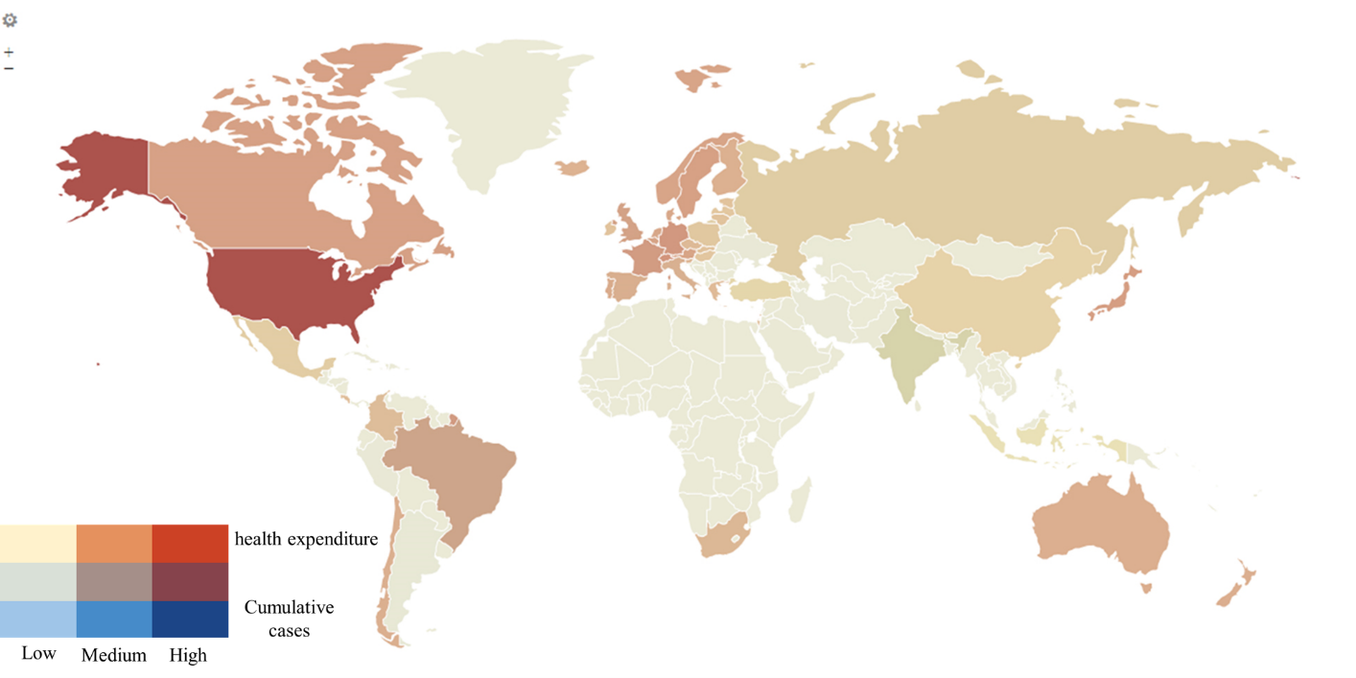
Figure 35. Health expenditure vs Covid-19 cumulative cases.

Hospital beds per 1000
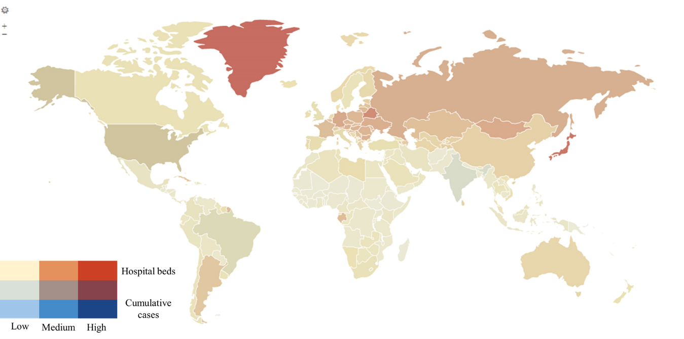
Figure 36. Hospital beds/1000 vs. Covid-19 cumulative cases.

Physicians per 1000

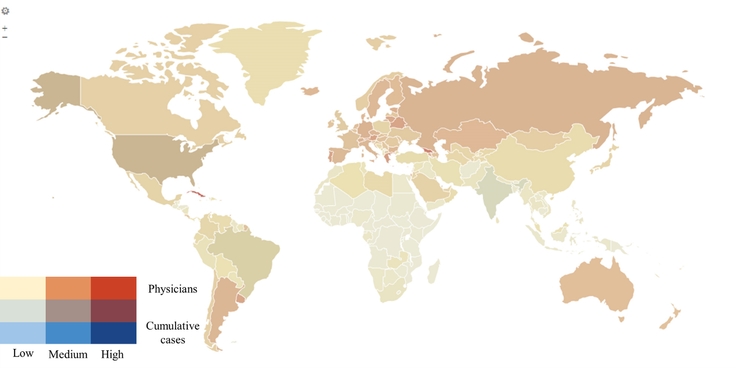
Figure 37. Physicians/1000 vs. Covid-19 cumulative cases.

Nurses per 1000
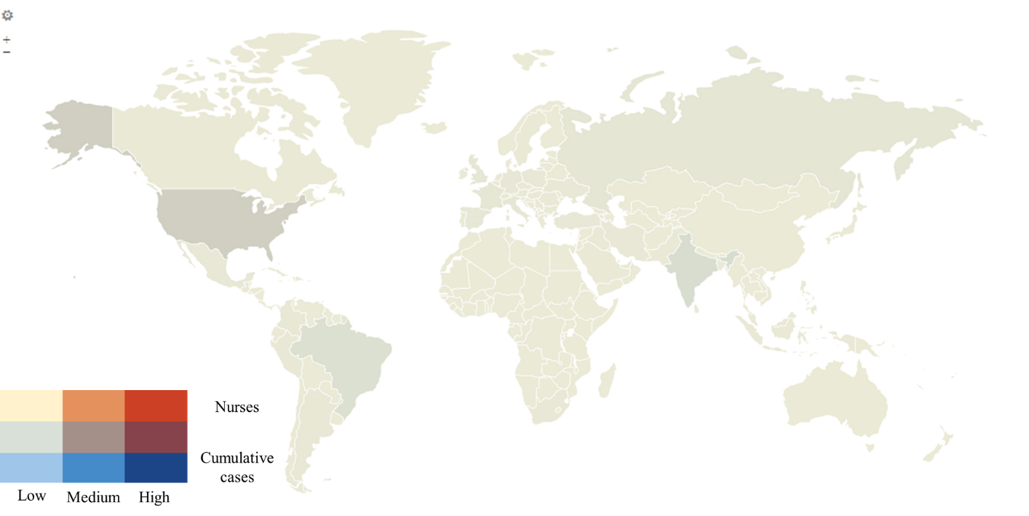
Figure 38. Nurses/1000 vs. Covid-19 cumulative cases.

Infant mortality per 1000
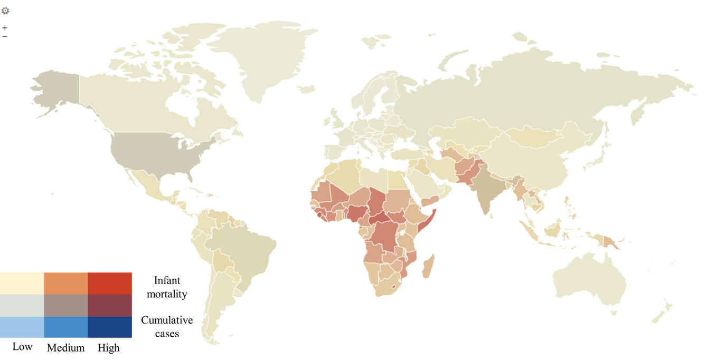
Figure 39. Infant mortality/1000 vs. Covid-19 cumulative cases.

Precautions related variables

Stay at home
Only 50% of the countries recommended not leaving the house policy. Other countries require not leaving the house except for necessity (12.7%). Only 18.6% of the countries have stay at home policy at all.
Table 38. Stay at home policies within countries.
Stay at home | N (%)
No measures | 41 (18.6%)
Recommend not leaving house | 109 (49.5%)
Require not leaving house except for necessity | 28 (12.7%)
Unknown | 42 (19.1%)

Table 39. Covid-19 cumulative cases vs. stay at home policies.
Cumulative cases (Thousands) | No measures | Recommend not leaving house | Require not leaving house except for necessity | Unknown
0 - 1 | 15 (36.6%) | 4 (3.7%) | 0 (0%) | 25 (59.5%)
1 - 10 | 11 (26.8%) | 21 (19.3%) | 4 (14.3%) | 11 (26.2%)
10 - 100 | 9 (22%) | 30 (27.5%) | 9 (32.1%) | 5 (11.9%)
100 - 200 | 2 (4.9%) | 17 (15.6%) | 7 (25%) | 1 (2.4%)
200 - 300 | 2 (4.9%) | 7 (6.4%) | 2 (7.1%) | 0 (0%)
300 - 400 | 0 (0%) | 4 (3.7%) | 0 (0%) | 0 (0%)
400 - 500 | 1 (2.4%) | 4 (3.7%) | 2 (7.1%) | 0 (0%)
500 - 600 | 0 (0%) | 3 (2.8%) | 0 (0%) | 0 (0%)
Above 600 | 1 (2.4%) | 19 (17.4%) | 4 (14.3%) | 0 (0%)
Mean cases | 68606.2 | 577241.0 | 587697.2 | 9173.5
Std. Err. | 33871.5 | 196968.1 | 366070.1 | 4307.8
Mean 95% | 28170.6 | 268633.6 | 217890.6 | 3649.4

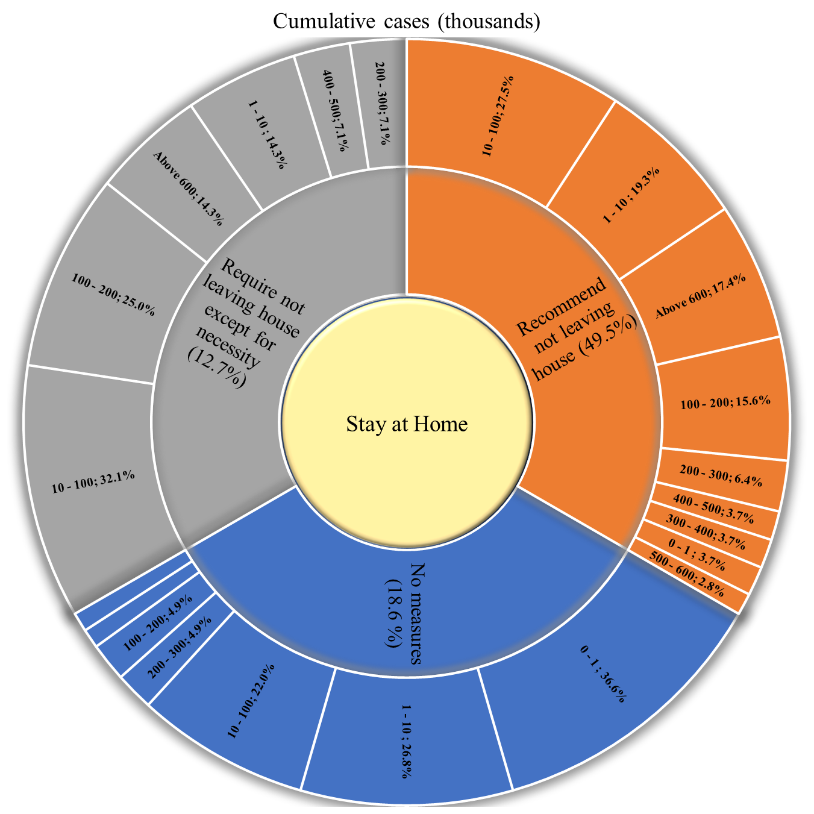
Figure 40. Covid-19 cumulative cases vs. stay at home policies.
Table 40. Covid-19 cumulative deaths vs. stay at home policies.
Cumulative deaths (Thousands) | No measures | Recommend not leaving house | Require not leaving house except for necessity | Unknown
0 - 1 | 36 (87.8%) | 52 (47.7%) | 7 (25%) | 40 (95.2%)
1 - 5 | 2 (4.9%) | 27 (24.8%) | 14 (50%) | 2 (4.8%)
5 - 10 | 2 (4.9%) | 8 (7.3%) | 2 (7.1%) | 0 (0%)
10 - 20 | 0 (0%) | 8 (7.3%) | 2 (7.1%) | 0 (0%)
20 - 50 | 1 (2.4%) | 5 (4.6%) | 2 (7.1%) | 0 (0%)
50 - 100 | 0 (0%) | 6 (5.5%) | 0 (0%) | 0 (0%)
Above 100 | 0 (0%) | 3 (2.8%) | 1 (3.6%) | 0 (0%)
Mean deaths | 1286.4 | 13306.7 | 11027.5 | 163.2
Std. Err. | 739.2 | 3924.8 | 5490.8 | 89.1
Mean 95% | 426.2 | 6242.5 | 5640.3 | 38.6

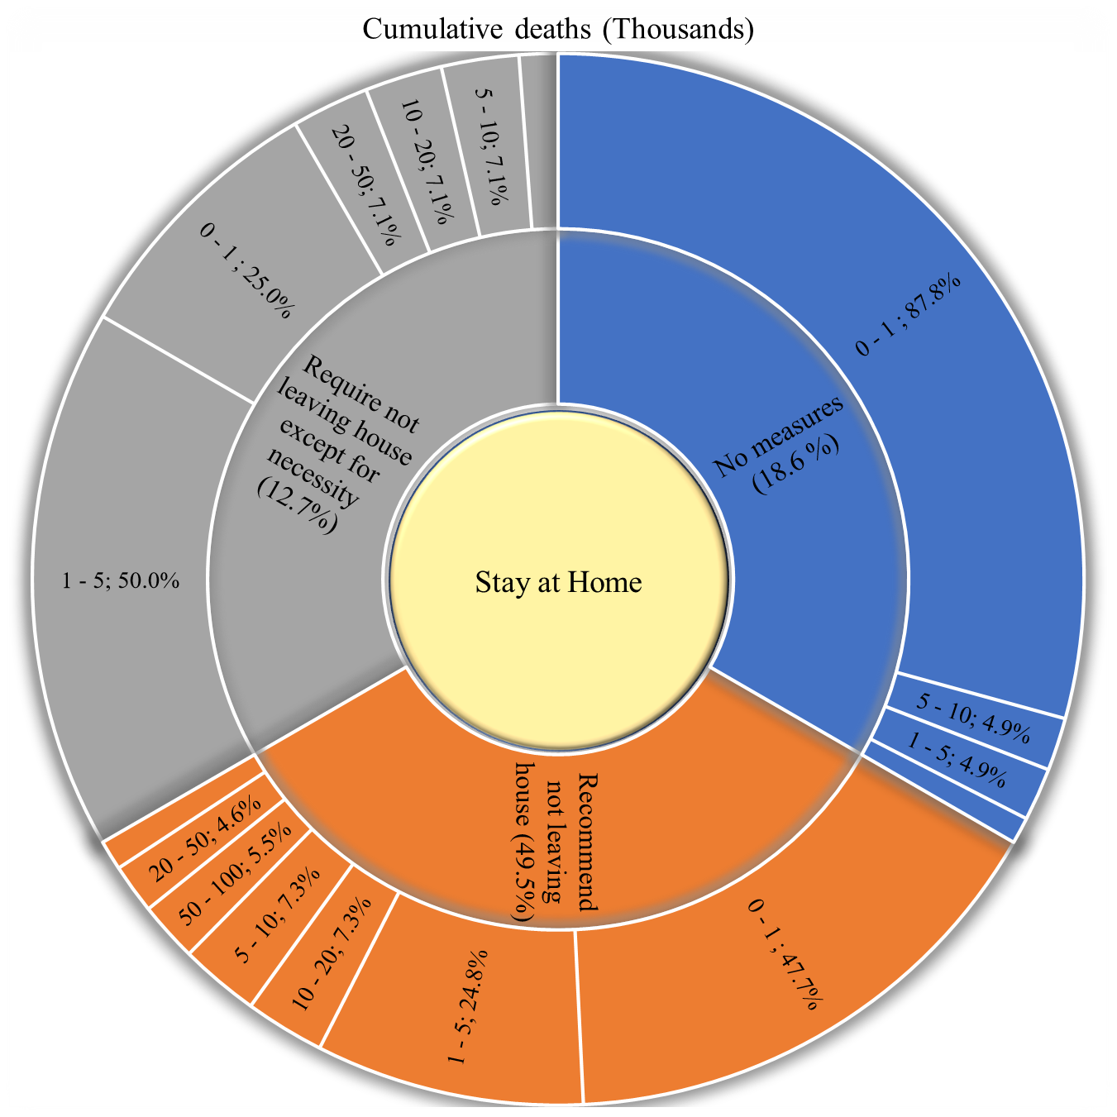
Figure 41. Covid-19 cumulative deaths vs. stay at home policies.

Table 41. Covid-19 population positive cases vs. stay at home policies.
Population positive cases | No measures | Recommend not leaving house | Require not leaving house except for necessity | Unknown
0% - 0.1 % | 18 (43.9%) | 23 (21.1%) | 3 (10.7%) | 6 (14.3%)
0.1% - 0.5% | 6 (14.6%) | 18 (16.5%) | 10 (35.7%) | 14 (33.3%)
0.5% - 1% | 4 (9.8%) | 8 (7.3%) | 2 (7.1%) | 4 (9.5%)
1%- 2% | 2 (4.9%) | 17 (15.6%) | 6 (21.4%) | 2 (4.8%)
2% - 3% | 6 (14.6%) | 13 (11.9%) | 2 (7.1%) | 7 (16.7%)
3% - 4% | 1 (2.4%) | 13 (11.9%) | 4 (14.3%) | 2 (4.8%)
4% - 5% | 0 (0%) | 8 (7.3%) | 0 (0%) | 2 (4.8%)
5% - 6% | 2 (4.9%) | 7 (6.4%) | 1 (3.6%) | 2 (4.8%)
6% - 7% | 0 (0%) | 1 (0.9%) | 0 (0%) | 2 (4.8%)
7% - 8% | 1 (2.4%) | 1 (0.9%) | 0 (0%) | 1 (2.4%)
10% and above | 1 (2.4%) | 0 (0%) | 0 (0%) | 0 (0%)
Mean cases | 1.31 | 1.84 | 1.26 | 1.73
Std. Err. | 0.36 | 0.18 | 0.27 | 0.32
Mean 95% | 0.97 | 1.70 | 1.11 | 1.54

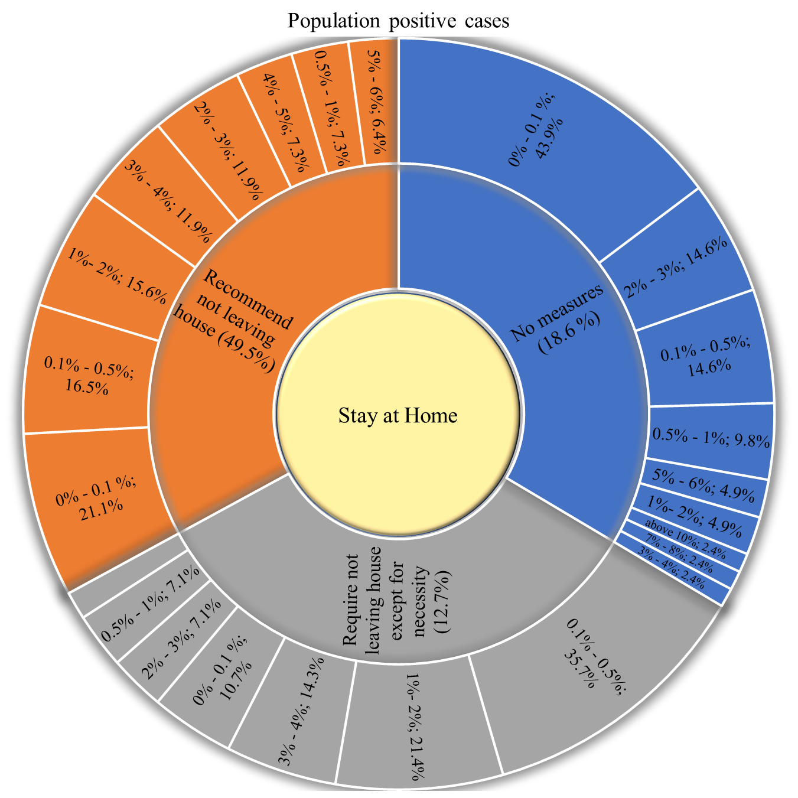
Figure 42. Covid-19 population positive cases vs. stay at home policies.

Table 42. Covid-19 population deaths vs. stay at home policies
Population Covid deaths | No measures | Recommend not leaving house | Require not leaving house except for necessity | Unknown
0‰ - 1‰ | 20 (48.8%) | 17 (15.6%) | 5 (17.9%) | 13 (31%)
1‰ - 5‰ | 5 (12.2%) | 21 (19.3%) | 5 (17.9%) | 7 (16.7%)
5‰ - 10‰ | 6 (14.6%) | 9 (8.3%) | 2 (7.1%) | 5 (11.9%)
10‰ - 50‰ | 4 (9.8%) | 35 (32.1%) | 10 (35.7%) | 12 (28.6%)
50‰ - 100‰ | 2 (4.9%) | 19 (17.4%) | 5 (17.9%) | 3 (7.1%)
100‰ and above | 4 (9.8%) | 8 (7.3%) | 1 (3.6%) | 2 (4.8%)
Mean Population Covid | 0.020 | 0.033 | 0.028 | 0.020
Std. Err. | 0.007 | 0.004 | 0.006 | 0.005
Mean 95% | 0.014 | 0.030 | 0.025 | 0.016

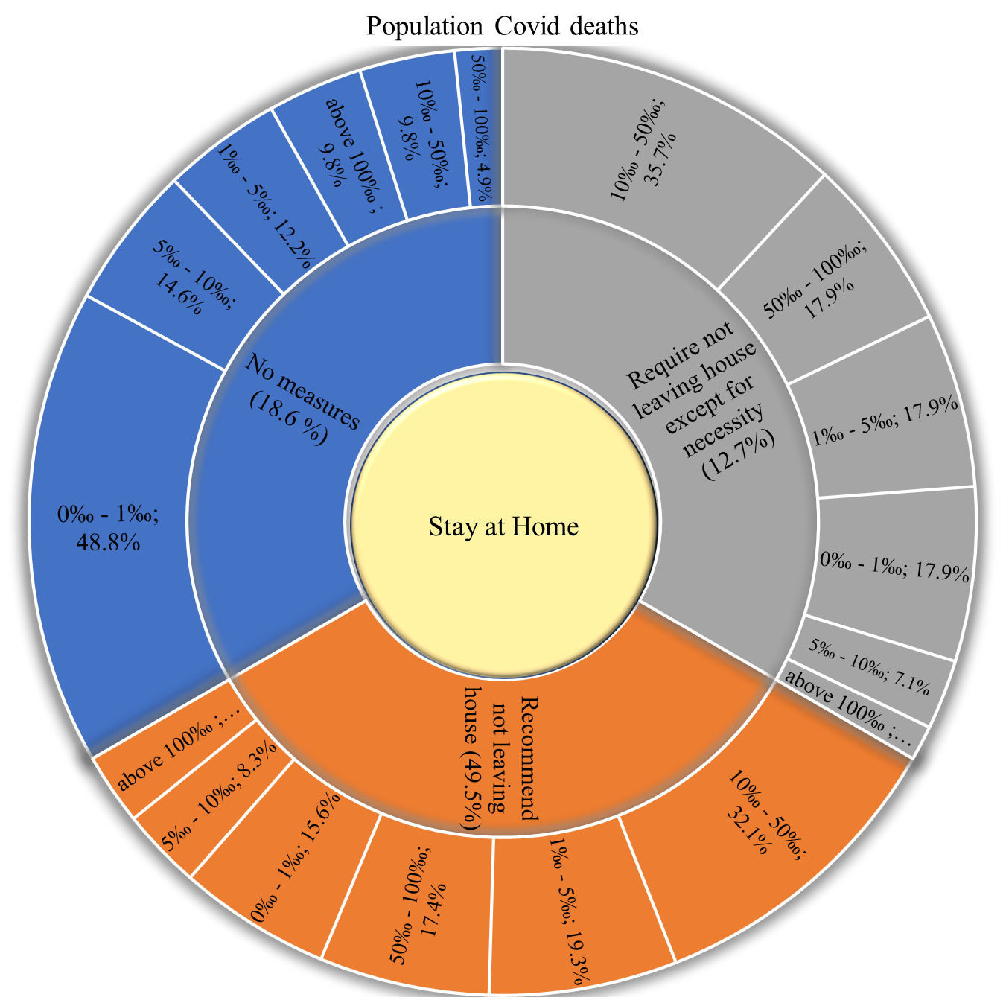
Figure 43. Covid-19 population deaths vs. stay at home policies

Table 43. Covid-19 death of infection vs. stay at home policies
Death of infection | No measures | Recommend not leaving house | Require not leaving house except for necessity | Unknown
0‰ - 5‰ | 12 (29.3%) | 8 (7.3%) | 1 (3.6%) | 17 (40.5%)
5‰ - 10‰ | 7 (17.1%) | 16 (14.7%) | 3 (10.7%) | 5 (11.9%)
10‰ - 20‰ | 12 (29.3%) | 40 (36.7%) | 11 (39.3%) | 15 (35.7%)
20‰ - 30‰ | 5 (12.2%) | 25 (22.9%) | 10 (35.7%) | 1 (2.4%)
30‰ - 40‰ | 4 (9.8%) | 9 (8.3%) | 1 (3.6%) | 1 (2.4%)
40‰ - 50‰ | 1 (2.4%) | 5 (4.6%) | 1 (3.6%) | 1 (2.4%)
50‰ - 60‰ | 0 (0%) | 1 (0.9%) | 1 (3.6%) | 0 (0%)
60‰ - 70‰ | 0 (0%) | 3 (2.8%) | 0 (0%) | 1 (2.4%)
70‰ - 80‰ | 0 (0%) | 0 (0%) | 0 (0%) | 1 (2.4%)
80‰ - 90‰ | 0 (0%) | 1 (0.9%) | 0 (0%) | 0 (0%)
100‰ and above | 0 (0%) | 1 (0.9%) | 0 (0%) | 0 (0%)
Mean Death of infection | 0.014 | 0.023 | 0.021 | 0.013
Std. Err. | 0.002 | 0.003 | 0.002 | 0.003
Mean 95% | 0.013 | 0.020 | 0.020 | 0.010

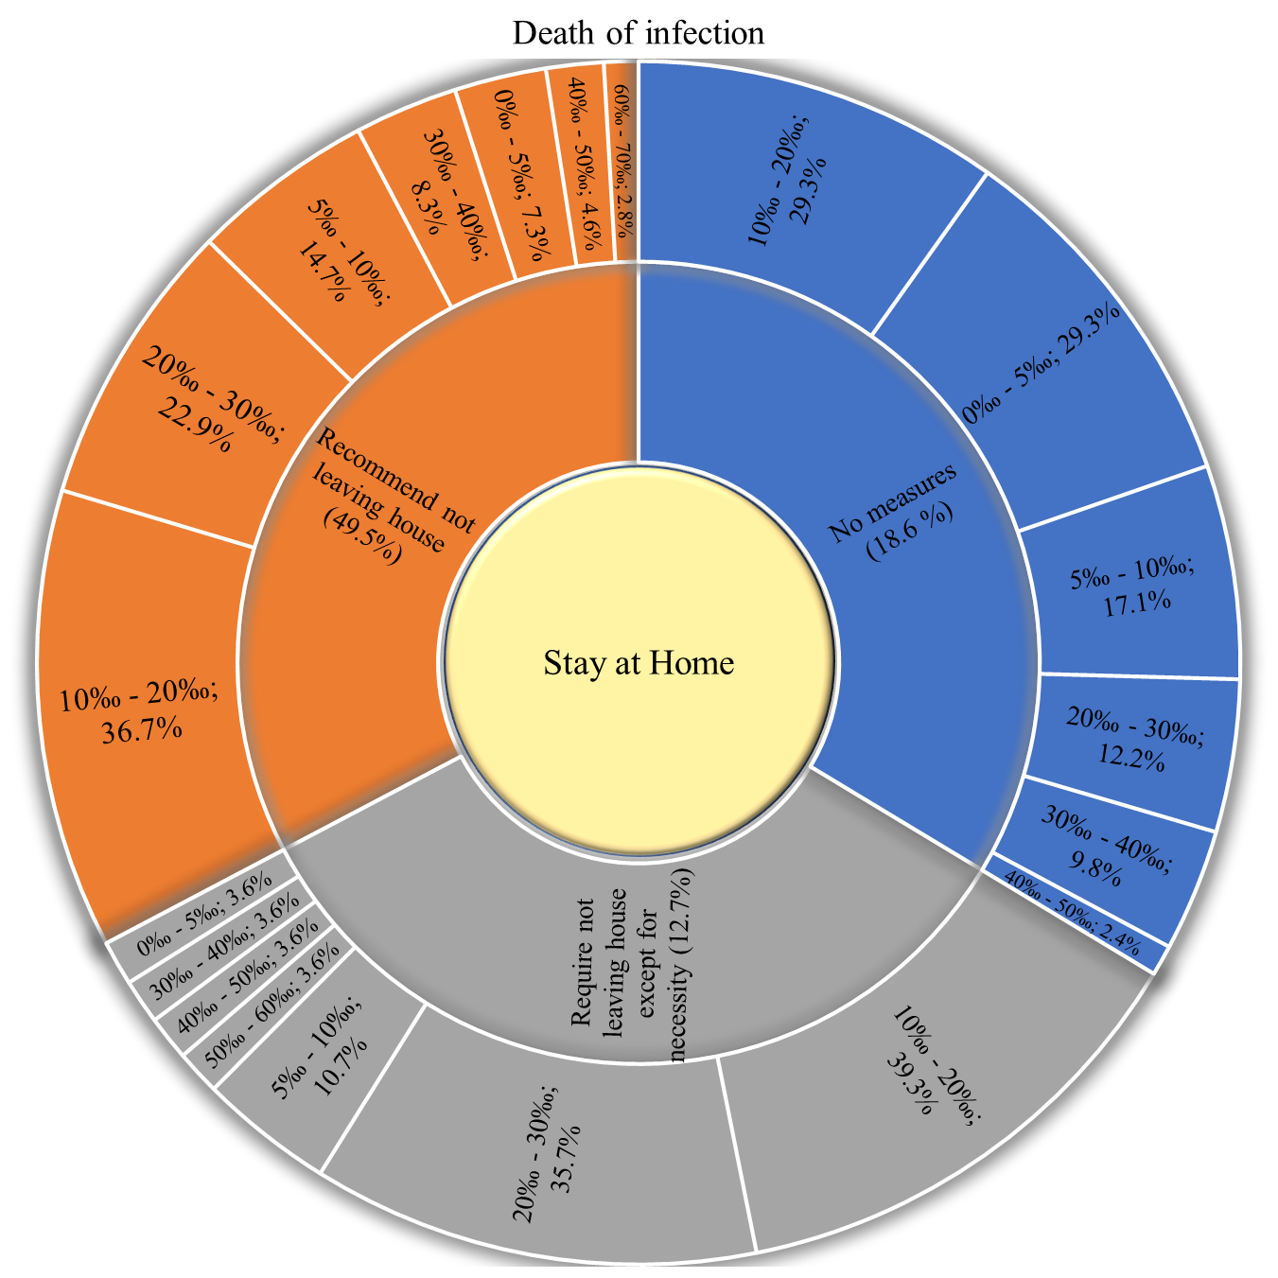
Figure 44. Covid-19 death of infection vs. stay at home policies

Facial covering
Table 44. Distribution of facial covering policies within countries.
Facial Covering Policies | N (%)
No Policy | 11 (5%)
Required (all levels) | 51 (23.2%)
Required in some specified shared/public spaces outside the home | 99 (45%)
Required in all specified shared/public spaces outside the home | 17 (7.7%)
Required outside the home at all times regardless of location | 1 (0.5%)
No data | 41 (18.6%)

Table 45. Covid-19 cumulative cases vs. facial covering policies.
Cumulative cases (Thousands) | No Policy | Required (all levels) | Required in some specified shared/public spaces outside the home | Required in all specified shared/public spaces outside the home | Required outside the home at all times regardless of location | Unknown
0 - 1 | 4 (36.4%) | 9 (17.6%) | 6 (6.1%) | 0 (0%) | 1 (100%) | 24 (58.5%)
1 - 10 | 2 (18.2%) | 11 (21.6%) | 22 (22.2%) | 1 (5.9%) | 0 (0%) | 11 (26.8%)
10 - 100 | 3 (27.3%) | 8 (15.7%) | 32 (32.3%) | 5 (29.4%) | 0 (0%) | 5 (12.2%)
100 - 200 | 1 (9.1%) | 9 (17.6%) | 13 (13.1%) | 3 (17.6%) | 0 (0%) | 1 (2.4%)
200 - 300 | 0 (0%) | 4 (7.8%) | 7 (7.1%) | 0 (0%) | 0 (0%) | 0 (0%)
300 - 400 | 0 (0%) | 2 (3.9%) | 2 (2%) | 0 (0%) | 0 (0%) | 0 (0%)
400 - 500 | 1 (9.1%) | 2 (3.9%) | 3 (3%) | 1 (5.9%) | 0 (0%) | 0 (0%)
500 - 600 | 0 (0%) | 0 (0%) | 2 (2%) | 1 (5.9%) | 0 (0%) | 0 (0%)
Above 600 | 0 (0%) | 6 (11.8%) | 12 (12.1%) | 6 (35.3%) | 0 (0%) | 0 (0%)
Mean cases | 61229.7 | 283620.6 | 238051.1 | 2557831.2 | - | 9378.6
Std. Err. | 40075.0 | 87324.4 | 46003.8 | 1279008.9 | - | 4409.2
Mean 95% | 43734.1 | 168722.1 | 162416.6 | 1753918.7 | - | 3783.6

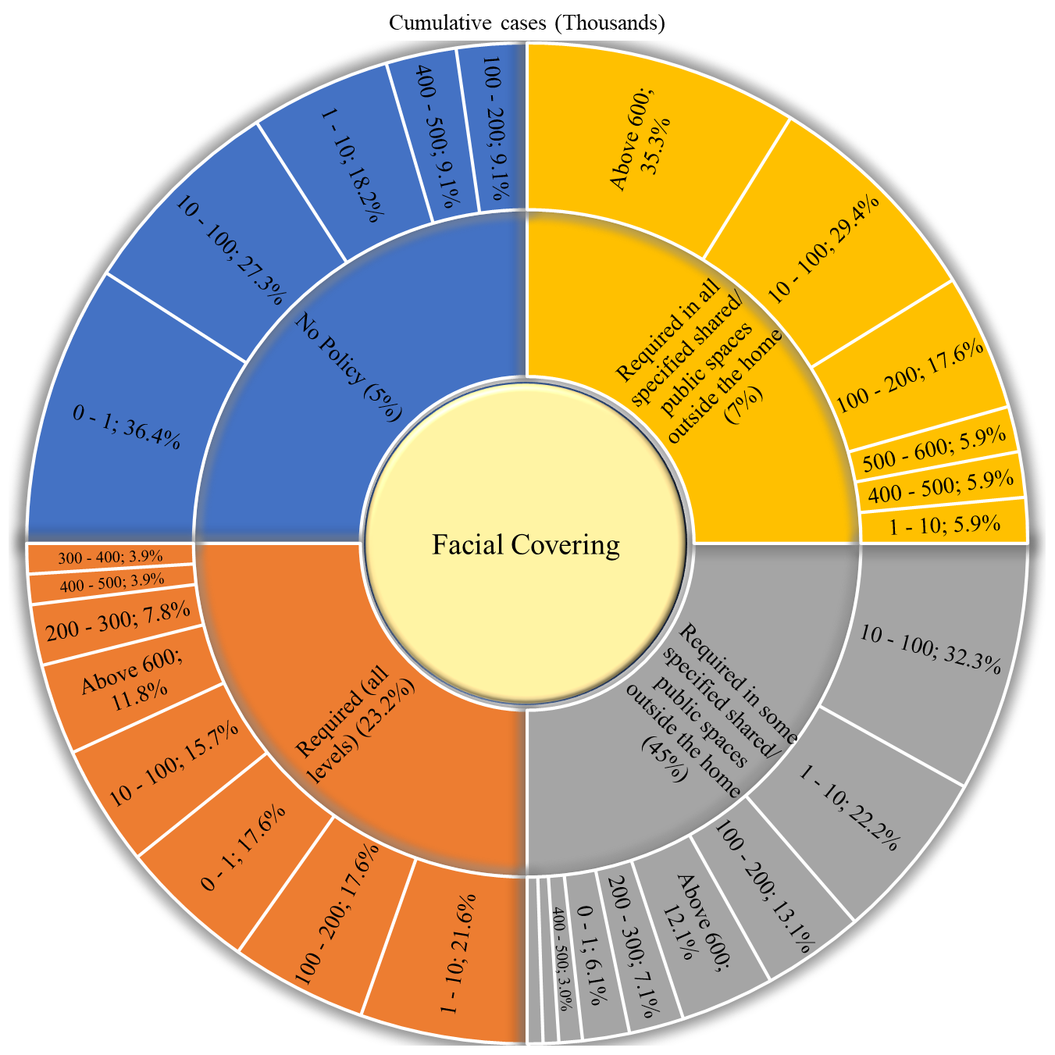
Figure 45. Covid-19 cumulative cases vs. facial covering policies.

Table 46. Covid-19 cumulative deaths vs. facial covering policies.
Cumulative deaths (Thousands) | No Policy | Required (all levels) | Required in some specified shared/public spaces outside the home | Required in all specified shared/public spaces outside the home | Required outside the home at all times regardless of location | Unknown
0 - 1 | 8 (72.7%) | 27 (52.9%) | 55 (55.6%) | 5 (29.4%) | 1 (100%) | 39 (95.1%)
1 - 5 | 2 (18.2%) | 15 (29.4%) | 22 (22.2%) | 4 (23.5%) | 0 (0%) | 2 (4.9%)
5 - 10 | 1 (9.1%) | 3 (5.9%) | 7 (7.1%) | 1 (5.9%) | 0 (0%) | 0 (0%)
10 - 20 | 0 (0%) | 2 (3.9%) | 7 (7.1%) | 1 (5.9%) | 0 (0%) | 0 (0%)
20 - 50 | 0 (0%) | 1 (2%) | 6 (6.1%) | 1 (5.9%) | 0 (0%) | 0 (0%)
50 - 100 | 0 (0%) | 3 (5.9%) | 2 (2%) | 1 (5.9%) | 0 (0%) | 0 (0%)
Above 100 | 0 (0%) | 0 (0%) | 0 (0%) | 4 (23.5%) | 0 (0%) | 0 (0%)
Mean Cumulative cases | 1254.6 | 6219.3 | 5517.3 | 54985.2 | - | 167.0
Std. Err. | 766.5 | 2154.4 | 1166.6 | 23191.6 | - | 91.2
Mean 95% | 909.2 | 3368.7 | 3469.4 | 42229.2 | - | 40.2

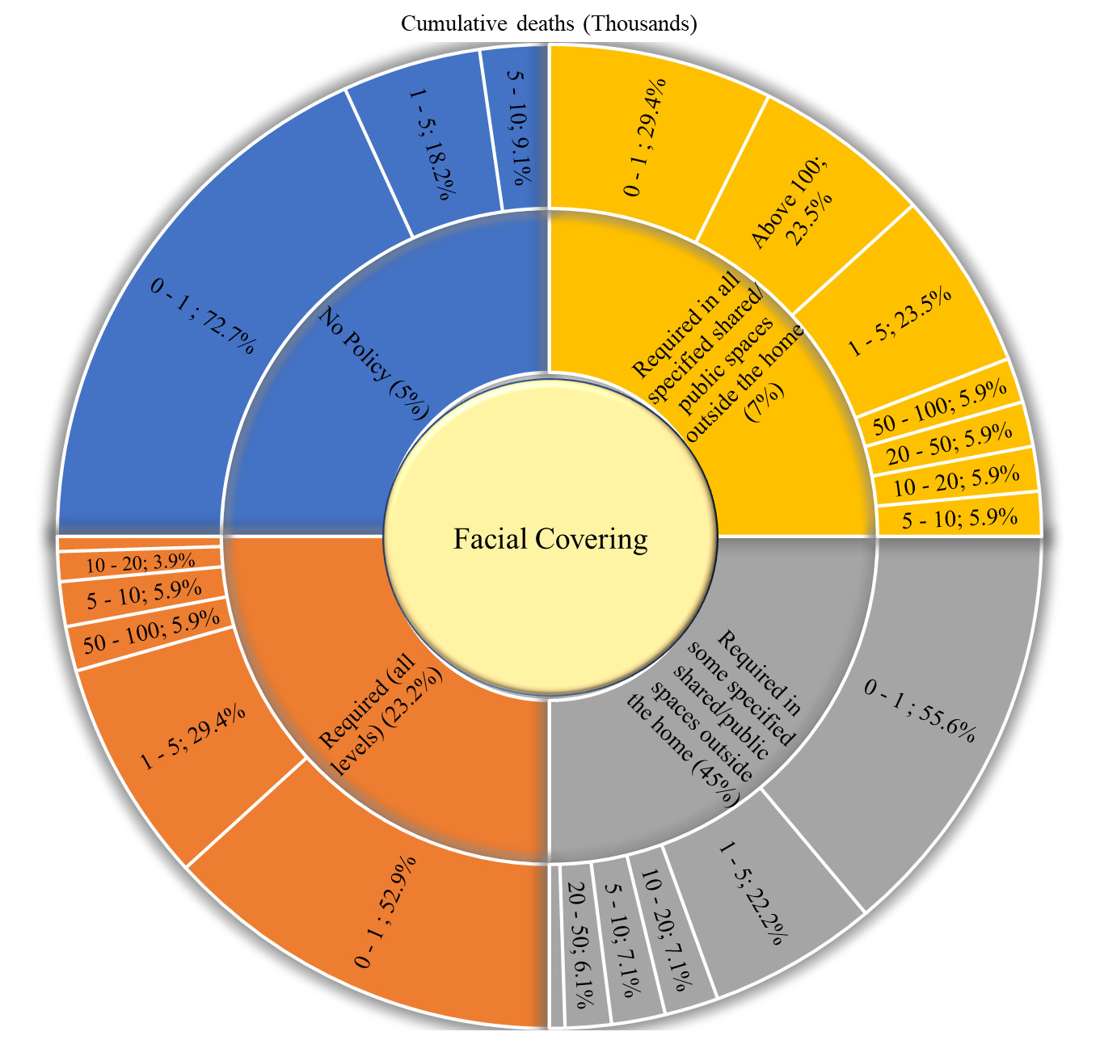
Figure 46. Covid-19 cumulative deaths vs. facial covering policies.

Table 47. Covid-19 population positive vs. facial covering policies.
Population positive cases | No Policy | Required (all levels) | Required in some specified shared/public spaces outside the home | Required in all specified shared/public spaces outside the home | Required outside the home at all times regardless of location | Unknown
0% - 0.1 % | 7 (63.6%) | 10 (19.6%) | 25 (25.3%) | 2 (11.8%) | 1 (100%) | 5 (12.2%)
0.1% - 0.5% | 0 (0%) | 9 (17.6%) | 20 (20.2%) | 5 (29.4%) | 0 (0%) | 14 (34.1%)
0.5% - 1% | 1 (9.1%) | 4 (7.8%) | 8 (8.1%) | 1 (5.9%) | 0 (0%) | 4 (9.8%)
1%- 2% | 1 (9.1%) | 6 (11.8%) | 14 (14.1%) | 4 (23.5%) | 0 (0%) | 2 (4.9%)
2% - 3% | 0 (0%) | 8 (15.7%) | 11 (11.1%) | 2 (11.8%) | 0 (0%) | 7 (17.1%)
3% - 4% | 1 (9.1%) | 6 (11.8%) | 9 (9.1%) | 2 (11.8%) | 0 (0%) | 2 (4.9%)
4% - 5% | 1 (9.1%) | 2 (3.9%) | 5 (5.1%) | 0 (0%) | 0 (0%) | 2 (4.9%)
5% - 6% | 0 (0%) | 5 (9.8%) | 4 (4%) | 1 (5.9%) | 0 (0%) | 2 (4.9%)
6% - 7% | 0 (0%) | 0 (0%) | 1 (1%) | 0 (0%) | 0 (0%) | 2 (4.9%)
7% - 8% | 0 (0%) | 1 (2%) | 1 (1%) | 0 (0%) | 0 (0%) | 1 (2.4%)
10% and above | 0 (0%) | 0 (0%) | 1 (1%) | 0 (0%) | 0 (0%) | 0 (0%)
Mean cases | 0.86 | 1.93 | 1.59 | 1.43 | - | 1.77
Std. Err. | 0.45 | 0.27 | 0.20 | 0.40 | - | 0.33
Mean 95% | 0.72 | 1.80 | 1.36 | 1.26 | - | 1.59

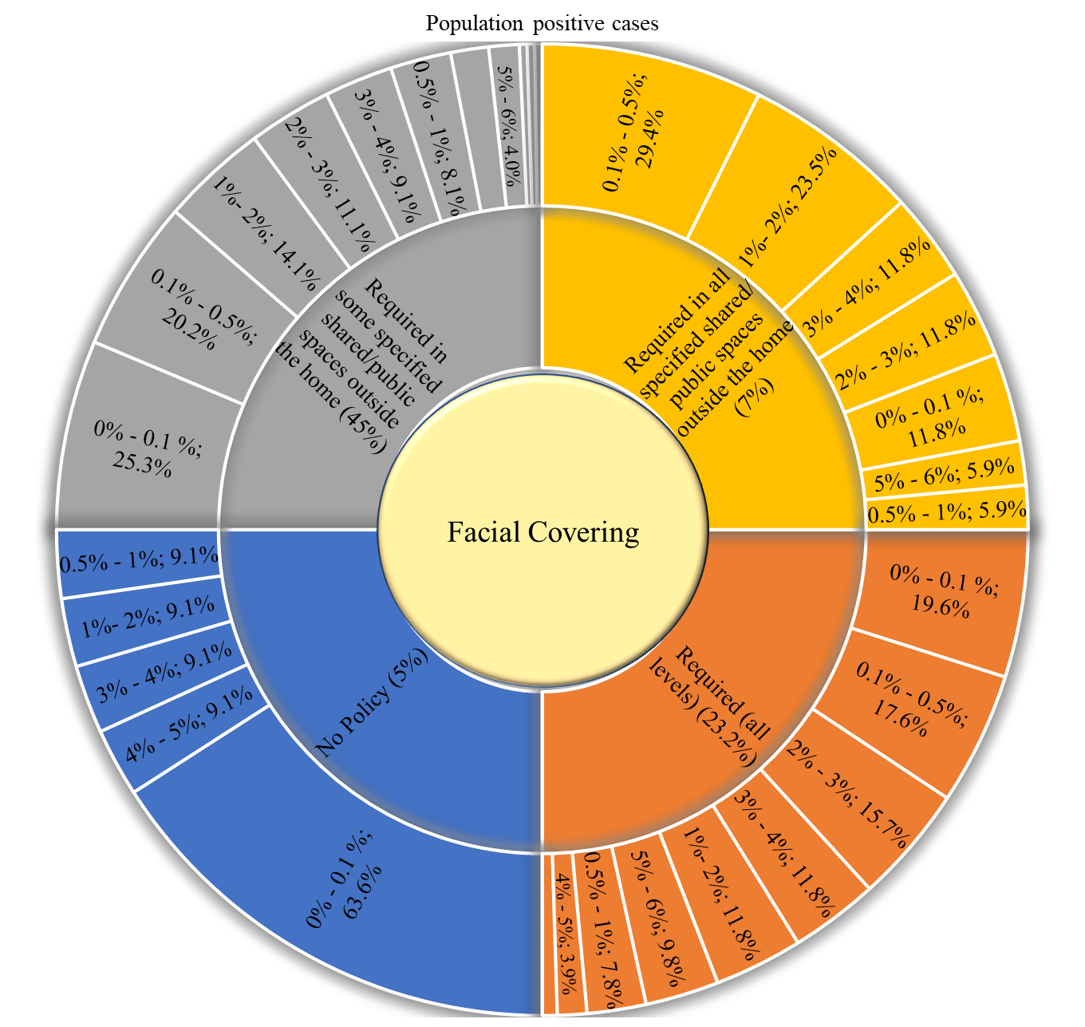
Figure 47. Covid-19 population positive vs. facial covering policies.

Table 48. Covid-19 population deaths vs. facial covering policies.
Population Covid deaths | No Policy | Required (all levels) | Required in some specified shared/public spaces outside the home | Required in all specified shared/public spaces outside the home | Required outside the home at all times regardless of location | Unknown
0‰ - 1‰ | 4 (36.4%) | 10 (19.6%) | 23 (23.2%) | 4 (23.5%) | 1 (100%) | 13 (31.7%)
1‰ - 5‰ | 4 (36.4%) | 7 (13.7%) | 18 (18.2%) | 3 (17.6%) | 0 (0%) | 6 (14.6%)
5‰ - 10‰ | 0 (0%) | 6 (11.8%) | 10 (10.1%) | 1 (5.9%) | 0 (0%) | 5 (12.2%)
10‰ - 50‰ | 2 (18.2%) | 16 (31.4%) | 26 (26.3%) | 5 (29.4%) | 0 (0%) | 12 (29.3%)
50‰ - 100‰ | 1 (9.1%) | 9 (17.6%) | 14 (14.1%) | 2 (11.8%) | 0 (0%) | 3 (7.3%)
100‰ and above | 0 (0%) | 3 (5.9%) | 8 (8.1%) | 2 (11.8%) | 0 (0%) | 2 (4.9%)
Mean deaths | 0.013 | 0.031 | 0.030 | 0.034 | - | 0.021
Std. Err. | 0.008 | 0.005 | 0.004 | 0.010 | - | 0.005
Mean 95% | 0.009 | 0.027 | 0.026 | 0.031 | - | 0.017

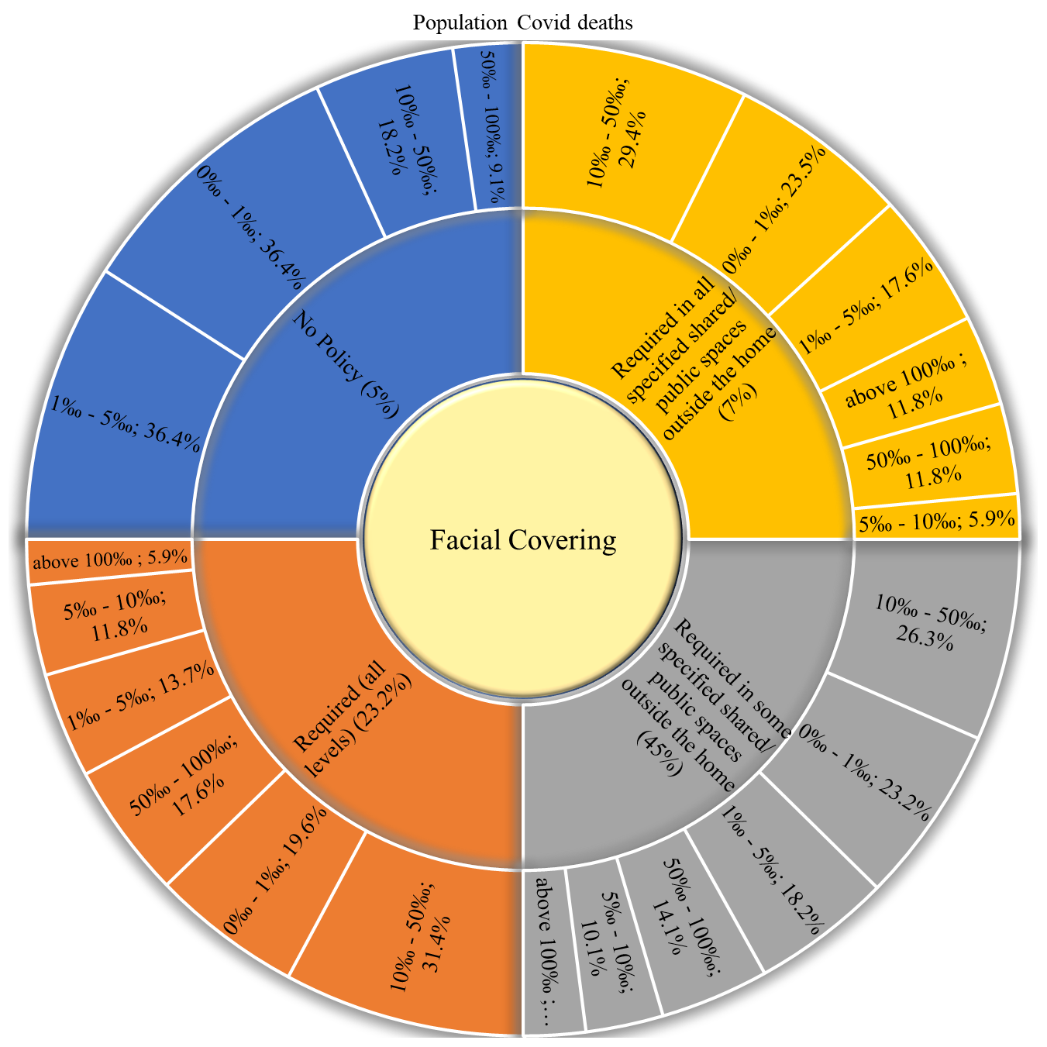
Figure 48. Covid-19 population deaths vs. facial covering policies.

Table 49. Covid-19 death of infection vs. facial covering policies.
Death of infection | No Policy | Required (all levels) | Required in some specified shared/public spaces outside the home | Required in all specified shared/public spaces outside the home | Required outside the home at all times regardless of location | Unknown
0‰ - 5‰ | 4 (36.4%) | 5 (9.8%) | 10 (10.1%) | 1 (5.9%) | 1 (100%) | 17 (41.5%)
5‰ - 10‰ | 1 (9.1%) | 9 (17.6%) | 14 (14.1%) | 2 (11.8%) | 0 (0%) | 5 (12.2%)
10‰ - 20‰ | 2 (18.2%) | 21 (41.2%) | 35 (35.4%) | 6 (35.3%) | 0 (0%) | 14 (34.1%)
20‰ - 30‰ | 0 (0%) | 11 (21.6%) | 24 (24.2%) | 5 (29.4%) | 0 (0%) | 1 (2.4%)
30‰ - 40‰ | 1 (9.1%) | 2 (3.9%) | 9 (9.1%) | 2 (11.8%) | 0 (0%) | 1 (2.4%)
40‰ - 50‰ | 0 (0%) | 3 (5.9%) | 4 (4%) | 0 (0%) | 0 (0%) | 1 (2.4%)
50‰ - 60‰ | 0 (0%) | 0 (0%) | 2 (2%) | 0 (0%) | 0 (0%) | 0 (0%)
60‰ - 70‰ | 2 (18.2%) | 0 (0%) | 1 (1%) | 0 (0%) | 0 (0%) | 1 (2.4%)
70‰ - 80‰ | 0 (0%) | 0 (0%) | 0 (0%) | 0 (0%) | 0 (0%) | 1 (2.4%)
80‰ - 90‰ | 0 (0%) | 0 (0%) | 0 (0%) | 1 (5.9%) | 0 (0%) | 0 (0%)
100‰ and above | 1 (9.1%) | 0 (0%) | 0 (0%) | 0 (0%) | 0 (0%) | 0 (0%)
Mean death | 0.045 | 0.017 | 0.020 | 0.023 | - | 0.013
Std. Err. | 0.025 | 0.001 | 0.001 | 0.005 | - | 0.003
Mean 95% | 0.034 | 0.017 | 0.019 | 0.020 | - | 0.010

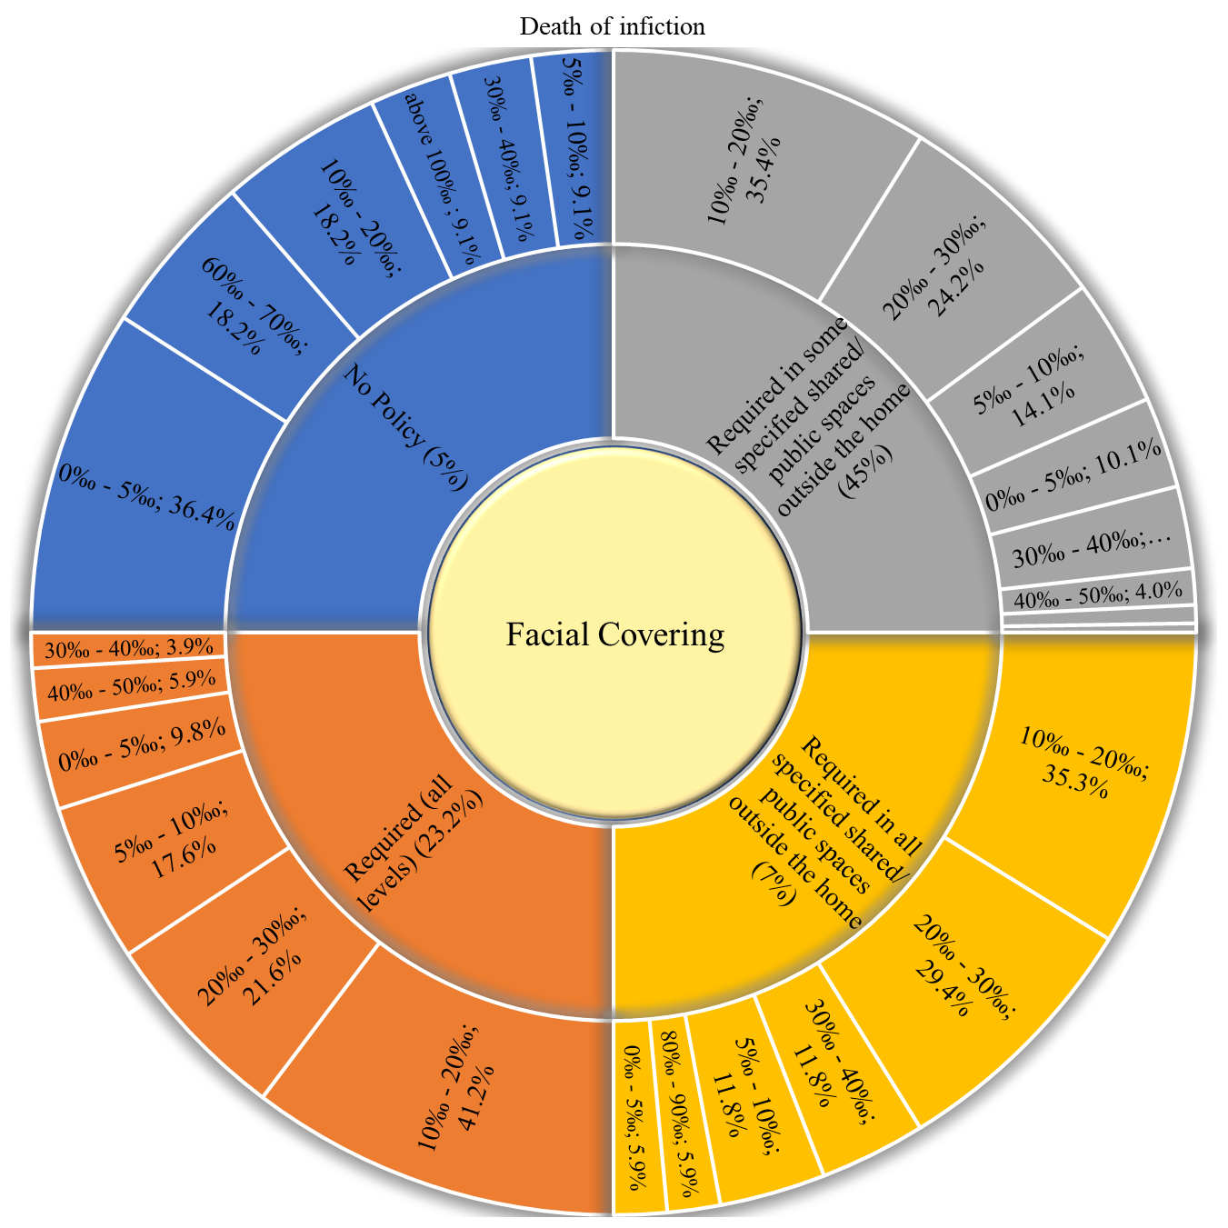
Figure 49. Covid-19 death of infection vs. facial covering policies.

Restriction on gatherings
Table 50. Distribution of restriction on gatherings within countries.
Restrictions on Gatherings | N (%)
No Restictions | 6 (2.7%)
Restrictions on gatherings of more than 1000 people | 17 (7.7%)
Restrictions on gatherings between 100-1000 people | 74 (33.6%)
Restrictions on gatherings between 10-100 people | 81 (36.8%)
Restrictions on gatherings of less than 10 people | 1 (0.5%)
No Data | 41 (18.6%)

Table 51. Covid-19 cumulative cases vs. restriction on gatherings policies.
Cumulative cases (Thousands) | No Restictions | Restrictions on gatherings of more than 1000 people | Restrictions on gatherings between 100-1000 people | Restrictions on gatherings between 10-100 people | Restrictions on gatherings of less than 10 people | No Data
0 - 1 | 2 (33.3%) | 5 (29.4%) | 10 (13.5%) | 2 (2.5%) | 0 (0%) | 25 (61%)
1 - 10 | 2 (33.3%) | 2 (11.8%) | 21 (28.4%) | 12 (14.8%) | 0 (0%) | 10 (24.4%)
10 - 100 | 0 (0%) | 7 (41.2%) | 20 (27%) | 20 (24.7%) | 1 (100%) | 5 (12.2%)
100 - 200 | 1 (16.7%) | 1 (5.9%) | 9 (12.2%) | 15 (18.5%) | 0 (0%) | 1 (2.4%)
200 - 300 | 1 (16.7%) | 0 (0%) | 3 (4.1%) | 7 (8.6%) | 0 (0%) | 0 (0%)
300 - 400 | 0 (0%) | 0 (0%) | 2 (2.7%) | 2 (2.5%) | 0 (0%) | 0 (0%)
400 - 500 | 0 (0%) | 0 (0%) | 2 (2.7%) | 5 (6.2%) | 0 (0%) | 0 (0%)
500 - 600 | 0 (0%) | 0 (0%) | 0 (0%) | 3 (3.7%) | 0 (0%) | 0 (0%)
Above 600 | 0 (0%) | 2 (11.8%) | 7 (9.5%) | 15 (18.5%) | 0 (0%) | 0 (0%)
Mean Cumulative cases | 73668.0 | 173997.2 | 173045.5 | 813428.5 | - | 9343.1
Std. Err. | 45687.3 | 105110.0 | 43723.5 | 287690.8 | - | 4410.8
Mean 95% | 68629.5 | 115188.2 | 107932.6 | 342672.9 | - | 3744.2
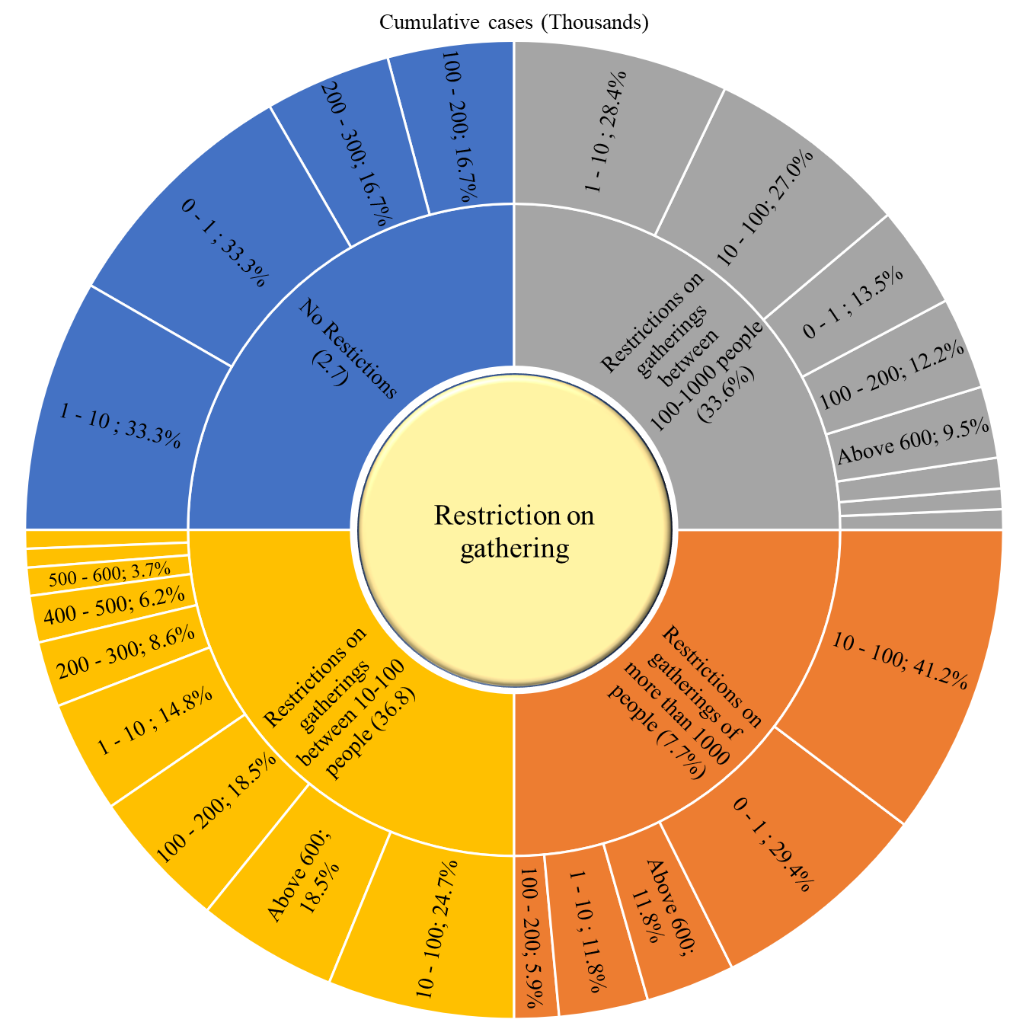
Figure 50. Covid-19 cumulative cases vs. restriction on gatherings policies.

Table 52. Covid-19 cumulative deaths vs. restriction on gatherings policies.
Cumulative deaths (Thousands) | No Restictions | Restrictions on gatherings of more than 1000 people | Restrictions on gatherings between 100-1000 people | Restrictions on gatherings between 10-100 people | Restrictions on gatherings of less than 10 people | No Data
0 - 1 | 4 (66.7%) | 13 (76.5%) | 50 (67.6%) | 29 (35.8%) | 0 (0%) | 39 (95.1%)
1 - 5 | 2 (33.3%) | 1 (5.9%) | 12 (16.2%) | 27 (33.3%) | 1 (100%) | 2 (4.9%)
5 - 10 | 0 (0%) | 1 (5.9%) | 5 (6.8%) | 6 (7.4%) | 0 (0%) | 0 (0%)
10 - 20 | 0 (0%) | 0 (0%) | 3 (4.1%) | 7 (8.6%) | 0 (0%) | 0 (0%)
20 - 50 | 0 (0%) | 1 (5.9%) | 2 (2.7%) | 5 (6.2%) | 0 (0%) | 0 (0%)
50 - 100 | 0 (0%) | 1 (5.9%) | 1 (1.4%) | 4 (4.9%) | 0 (0%) | 0 (0%)
Above 100 | 0 (0%) | 0 (0%) | 1 (1.4%) | 3 (3.7%) | 0 (0%) | 0 (0%)
Mean Cumulative cases | 954.2 | 5197.4 | 5179.9 | 16417.1 | - | 166.4
Std. Err. | 558.0 | 3382.9 | 2028.5 | 5243.2 | - | 91.2
Mean 95% | 865.0 | 2700.6 | 2010.5 | 7800.9 | - | 39.6

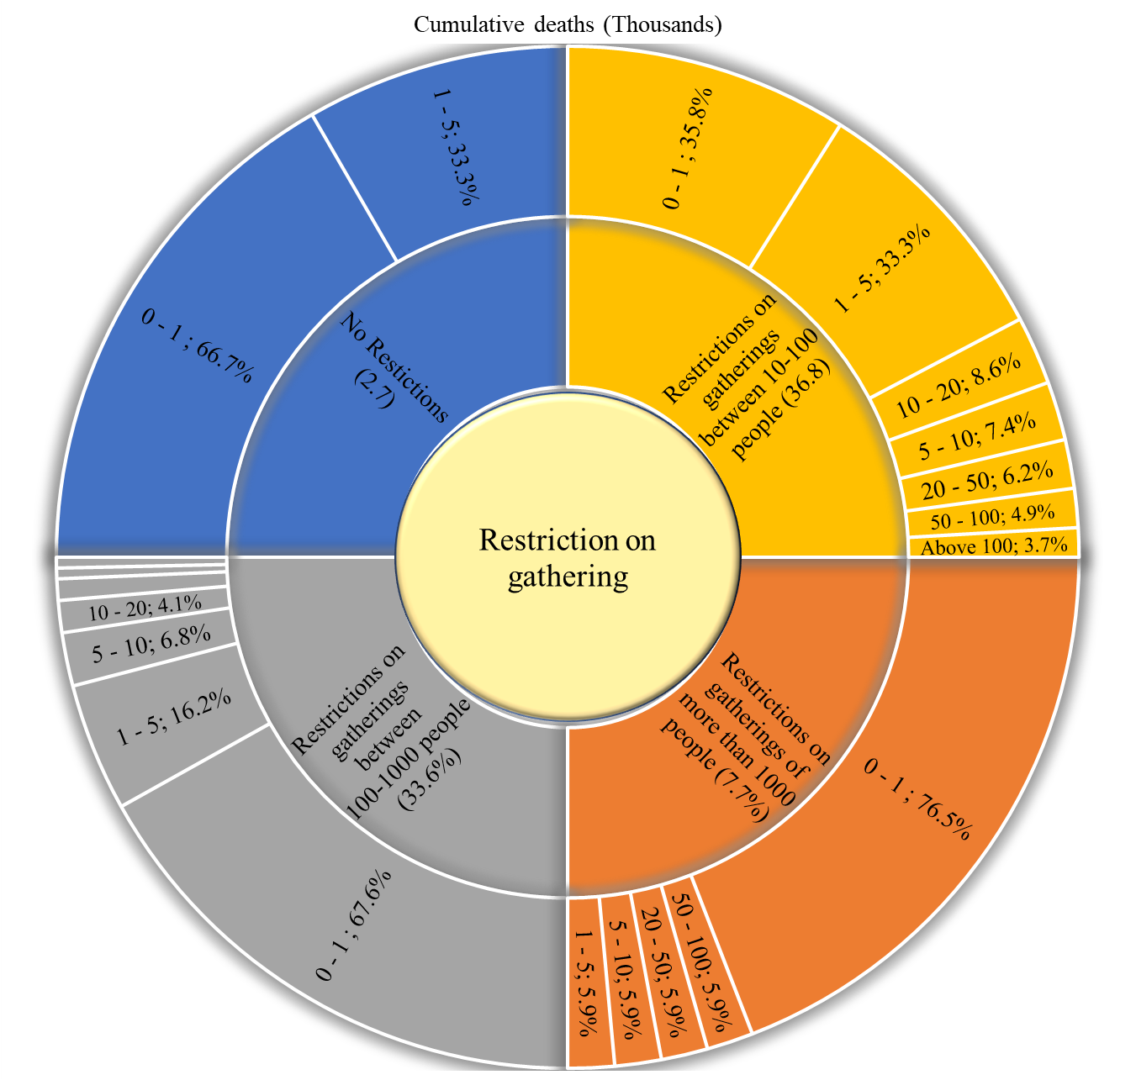
Figure 51. Covid-19 cumulative deaths vs. restriction on gatherings policies.

Table 53. Covid-19 population positive cases vs. restriction on gatherings policies.
Population positive cases | No Restictions | Restrictions on gatherings of more than 1000 people | Restrictions on gatherings between 100-1000 people | Restrictions on gatherings between 10-100 people | Restrictions on gatherings of less than 10 people | No Data
0% - 0.1 % | 4 (66.7%) | 7 (41.2%) | 25 (33.8%) | 7 (8.6%) | 1 (100%) | 6 (14.6%)
0.1% - 0.5% | 1 (16.7%) | 6 (35.3%) | 12 (16.2%) | 15 (18.5%) | 0 (0%) | 14 (34.1%)
0.5% - 1% | 0 (0%) | 2 (11.8%) | 4 (5.4%) | 8 (9.9%) | 0 (0%) | 4 (9.8%)
1%- 2% | 0 (0%) | 2 (11.8%) | 9 (12.2%) | 14 (17.3%) | 0 (0%) | 2 (4.9%)
2% - 3% | 1 (16.7%) | 0 (0%) | 7 (9.5%) | 13 (16%) | 0 (0%) | 7 (17.1%)
3% - 4% | 0 (0%) | 0 (0%) | 9 (12.2%) | 9 (11.1%) | 0 (0%) | 2 (4.9%)
4% - 5% | 0 (0%) | 0 (0%) | 1 (1.4%) | 7 (8.6%) | 0 (0%) | 2 (4.9%)
5% - 6% | 0 (0%) | 0 (0%) | 4 (5.4%) | 7 (8.6%) | 0 (0%) | 1 (2.4%)
6% - 7% | 0 (0%) | 0 (0%) | 1 (1.4%) | 0 (0%) | 0 (0%) | 2 (4.9%)
7% - 8% | 0 (0%) | 0 (0%) | 1 (1.4%) | 1 (1.2%) | 0 (0%) | 1 (2.4%)
10% and above | 0 (0%) | 0 (0%) | 1 (1.4%) | 0 (0%) | 0 (0%) | 0 (0%)
Mean Population positive | 0.4 | 0.3 | 1.6 | 2.1 | - | 1.6
Std. Err. | 0.3 | 0.1 | 0.2 | 0.2 | - | 0.3
Mean 95% | 0.3 | 0.3 | 1.3 | 2.0 | - | 1.4

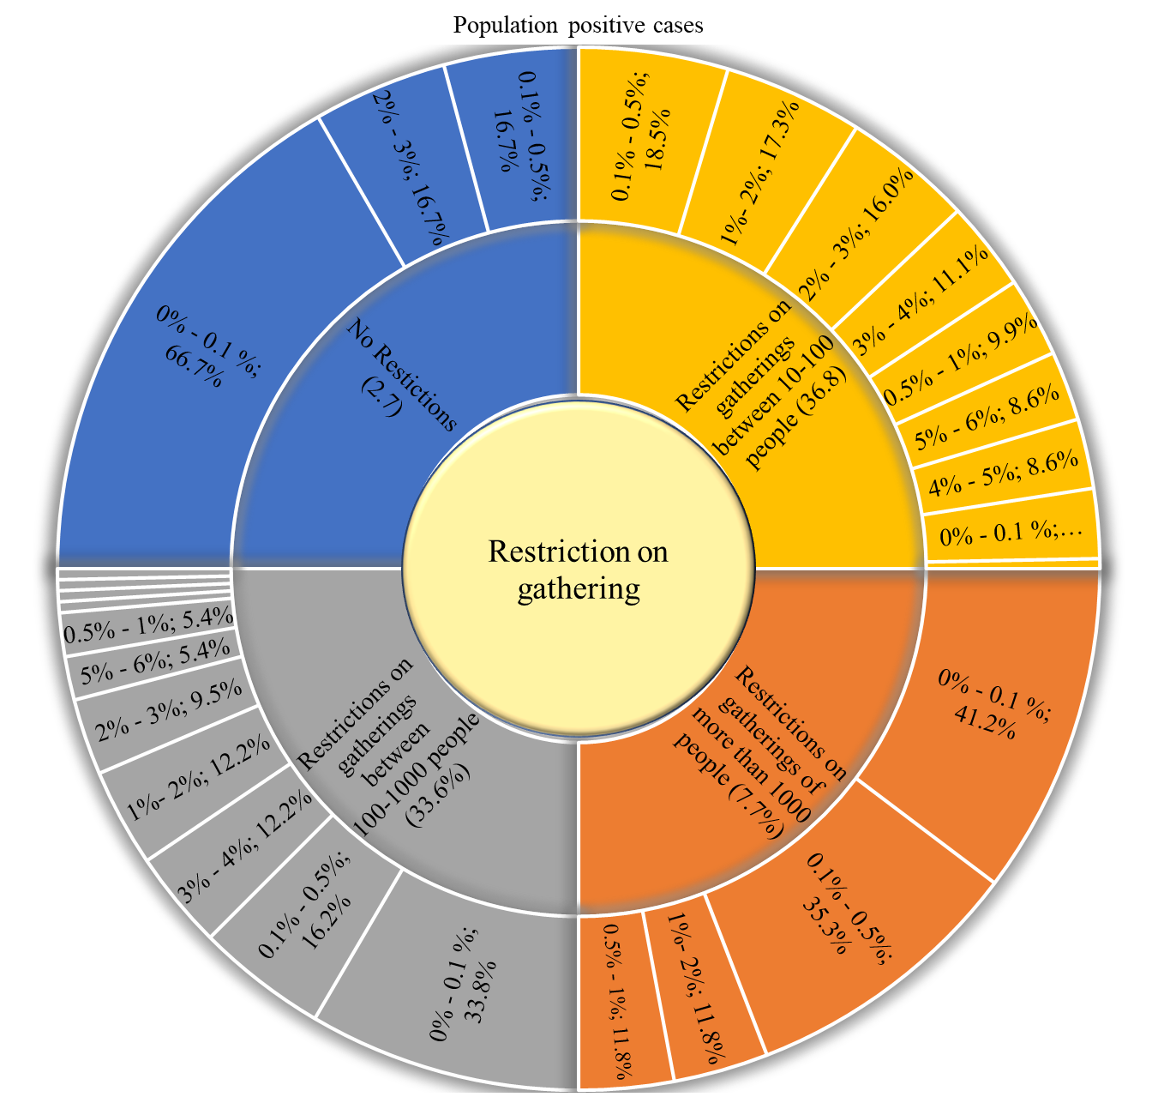
Figure 52. Covid-19 population positive cases vs. restriction on gatherings policies.

Table 54. Covid-19 population deaths vs. restriction on gatherings policies.
Population Covid deaths | No Restrictions | Restrictions on gatherings of more than 1000 people | Restrictions on gatherings between 100-1000 people | Restrictions on gatherings between 10-100 people | Restrictions on gatherings of less than 10 people | No Data
0‰ - 1‰ | 2 (33.3%) | 9 (52.9%) | 25 (33.8%) | 5 (6.2%) | 1 (100%) | 13 (31.7%)
1‰ - 5‰ | 3 (50%) | 1 (5.9%) | 14 (18.9%) | 13 (16%) | 0 (0%) | 7 (17.1%)
5‰ - 10‰ | 0 (0%) | 4 (23.5%) | 2 (2.7%) | 11 (13.6%) | 0 (0%) | 5 (12.2%)
10‰ - 50‰ | 1 (16.7%) | 2 (11.8%) | 19 (25.7%) | 27 (33.3%) | 0 (0%) | 12 (29.3%)
50‰ - 100‰ | 0 (0%) | 1 (5.9%) | 7 (9.5%) | 19 (23.5%) | 0 (0%) | 2 (4.9%)
100‰ and above | 0 (0%) | 0 (0%) | 7 (9.5%) | 6 (7.4%) | 0 (0%) | 2 (4.9%)
Mean deaths | 0.004 | 0.008 | 0.028 | 0.038 | - | 0.019
Std. Err. | 0.002 | 0.004 | 0.005 | 0.004 | - | 0.005
Mean 95% | 0.003 | 0.005 | 0.024 | 0.035 | - | 0.014

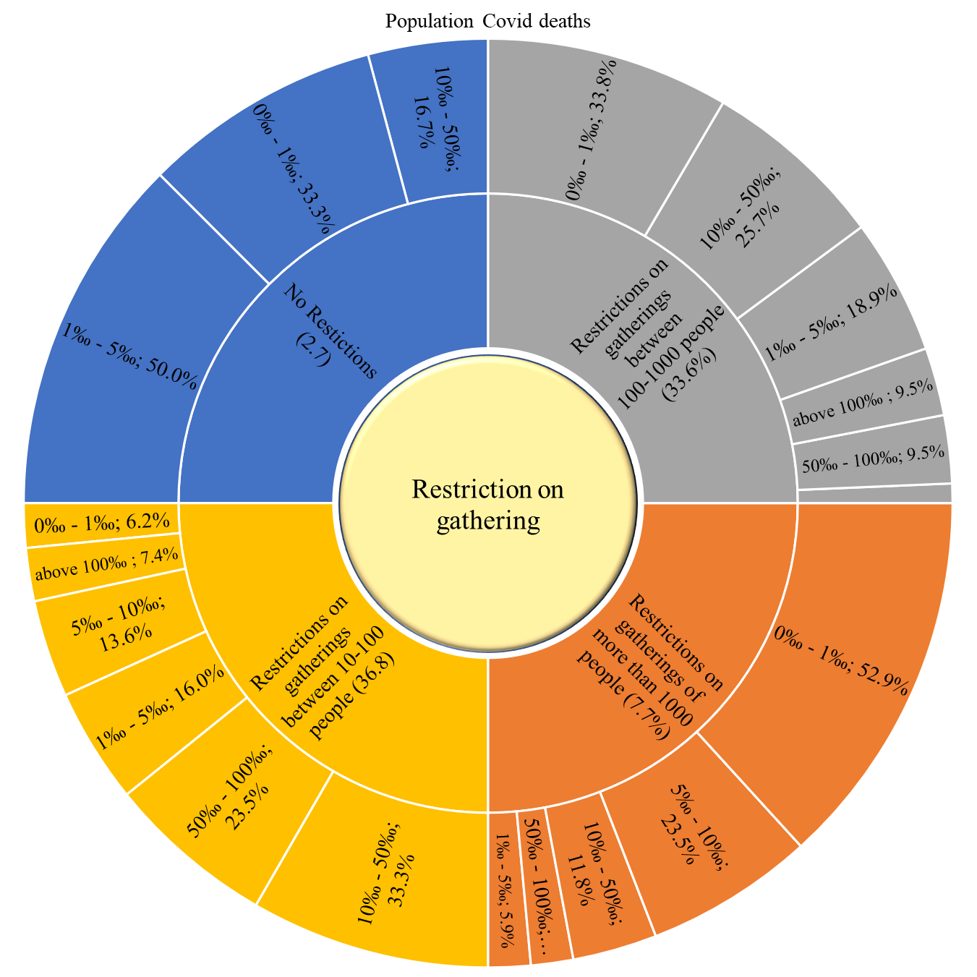
Figure 53. Covid-19 population deaths vs. restriction on gatherings policies.

Table 55. Covid-19 death of infection vs. restriction on gatherings policies.
Death of infection | No Restrictions | Restrictions on gatherings of more than 1000 people | Restrictions on gatherings between 100-1000 people | Restrictions on gatherings between 10-100 people | Restrictions on gatherings of less than 10 people | No Data
0‰ - 5‰ | 2 (33.3%) | 3 (17.6%) | 9 (12.2%) | 7 (8.6%) | 0 (0%) | 17 (41.5%)
5‰ - 10‰ | 1 (16.7%) | 3 (17.6%) | 12 (16.2%) | 10 (12.3%) | 0 (0%) | 5 (12.2%)
10‰ - 20‰ | 1 (16.7%) | 5 (29.4%) | 30 (40.5%) | 28 (34.6%) | 0 (0%) | 14 (34.1%)
20‰ - 30‰ | 0 (0%) | 1 (5.9%) | 13 (17.6%) | 26 (32.1%) | 0 (0%) | 1 (2.4%)
30‰ - 40‰ | 1 (16.7%) | 2 (11.8%) | 5 (6.8%) | 6 (7.4%) | 0 (0%) | 1 (2.4%)
40‰ - 50‰ | 0 (0%) | 2 (11.8%) | 2 (2.7%) | 2 (2.5%) | 1 (100%) | 1 (2.4%)
50‰ - 60‰ | 0 (0%) | 1 (5.9%) | 0 (0%) | 1 (1.2%) | 0 (0%) | 0 (0%)
60‰ - 70‰ | 0 (0%) | 0 (0%) | 2 (2.7%) | 1 (1.2%) | 0 (0%) | 1 (2.4%)
70‰ - 80‰ | 0 (0%) | 0 (0%) | 0 (0%) | 0 (0%) | 0 (0%) | 1 (2.4%)
80‰ - 90‰ | 0 (0%) | 0 (0%) | 1 (1.4%) | 0 (0%) | 0 (0%) | 0 (0%)
100‰ and above | 1 (16.7%) | 0 (0%) | 0 (0%) | 0 (0%) | 0 (0%) | 0 (0%)
Mean Death of infiction | 0.058 | 0.020 | 0.019 | 0.020 | - | 0.013
Std. Err. | 0.047 | 0.004 | 0.002 | 0.001 | - | 0.003
Mean 95% | 0.048 | 0.019 | 0.017 | 0.019 | - | 0.010

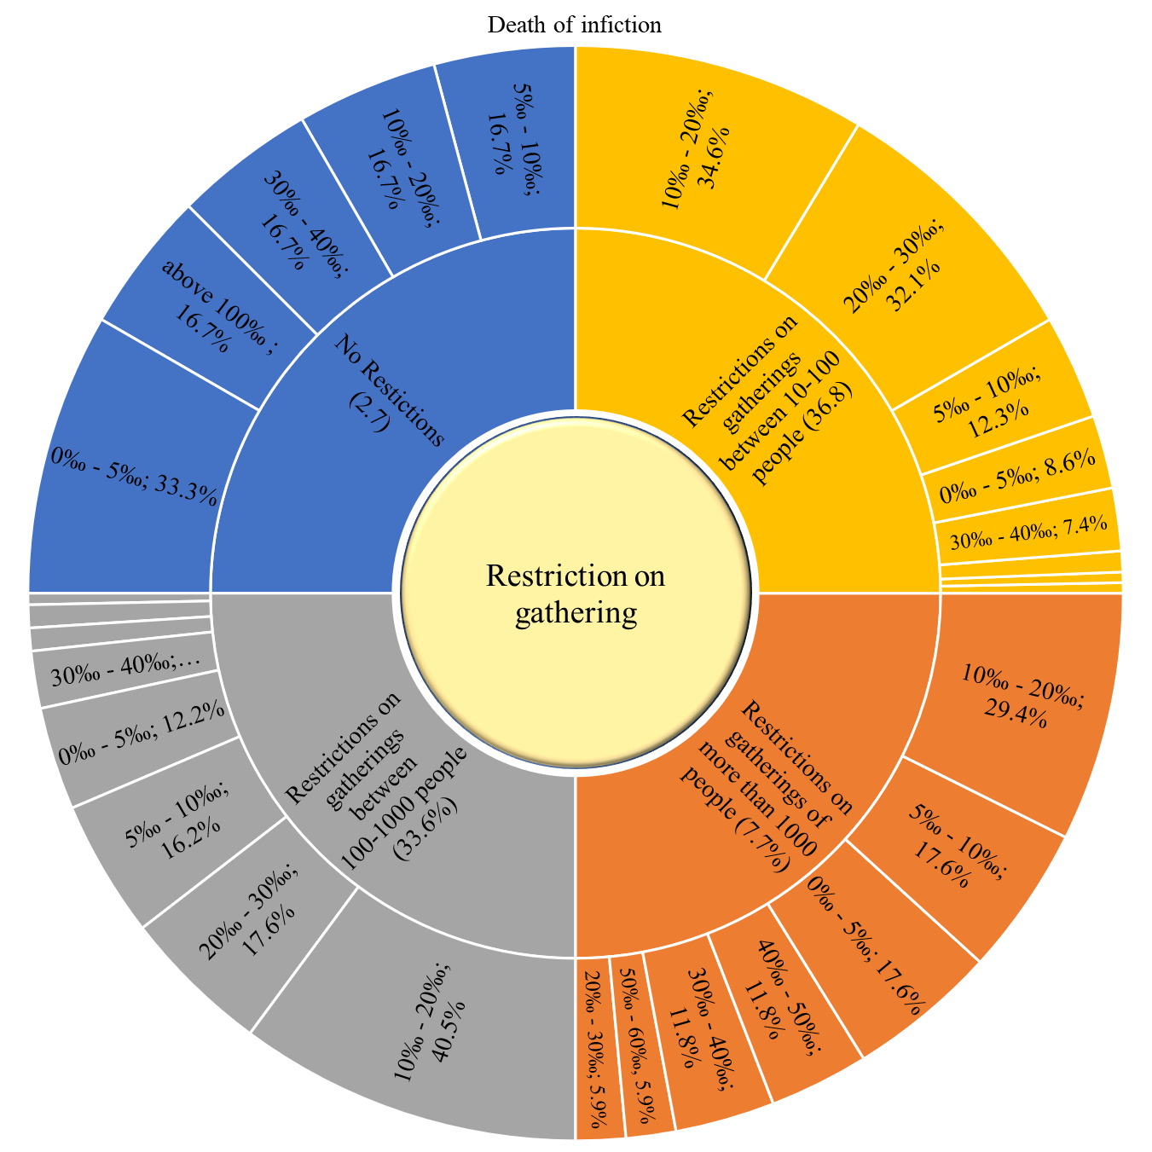
Figure 54. Covid-19 death of infection vs. restriction on gatherings policies.

School closer

Table 56. Distribution of school closure policies within countries.
School Closure | N (%)
No Measures | 6 (2.7%)
Recommend closing | 39 (17.7%)
Required in some categories (just high school or just public schools) | 133 (60.5%)
Required (all levels) | 1 (0.5%)
No data | 41 (18.6%)

Table 57. Covid-19 cumulative cases vs. school closure policies
Cumulative cases (Thousands) | No Measures | Recommend closing | Required in some categories (just highschool or just public schools) | Required (all levels) | No data
0 - 1 | 3 (50%) | 9 (23.1%) | 7 (5.3%) | 0 (0%) | 25 (61%)
1 - 10 | 0 (0%) | 13 (33.3%) | 24 (18%) | 0 (0%) | 10 (24.4%)
10 - 100 | 1 (16.7%) | 10 (25.6%) | 37 (27.8%) | 0 (0%) | 5 (12.2%)
100 - 200 | 1 (16.7%) | 1 (2.6%) | 23 (17.3%) | 1 (100%) | 1 (2.4%)
200 - 300 | 0 (0%) | 1 (2.6%) | 10 (7.5%) | 0 (0%) | 0 (0%)
300 - 400 | 0 (0%) | 1 (2.6%) | 3 (2.3%) | 0 (0%) | 0 (0%)
400 - 500 | 1 (16.7%) | 1 (2.6%) | 5 (3.8%) | 0 (0%) | 0 (0%)
500 - 600 | 0 (0%) | 0 (0%) | 3 (2.3%) | 0 (0%) | 0 (0%)
Above 600 | 0 (0%) | 3 (7.7%) | 21 (15.8%) | 0 (0%) | 0 (0%)
Mean cases | 110152.2 | 104695.0 | 581165.2 | - | 9343.1
Std. Err. | 74932.1 | 38339.9 | 178327.8 | - | 4410.8
Mean 95% | 97387.1 | 64389.1 | 250607.9 | - | 3744.2

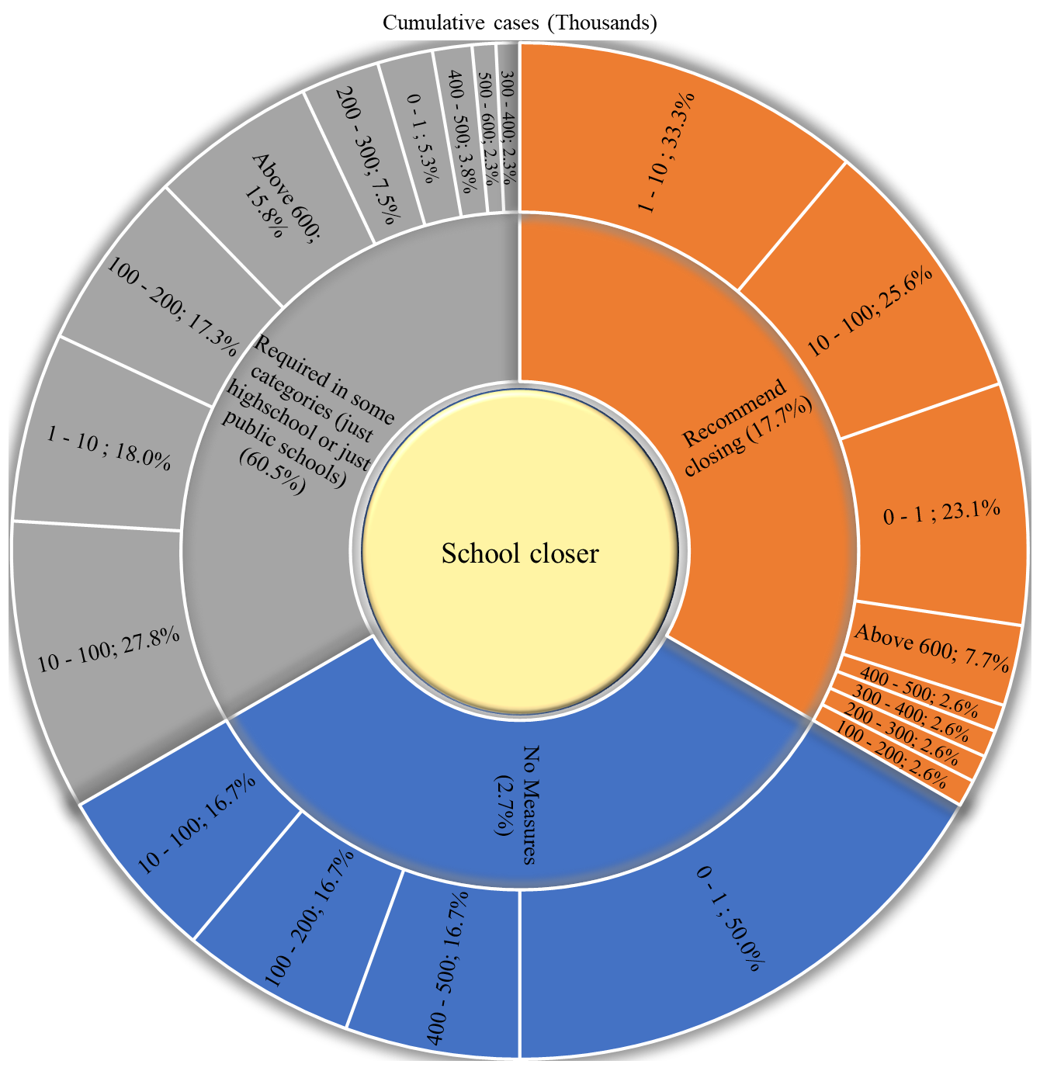
Figure 55. Covid-19 cumulative cases vs. school closure policies

Table 58. Covid-19 cumulative deaths vs. school closure policies
Cumulative deaths (Thousands) | No Measures | Recommend closing | Required in some categories (just highschool or just public schools) | Required (all levels) | No data
0 - 1 | 4 (66.7%) | 32 (82.1%) | 59 (44.4%) | 1 (100%) | 39 (95.1%)
1 - 5 | 1 (16.7%) | 2 (5.1%) | 40 (30.1%) | 0 (0%) | 2 (4.9%)
5 - 10 | 1 (16.7%) | 2 (5.1%) | 9 (6.8%) | 0 (0%) | 0 (0%)
10 - 20 | 0 (0%) | 2 (5.1%) | 8 (6%) | 0 (0%) | 0 (0%)
20 - 50 | 0 (0%) | 1 (2.6%) | 7 (5.3%) | 0 (0%) | 0 (0%)
50 - 100 | 0 (0%) | 0 (0%) | 6 (4.5%) | 0 (0%) | 0 (0%)
Above 100 | 0 (0%) | 0 (0%) | 4 (3%) | 0 (0%) | 0 (0%)
Mean death | 1428.8 | 2121.0 | 12930.4 | - | 166.4
Std. Err. | 1147.5 | 929.7 | 3409.3 | - | 91.2
Mean 95% | 1196.0 | 1015.6 | 6011.8 | - | 39.6

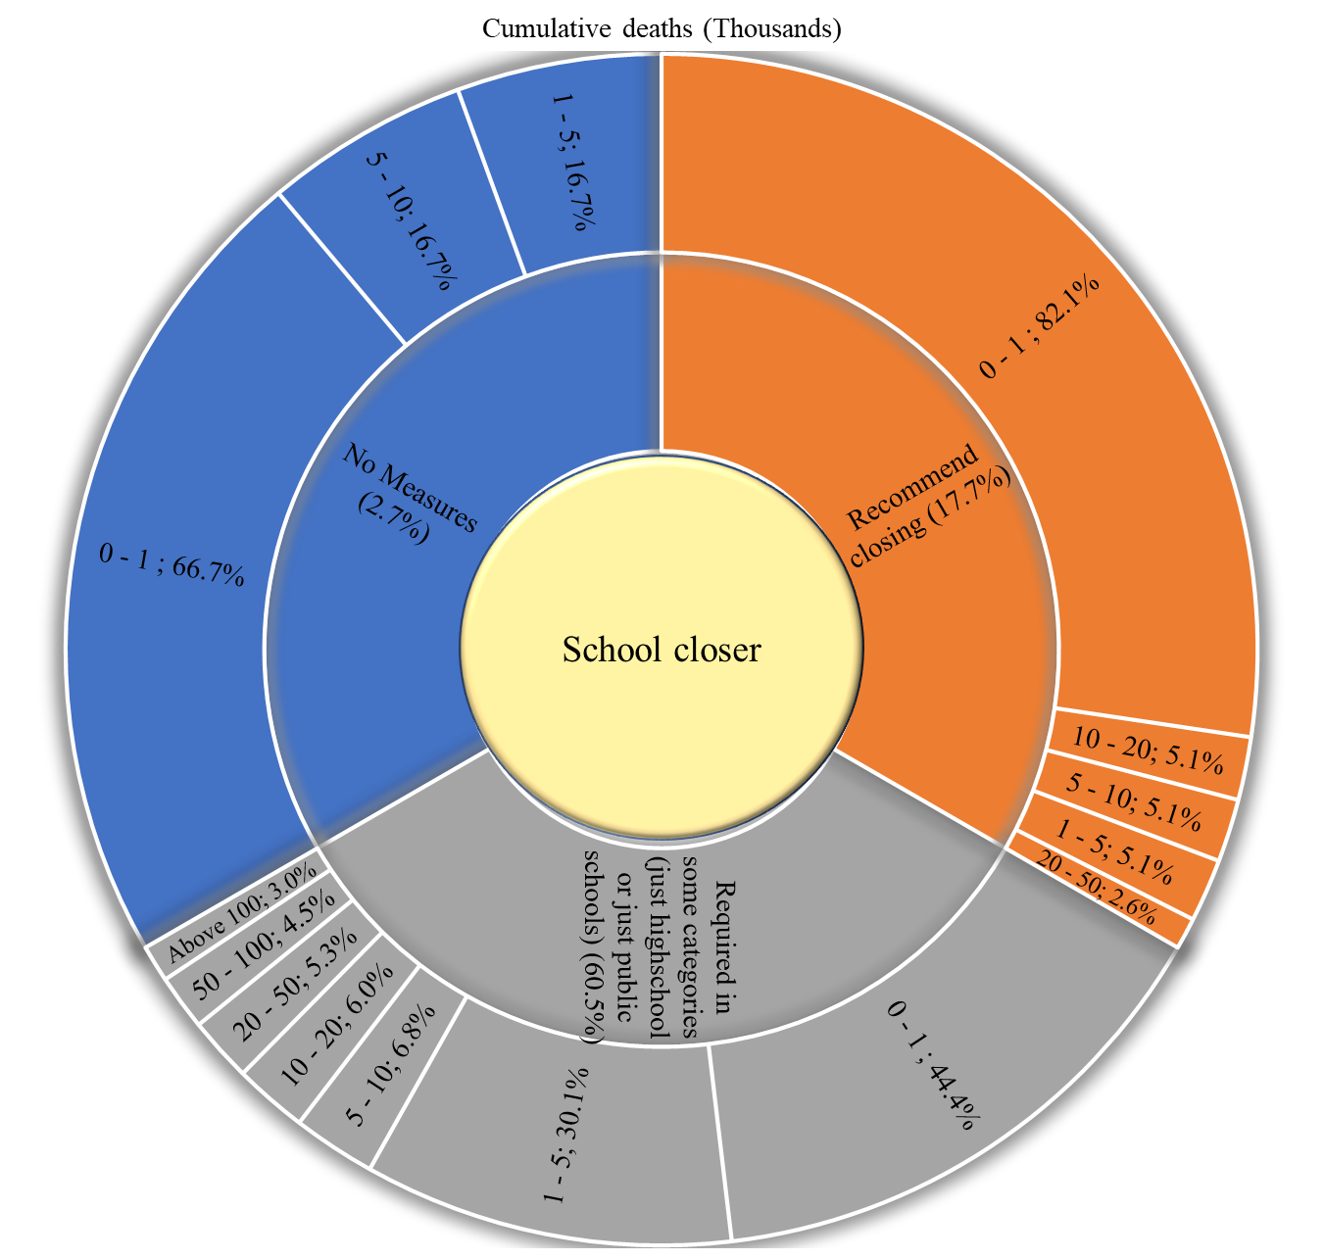
Figure 56. Covid-19 cumulative deaths vs. school closure policies

Table 59. Covid-19 population positive cases vs. school closure policies
Population positive cases | No Measures | Recommend closing | Required in some categories (just highschool or just public schools) | Required (all levels) | No data
0% - 0.1 % | 2 (33.3%) | 15 (38.5%) | 27 (20.3%) | 0 (0%) | 6 (14.6%)
0.1% - 0.5% | 1 (16.7%) | 6 (15.4%) | 27 (20.3%) | 0 (0%) | 14 (34.1%)
0.5% - 1% | 0 (0%) | 5 (12.8%) | 9 (6.8%) | 0 (0%) | 4 (9.8%)
1%- 2% | 1 (16.7%) | 3 (7.7%) | 21 (15.8%) | 0 (0%) | 2 (4.9%)
2% - 3% | 1 (16.7%) | 3 (7.7%) | 17 (12.8%) | 0 (0%) | 7 (17.1%)
3% - 4% | 0 (0%) | 0 (0%) | 17 (12.8%) | 1 (100%) | 2 (4.9%)
4% - 5% | 0 (0%) | 3 (7.7%) | 5 (3.8%) | 0 (0%) | 2 (4.9%)
5% - 6% | 1 (16.7%) | 2 (5.1%) | 8 (6%) | 0 (0%) | 1 (2.4%)
6% - 7% | 0 (0%) | 0 (0%) | 1 (0.8%) | 0 (0%) | 2 (4.9%)
7% - 8% | 0 (0%) | 1 (2.6%) | 1 (0.8%) | 0 (0%) | 1 (2.4%)
10% and above | 0 (0%) | 1 (2.6%) | 0 (0%) | 0 (0%) | 0 (0%)
Mean cases | 1.4 | 1.5 | 1.7 | - | 1.6
Std. Err. | 0.8 | 0.4 | 0.2 | - | 0.3
Mean 95% | 1.3 | 1.2 | 1.5 | - | 1.4

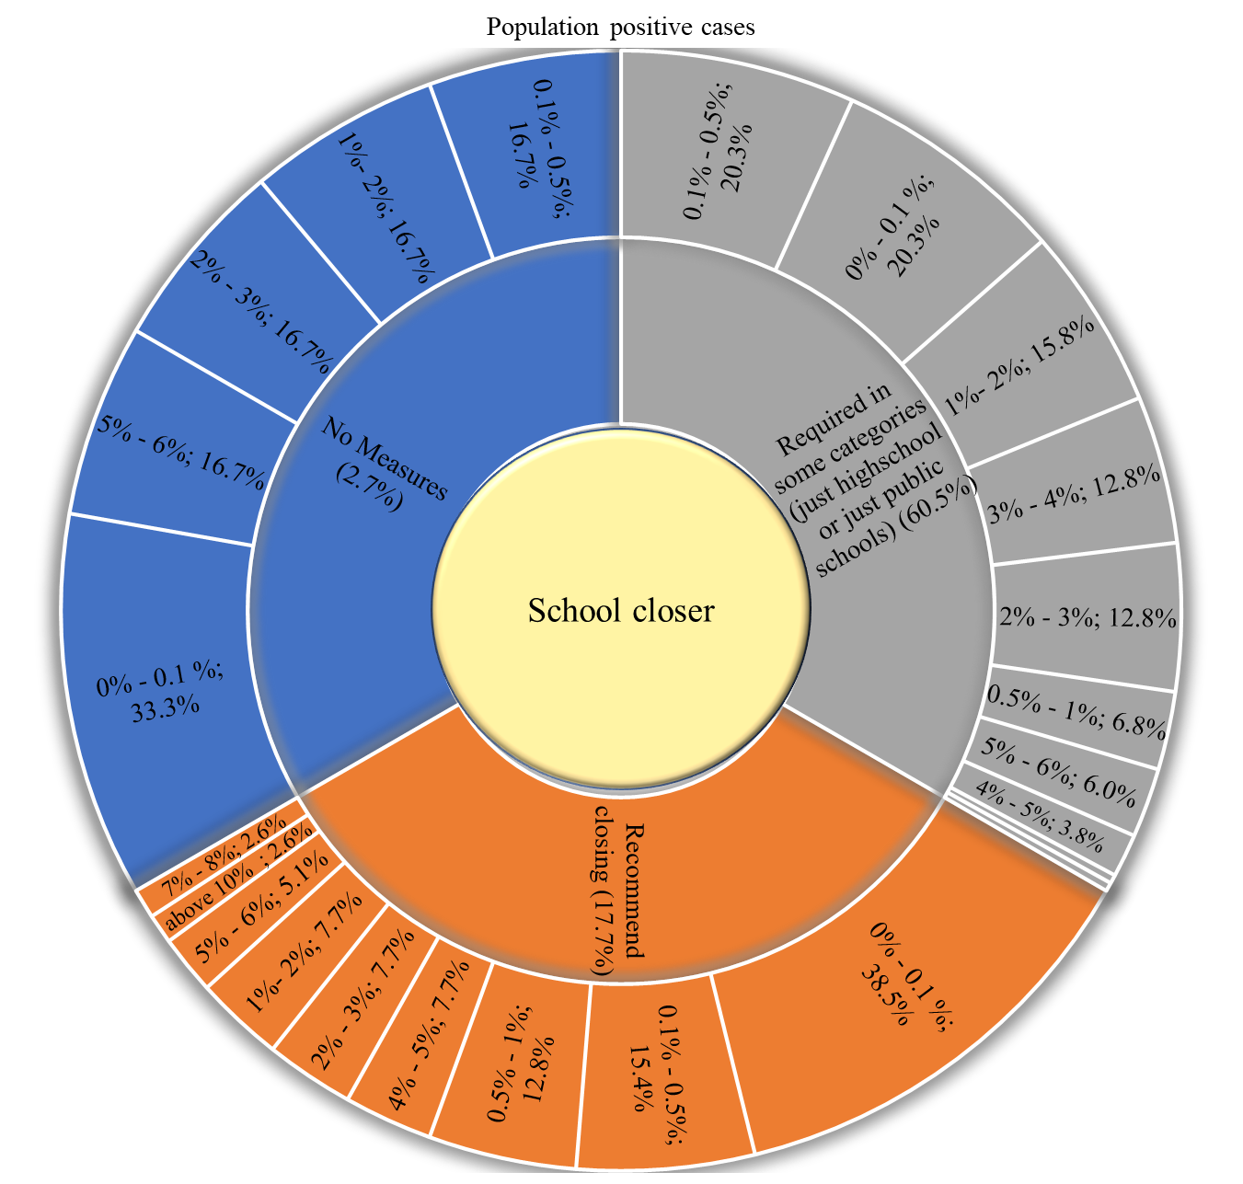
Figure 57. Covid-19 population positive cases vs. school closure policies

Table 60. Covid-19 population deaths vs. school closure policies.
Population Covid deaths | No Measures | Recommend closing | Required in some categories (just highschool or just public schools) | Required (all levels) | No data
0‰ - 1‰ | 4 (66.7%) | 17 (43.6%) | 21 (15.8%) | 0 (0%) | 13 (31.7%)
1‰ - 5‰ | 0 (0%) | 6 (15.4%) | 25 (18.8%) | 0 (0%) | 7 (17.1%)
5‰ - 10‰ | 0 (0%) | 4 (10.3%) | 13 (9.8%) | 0 (0%) | 5 (12.2%)
10‰ - 50‰ | 1 (16.7%) | 6 (15.4%) | 41 (30.8%) | 1 (100%) | 12 (29.3%)
50‰ - 100‰ | 1 (16.7%) | 4 (10.3%) | 22 (16.5%) | 0 (0%) | 2 (4.9%)
100‰ and above | 0 (0%) | 2 (5.1%) | 11 (8.3%) | 0 (0%) | 2 (4.9%)
Mean Population Covid | 0.016 | 0.021 | 0.033 | - | 0.019
Std. Err. | 0.013 | 0.006 | 0.003 | - | 0.005
Mean 95% | 0.014 | 0.016 | 0.030 | - | 0.014

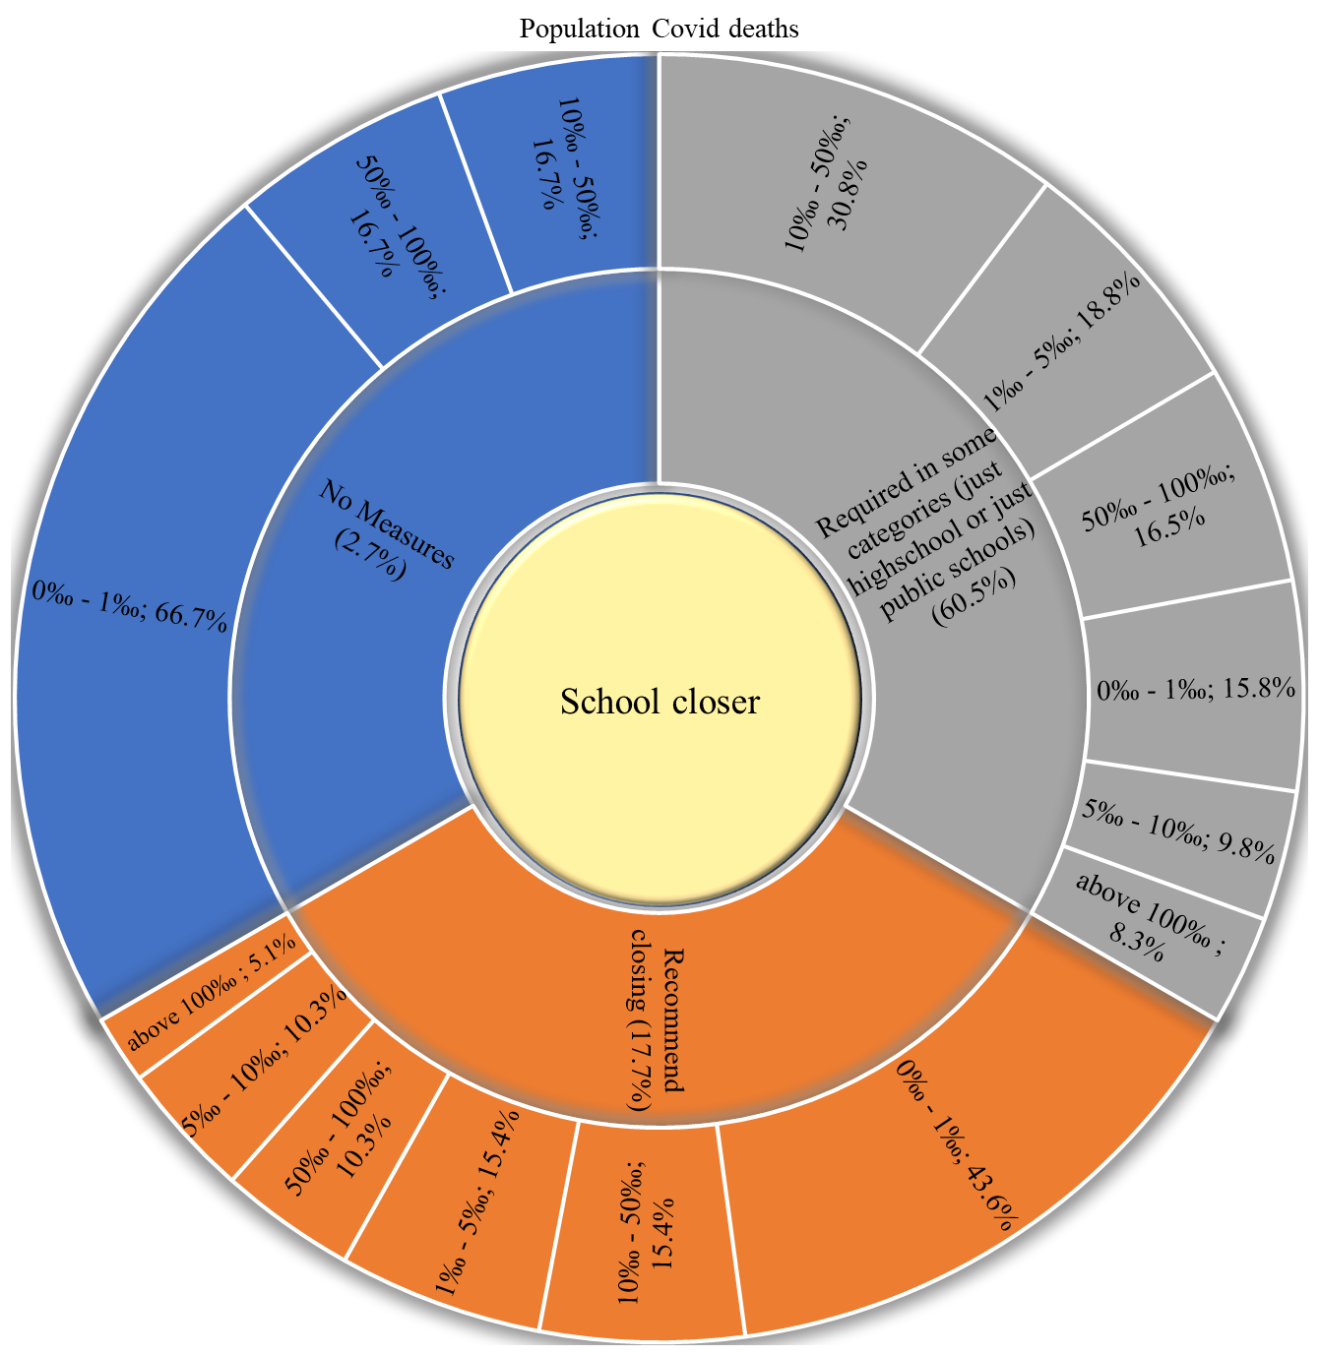
Figure 58. Covid-19 population deaths vs. school closure policies.

Table 61. Covid-19 death of infection vs. school closure policies.
Death of infection | No  Measures | Recommend closing | Required in some categories (just high school or just public schools) | Required (all levels) | No data
0‰ - 5‰ | 3 (50%) | 6 (15.4%) | 12 (9%) | 0 (0%) | 17 (41.5%)
5‰ - 10‰ | 2 (33.3%) | 9 (23.1%) | 14 (10.5%) | 1 (100%) | 5 (12.2%)
10‰ - 20‰ | 1 (16.7%) | 18 (46.2%) | 45 (33.8%) | 0 (0%) | 14 (34.1%)
20‰ - 30‰ | 0 (0%) | 1 (2.6%) | 39 (29.3%) | 0 (0%) | 1 (2.4%)
30‰ - 40‰ | 0 (0%) | 3 (7.7%) | 11 (8.3%) | 0 (0%) | 1 (2.4%)
40‰ - 50‰ | 0 (0%) | 2 (5.1%) | 5 (3.8%) | 0 (0%) | 1 (2.4%)
50‰ - 60‰ | 0 (0%) | 0 (0%) | 2 (1.5%) | 0 (0%) | 0 (0%)
60‰ - 70‰ | 0 (0%) | 0 (0%) | 3 (2.3%) | 0 (0%) | 1 (2.4%)
70‰ - 80‰ | 0 (0%) | 0 (0%) | 0 (0%) | 0 (0%) | 1 (2.4%)
80‰ - 90‰ | 0 (0%) | 0 (0%) | 1 (0.8%) | 0 (0%) | 0 (0%)
100‰ and above | 0 (0%) | 0 (0%) | 1 (0.8%) | 0 (0%) | 0 (0%)
Mean death | 0.005 | 0.014 | 0.023 | - | 0.013
Std. Err. | 0.002 | 0.002 | 0.002 | - | 0.003
Mean 95% | 0.005 | 0.013 | 0.020 | - | 0.010

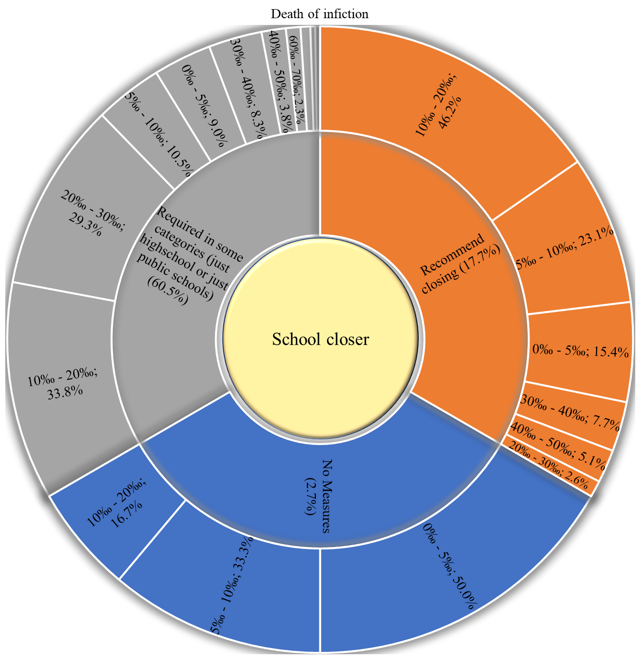
Figure 59. Covid-19 death of infection vs. school closure policies.

Testing policies
Table 62. Distribution of Covid-19 testing policies within countries.
Testing policies | N (%)
No testing policy | 3 (1.4%)
Symptoms and key groups | 76 (34.5%)
Anyone with symptoms | 94 (42.7%)
Open public testing (including asymptomatic) | 5 (2.3%)
Unknown | 42 (19.1%)

Table 63. Covid-19 cumulative cases vs. testing policies.
Cumulative cases (Thousands) | No testing policy | Symptoms and key groups | Anyone with symptoms | Open public testing (including asymptomatic) | Unknown
0 - 1 | 2 (66.7%) | 5 (6.6%) | 12 (12.8%) | 0 (0%) | 25 (59.5%)
1 - 10 | 1 (33.3%) | 21 (27.6%) | 13 (13.8%) | 1 (20%) | 11 (26.2%)
10 - 100 | 0 (0%) | 26 (34.2%) | 19 (20.2%) | 3 (60%) | 5 (11.9%)
100 - 200 | 0 (0%) | 11 (14.5%) | 15 (16%) | 0 (0%) | 1 (2.4%)
200 - 300 | 0 (0%) | 2 (2.6%) | 9 (9.6%) | 0 (0%) | 0 (0%)
300 - 400 | 0 (0%) | 2 (2.6%) | 2 (2.1%) | 0 (0%) | 0 (0%)
400 - 500 | 0 (0%) | 1 (1.3%) | 6 (6.4%) | 0 (0%) | 0 (0%)
500 - 600 | 0 (0%) | 1 (1.3%) | 2 (2.1%) | 0 (0%) | 0 (0%)
Above 600 | 0 (0%) | 7 (9.2%) | 16 (17%) | 1 (20%) | 0 (0%)
Mean cases | 877.0 | 162541.6 | 532692.1 | 3951759.2 | 9173.5
Std. Err. | 630.2 | 38509.7 | 145720.4 | 3906648.8 | 4307.8
Mean 95% | - | 102377.0 | 289636.2 | 3302699.1 | 3649.4

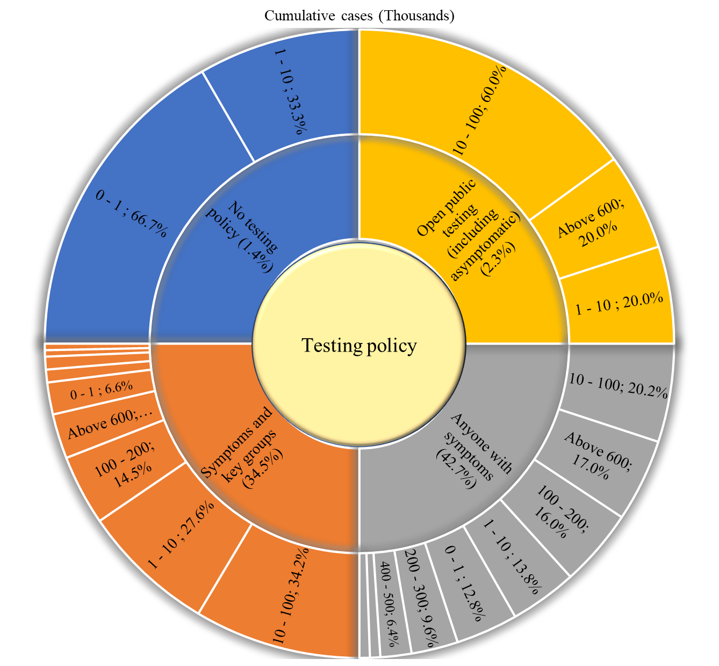
Figure 60. Covid-19 cumulative cases vs. testing policies.

Table 64. Covid-19 cumulative deaths vs. testing policies.
Cumulative deaths (Thousands) | No testing policy | Symptoms and key groups | Anyone with symptoms | Open public testing (including asymptomatic) | Unknown
0 - 1 | 3 (100%) | 45 (59.2%) | 44 (46.8%) | 3 (60%) | 40 (95.2%)
1 - 5 | 0 (0%) | 18 (23.7%) | 24 (25.5%) | 1 (20%) | 2 (4.8%)
5 - 10 | 0 (0%) | 5 (6.6%) | 7 (7.4%) | 0 (0%) | 0 (0%)
10 - 20 | 0 (0%) | 3 (3.9%) | 7 (7.4%) | 0 (0%) | 0 (0%)
20 - 50 | 0 (0%) | 3 (3.9%) | 5 (5.3%) | 0 (0%) | 0 (0%)
50 - 100 | 0 (0%) | 1 (1.3%) | 5 (5.3%) | 0 (0%) | 0 (0%)
Above 100 | 0 (0%) | 1 (1.3%) | 2 (2.1%) | 1 (20%) | 0 (0%)
Mean death | 210.7 | 5437.3 | 11196.6 | 69118.6 | 163.2
Std. Err. | 200.3 | 1925.1 | 2974.1 | 67613.3 | 89.1
Mean 95% | - | 2421.0 | 6081.5 | 57929.4 | 38.6

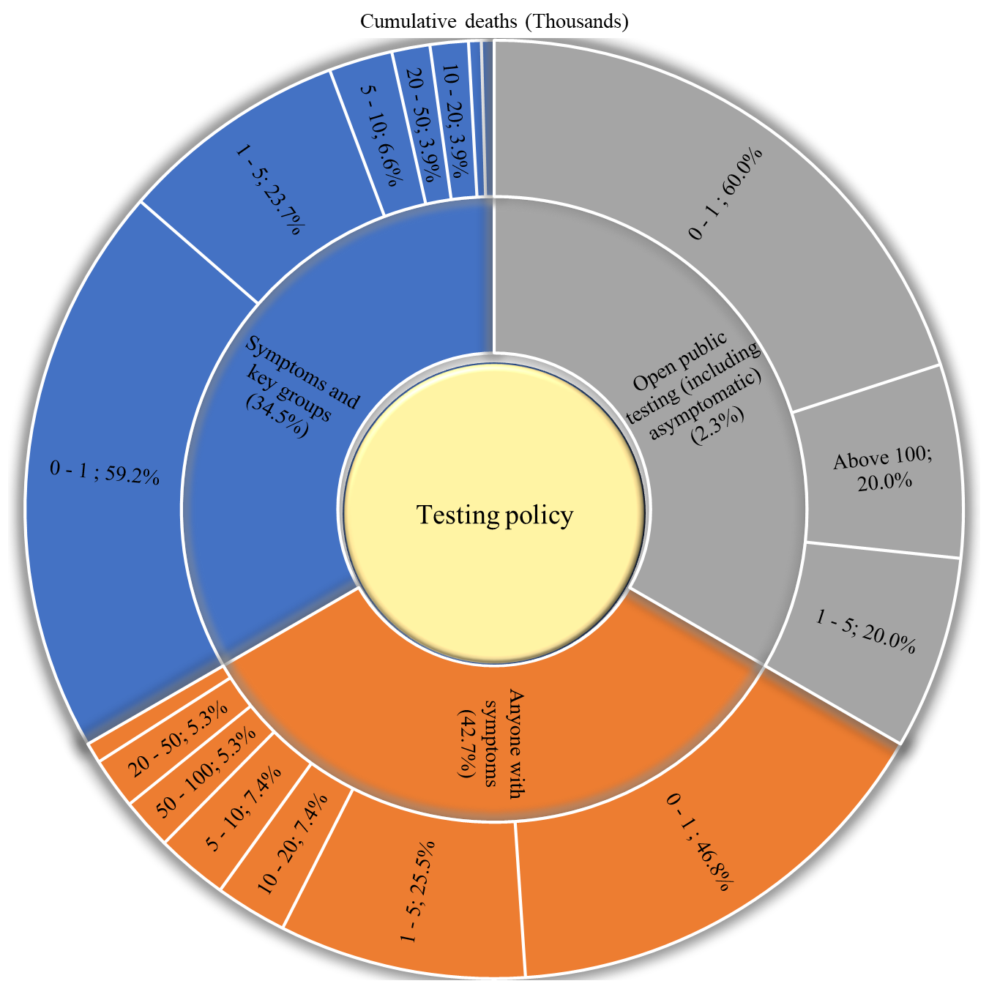
Figure 61. Covid-19 cumulative deaths vs. testing policies.

Table 65. Covid-19 population positive cases vs. testing policies.
Population positive cases | No testing policy | Symptoms and key groups | Anyone with symptoms | Open public testing (including asymptomatic) | Unknown
0% - 0.1 % | 3 (100%) | 26 (34.2%) | 13 (13.8%) | 2 (40%) | 6 (14.3%)
0.1% - 0.5% | 0 (0%) | 14 (18.4%) | 19 (20.2%) | 1 (20%) | 14 (33.3%)
0.5% - 1% | 0 (0%) | 7 (9.2%) | 7 (7.4%) | 0 (0%) | 4 (9.5%)
1%- 2% | 0 (0%) | 11 (14.5%) | 14 (14.9%) | 0 (0%) | 2 (4.8%)
2% - 3% | 0 (0%) | 7 (9.2%) | 13 (13.8%) | 1 (20%) | 7 (16.7%)
3% - 4% | 0 (0%) | 8 (10.5%) | 10 (10.6%) | 0 (0%) | 2 (4.8%)
4% - 5% | 0 (0%) | 1 (1.3%) | 7 (7.4%) | 0 (0%) | 2 (4.8%)
5% - 6% | 0 (0%) | 2 (2.6%) | 7 (7.4%) | 1 (20%) | 2 (4.8%)
6% - 7% | 0 (0%) | 0 (0%) | 1 (1.1%) | 0 (0%) | 2 (4.8%)
7% - 8% | 0 (0%) | 0 (0%) | 2 (2.1%) | 0 (0%) | 1 (2.4%)
10% and above | 0 (0%) | 0 (0%) | 1 (1.1%) | 0 (0%) | 0 (0%)
Mean Population positive | 0.0 | 1.1 | 2.1 | 1.8 | 1.7
Std. Err. | 0.0 | 0.2 | 0.2 | 1.2 | 0.3
Mean 95% | - | 1.0 | 1.9 | 1.7 | 1.5

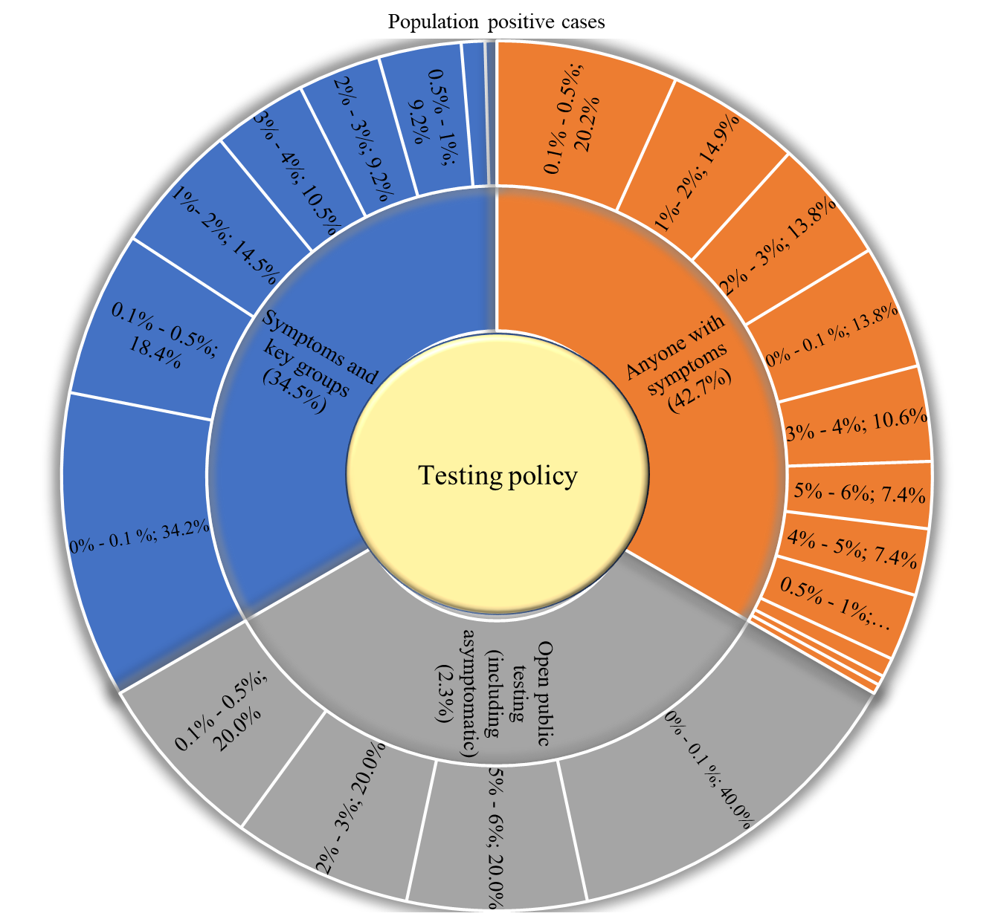
Figure 62. Covid-19 population positive cases vs. testing policies.

Table 66. Covid-19 population positive deaths vs. testing policies.
Population Covid deaths | No testing policy | Symptoms and key groups | Anyone with symptoms | Open public testing (including asymptomatic) | Unknown
0‰ - 1‰ | 2 (66.7%) | 20 (26.3%) | 18 (19.1%) | 2 (40%) | 13 (31%)
1‰ - 5‰ | 1 (33.3%) | 16 (21.1%) | 13 (13.8%) | 1 (20%) | 7 (16.7%)
5‰ - 10‰ | 0 (0%) | 8 (10.5%) | 9 (9.6%) | 0 (0%) | 5 (11.9%)
10‰ - 50‰ | 0 (0%) | 18 (23.7%) | 30 (31.9%) | 1 (20%) | 12 (28.6%)
50‰ - 100‰ | 0 (0%) | 11 (14.5%) | 15 (16%) | 0 (0%) | 3 (7.1%)
100‰ and above | 0 (0%) | 3 (3.9%) | 9 (9.6%) | 1 (20%) | 2 (4.8%)
Mean deaths | 0.001 | 0.024 | 0.035 | 0.031 | 0.020
Std. Err. | 0.001 | 0.004 | 0.004 | 0.020 | 0.005
Mean 95% | - | 0.020 | 0.031 | 0.029 | 0.016

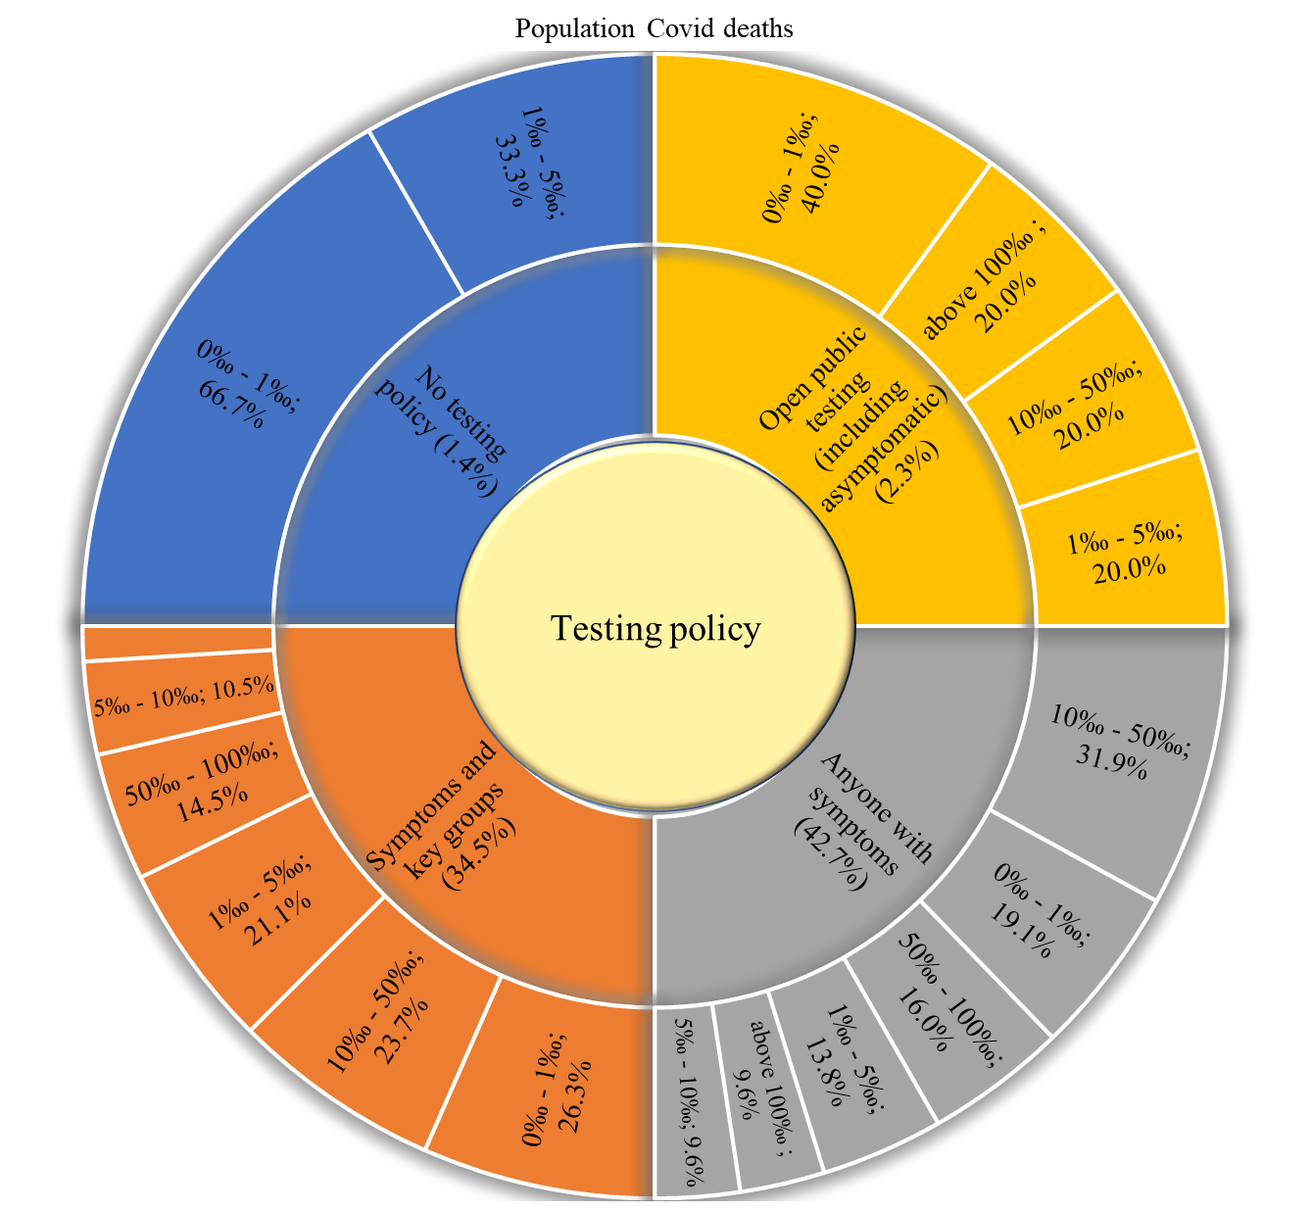
Figure 63. Covid-19 population positive deaths vs. testing policies.

Table 67. Covid-19 death of infection vs. testing policies.
Death of infiction | No testing policy | Symptoms and key groups | Anyone with symptoms | Open public testing (including asymptomatic) | Unknown
0‰ - 5‰ | 1 (33.3%) | 7 (9.2%) | 13 (13.8%) | 0 (0%) | 17 (40.5%)
5‰ - 10‰ | 0 (0%) | 11 (14.5%) | 15 (16%) | 0 (0%) | 5 (11.9%)
10‰ - 20‰ | 0 (0%) | 22 (28.9%) | 37 (39.4%) | 4 (80%) | 15 (35.7%)
20‰ - 30‰ | 0 (0%) | 21 (27.6%) | 19 (20.2%) | 0 (0%) | 1 (2.4%)
30‰ - 40‰ | 0 (0%) | 7 (9.2%) | 7 (7.4%) | 0 (0%) | 1 (2.4%)
40‰ - 50‰ | 1 (33.3%) | 3 (3.9%) | 2 (2.1%) | 1 (20%) | 1 (2.4%)
50‰ - 60‰ | 0 (0%) | 2 (2.6%) | 0 (0%) | 0 (0%) | 0 (0%)
60‰ - 70‰ | 0 (0%) | 2 (2.6%) | 1 (1.1%) | 0 (0%) | 1 (2.4%)
70‰ - 80‰ | 0 (0%) | 0 (0%) | 0 (0%) | 0 (0%) | 1 (2.4%)
80‰ - 90‰ | 0 (0%) | 1 (1.3%) | 0 (0%) | 0 (0%) | 0 (0%)
100‰ and above | 1 (33.3%) | 0 (0%) | 0 (0%) | 0 (0%) | 0 (0%)
Mean death | 0.111 | 0.022 | 0.017 | 0.022 | 0.013
Std. Err. | 0.091 | 0.002 | 0.001 | 0.007 | 0.003
Mean 95% | - | 0.021 | 0.016 | 0.021 | 0.010

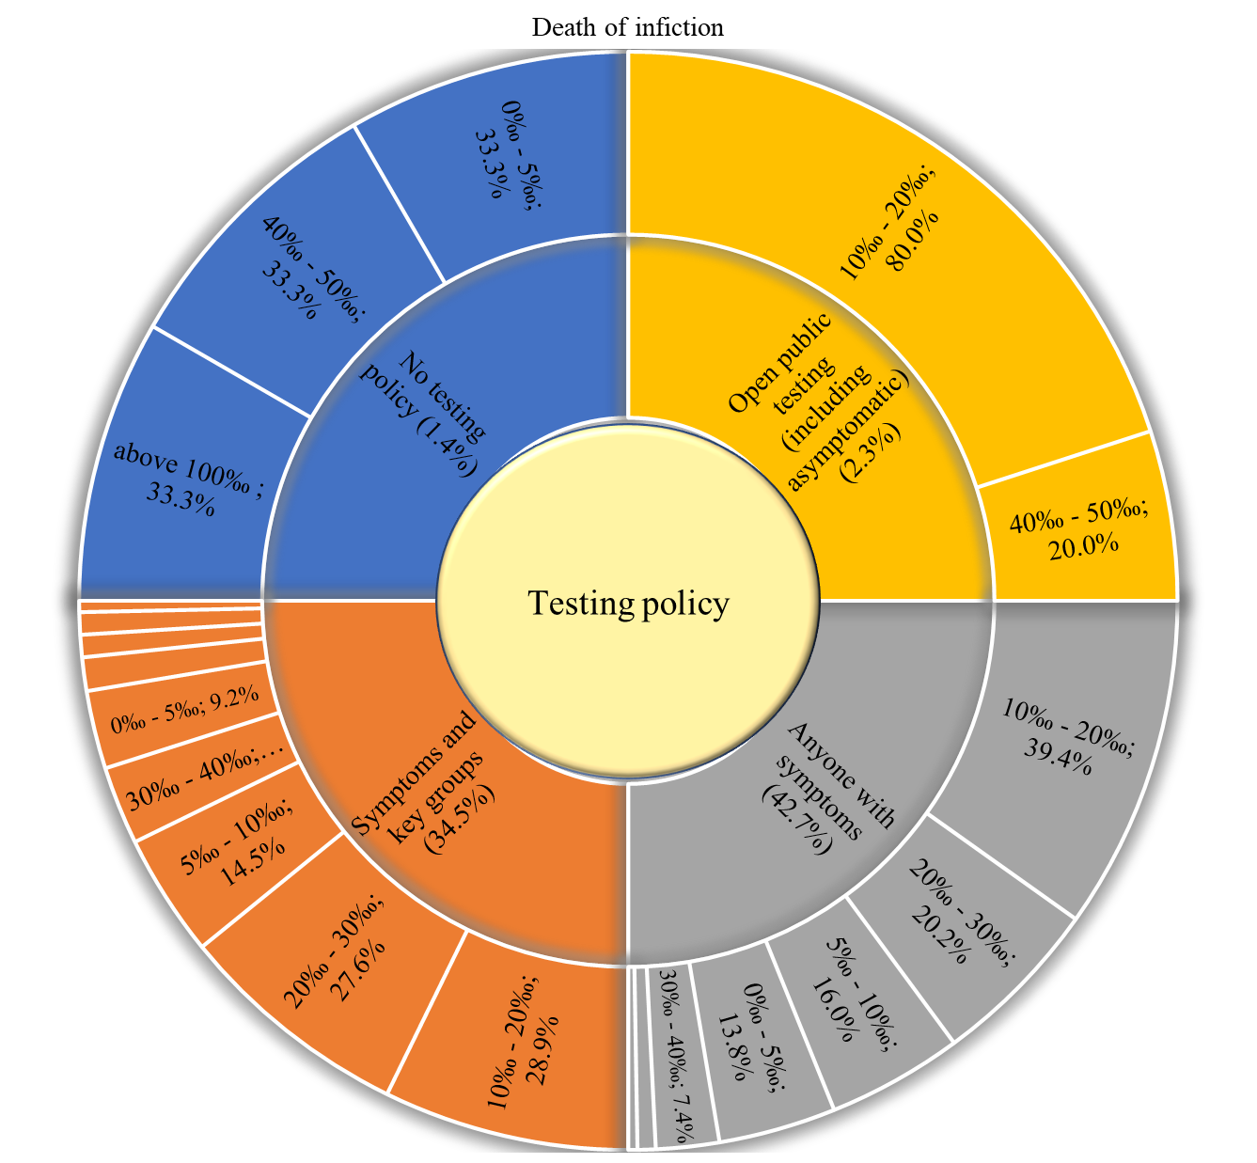
Figure 64. Covid-19 death of infection vs. testing policies.

International travel control
Table 68. Distribution of international travel control policies within countries.
International travel controls | N (%)
Screening | 13 (5.9%)
Quarantine arrivals from high-risk regions | 85 (38.6%)
Ban on High-risk regions | 78 (35.5%)
Total Border Closure | 3 (1.4%)
Unknown | 41 (18.6%)

Table 69. Covid-19 cumulative cases vs. international travel control policies
Cumulative cases (Thousands) | Screening | Quarantine arrivals from high-risk regions | Ban on High-risk regions | Total Border Closure | Unknown
0 - 1 | 2 (15.4%) | 10 (11.8%) | 7 (9%) | 0 (0%) | 25 (61%)
1 - 10 | 4 (30.8%) | 17 (20%) | 14 (17.9%) | 2 (66.7%) | 10 (24.4%)
10 - 100 | 4 (30.8%) | 26 (30.6%) | 17 (21.8%) | 1 (33.3%) | 5 (12.2%)
100 - 200 | 0 (0%) | 15 (17.6%) | 11 (14.1%) | 0 (0%) | 1 (2.4%)
200 - 300 | 0 (0%) | 5 (5.9%) | 6 (7.7%) | 0 (0%) | 0 (0%)
300 - 400 | 1 (7.7%) | 1 (1.2%) | 2 (2.6%) | 0 (0%) | 0 (0%)
400 - 500 | 0 (0%) | 4 (4.7%) | 3 (3.8%) | 0 (0%) | 0 (0%)
500 - 600 | 0 (0%) | 2 (2.4%) | 1 (1.3%) | 0 (0%) | 0 (0%)
Above 600 | 2 (15.4%) | 5 (5.9%) | 17 (21.8%) | 0 (0%) | 0 (0%)
Mean cases | 333922.4 | 237826.5 | 738489.3 | 10484.3 | 9343.1
Std. Err. | 206554.2 | 93280.7 | 285195.4 | 8972.9 | 4410.8
Mean 95% | 229770.5 | 110262.5 | 315802.4 | - | 3744.2

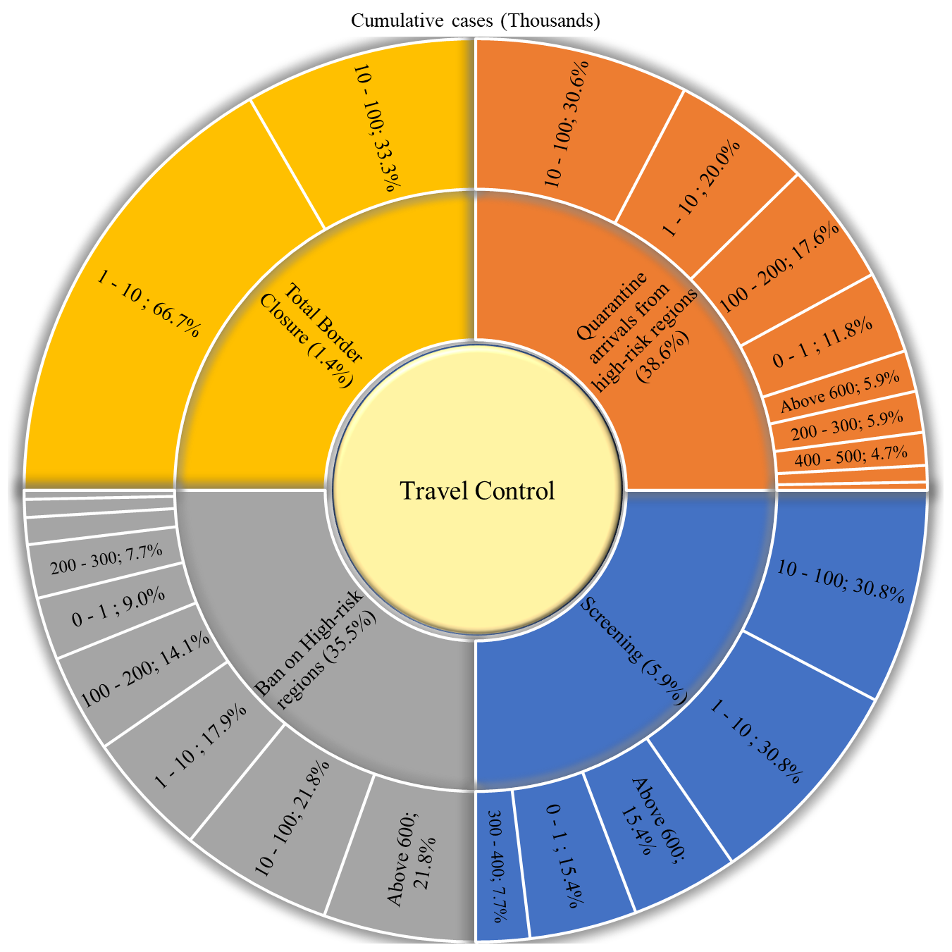
Figure 65. Covid-19 cumulative cases vs. international travel control policies

Table 70. Covid-19 cumulative deaths vs. international travel control policies
Cumulative deaths (Thousands) | Screening | Quarantine arrivals from high-risk regions | Ban on High-risk regions | Total Border Closure | Unknown
0 - 1 | 7 (53.8%) | 49 (57.6%) | 37 (47.4%) | 3 (100%) | 39 (95.1%)
1 - 5 | 4 (30.8%) | 20 (23.5%) | 19 (24.4%) | 0 (0%) | 2 (4.9%)
5 - 10 | 0 (0%) | 8 (9.4%) | 4 (5.1%) | 0 (0%) | 0 (0%)
10 - 20 | 0 (0%) | 5 (5.9%) | 5 (6.4%) | 0 (0%) | 0 (0%)
20 - 50 | 0 (0%) | 1 (1.2%) | 7 (9%) | 0 (0%) | 0 (0%)
50 - 100 | 2 (15.4%) | 0 (0%) | 4 (5.1%) | 0 (0%) | 0 (0%)
Above 100 | 0 (0%) | 2 (2.4%) | 2 (2.6%) | 0 (0%) | 0 (0%)
Mean deaths | 10635.2 | 6271.1 | 14612.0 | 311.3 | 166.4
Std. Err. | 6748.8 | 2712.3 | 4942.2 | 298.9 | 91.2
Mean 95% | 7698.8 | 2208.5 | 7384.6 | - | 39.6

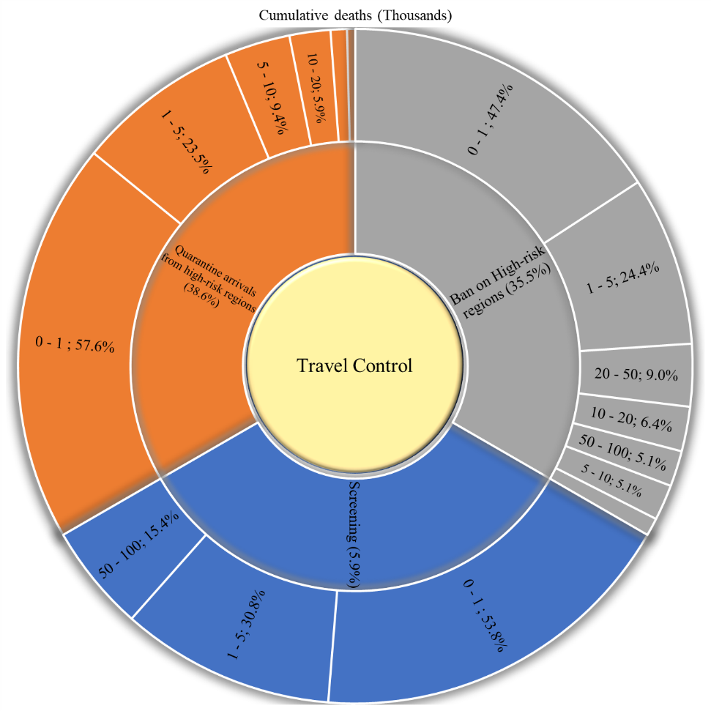
Figure 66. Covid-19 cumulative deaths vs. international travel control policies

Table 71. Covid-19 population positive cases vs. international travel control policies
Population positive cases | Screening | Quarantine arrivals from high-risk regions | Ban on High-risk regions | Total Border Closure | Unknown
0% - 0.1 % | 2 (15.4%) | 24 (28.2%) | 16 (20.5%) | 2 (66.7%) | 6 (14.6%)
0.1% - 0.5% | 1 (7.7%) | 19 (22.4%) | 13 (16.7%) | 1 (33.3%) | 14 (34.1%)
0.5% - 1% | 0 (0%) | 4 (4.7%) | 10 (12.8%) | 0 (0%) | 4 (9.8%)
1%- 2% | 3 (23.1%) | 10 (11.8%) | 12 (15.4%) | 0 (0%) | 2 (4.9%)
2% - 3% | 2 (15.4%) | 10 (11.8%) | 9 (11.5%) | 0 (0%) | 7 (17.1%)
3% - 4% | 2 (15.4%) | 5 (5.9%) | 11 (14.1%) | 0 (0%) | 2 (4.9%)
4% - 5% | 0 (0%) | 5 (5.9%) | 3 (3.8%) | 0 (0%) | 2 (4.9%)
5% - 6% | 1 (7.7%) | 7 (8.2%) | 3 (3.8%) | 0 (0%) | 1 (2.4%)
6% - 7% | 0 (0%) | 0 (0%) | 1 (1.3%) | 0 (0%) | 2 (4.9%)
7% - 8% | 1 (7.7%) | 1 (1.2%) | 0 (0%) | 0 (0%) | 1 (2.4%)
10% and above | 1 (7.7%) | 0 (0%) | 0 (0%) | 0 (0%) | 0 (0%)
Mean cases | 3.2 | 1.5 | 1.6 | 0.1 | 1.6
Std. Err. | 0.9 | 0.2 | 0.2 | 0.0 | 0.3
Mean 95% | 2.9 | 1.4 | 1.5 | - | 1.4

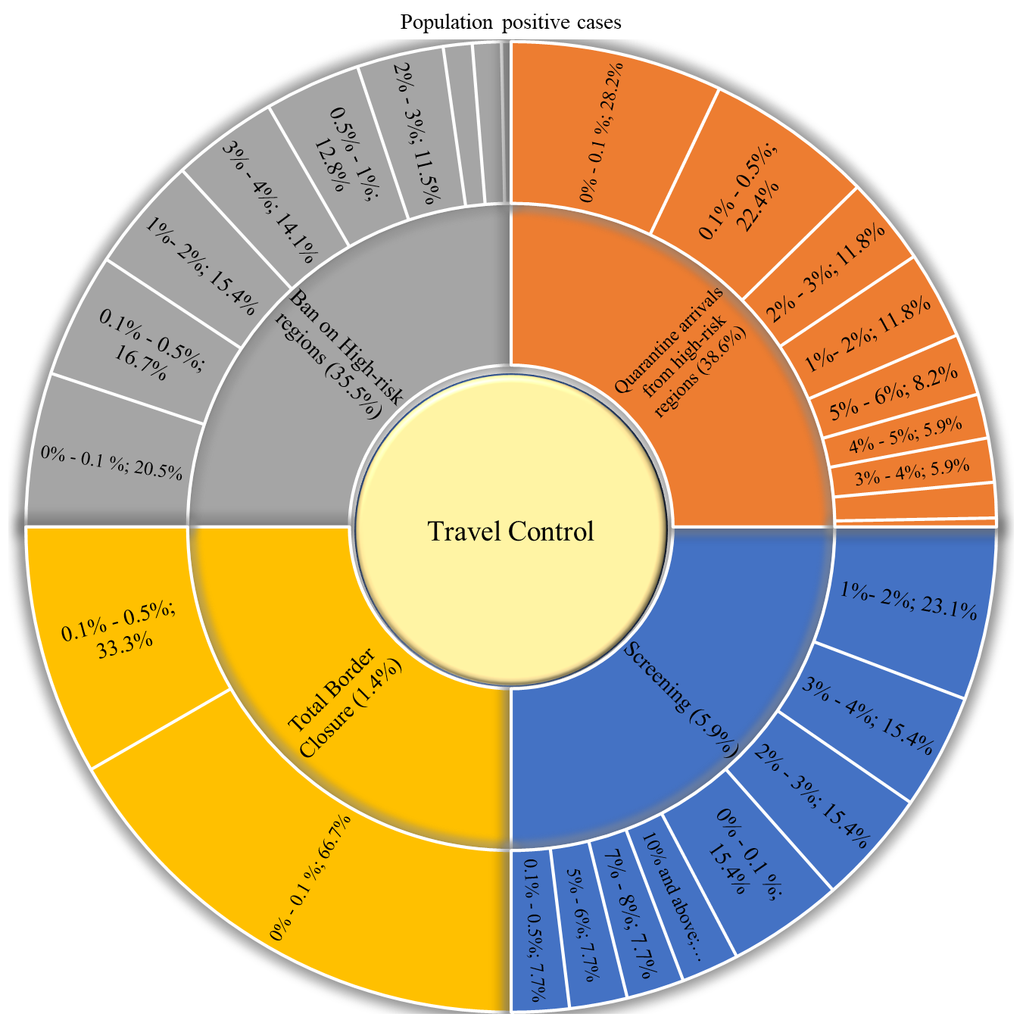
Figure 67. Covid-19 population positive cases vs. international travel control policies

Table 72. Covid-19 population positive deaths vs. international travel control policies
Population Covid deaths | Screening | Quarantine arrivals from high-risk regions | Ban on High-risk regions | Total Border Closure | Unknown
0‰ - 1‰ | 2 (15.4%) | 23 (27.1%) | 15 (19.2%) | 2 (66.7%) | 13 (31.7%)
1‰ - 5‰ | 1 (7.7%) | 17 (20%) | 12 (15.4%) | 1 (33.3%) | 7 (17.1%)
5‰ - 10‰ | 1 (7.7%) | 7 (8.2%) | 9 (11.5%) | 0 (0%) | 5 (12.2%)
10‰ - 50‰ | 3 (23.1%) | 20 (23.5%) | 26 (33.3%) | 0 (0%) | 12 (29.3%)
50‰ - 100‰ | 4 (30.8%) | 14 (16.5%) | 9 (11.5%) | 0 (0%) | 2 (4.9%)
100‰ and above | 2 (15.4%) | 4 (4.7%) | 7 (9%) | 0 (0%) | 2 (4.9%)
Mean deaths | 0.048 | 0.027 | 0.030 | 0.001 | 0.019
Std. Err. | 0.011 | 0.004 | 0.004 | 0.001 | 0.005
Mean 95% | 0.048 | 0.023 | 0.027 |  | 0.014

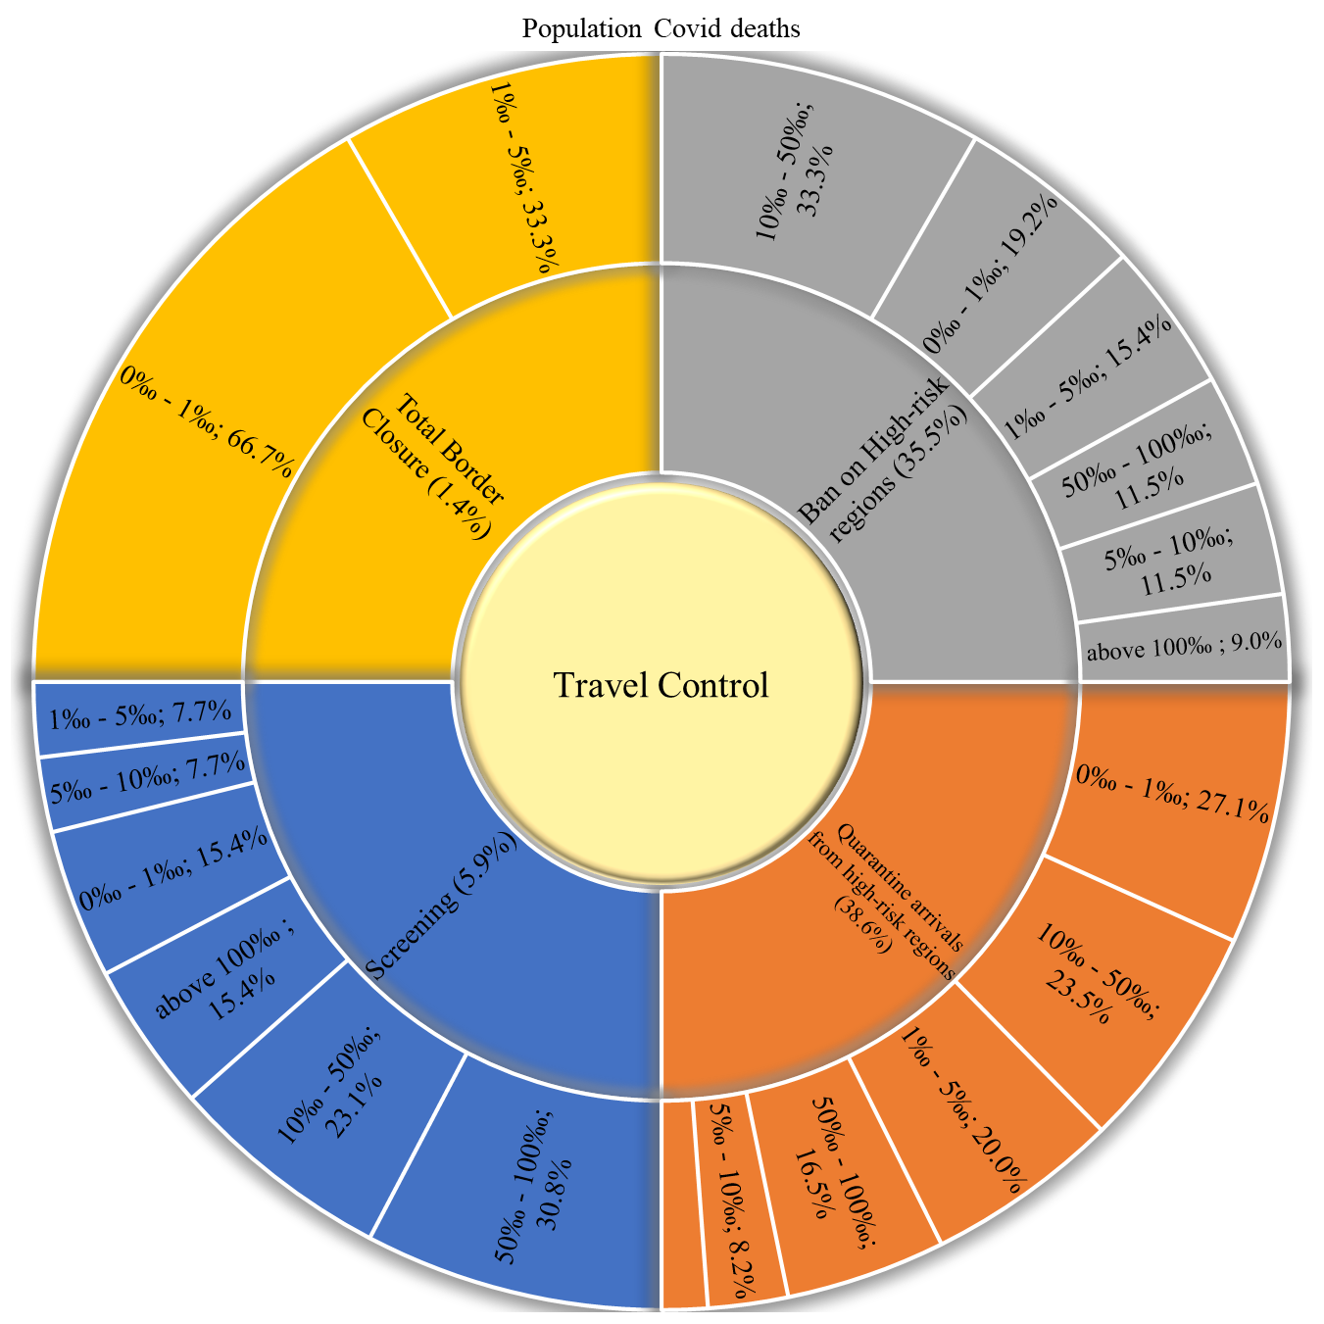
Figure 68. Covid-19 population positive deaths vs. international travel control policies

Table 73. Covid-19 death of infection vs. international travel control policies.
Death of infection | Screening | Quarantine arrivals from high-risk regions | Ban on High-risk regions | Total Border Closure | Unknown
0‰ - 5‰ | 1 (7.7%) | 9 (10.6%) | 10 (12.8%) | 1 (33.3%) | 17 (41.5%)
5‰ - 10‰ | 1 (7.7%) | 13 (15.3%) | 12 (15.4%) | 0 (0%) | 5 (12.2%)
10‰ - 20‰ | 4 (30.8%) | 35 (41.2%) | 24 (30.8%) | 1 (33.3%) | 14 (34.1%)
20‰ - 30‰ | 3 (23.1%) | 13 (15.3%) | 24 (30.8%) | 0 (0%) | 1 (2.4%)
30‰ - 40‰ | 1 (7.7%) | 7 (8.2%) | 5 (6.4%) | 1 (33.3%) | 1 (2.4%)
40‰ - 50‰ | 3 (23.1%) | 3 (3.5%) | 1 (1.3%) | 0 (0%) | 1 (2.4%)
50‰ - 60‰ | 0 (0%) | 2 (2.4%) | 0 (0%) | 0 (0%) | 0 (0%)
60‰ - 70‰ | 0 (0%) | 2 (2.4%) | 1 (1.3%) | 0 (0%) | 1 (2.4%)
70‰ - 80‰ | 0 (0%) | 0 (0%) | 0 (0%) | 0 (0%) | 1 (2.4%)
80‰ - 90‰ | 0 (0%) | 1 (1.2%) | 0 (0%) | 0 (0%) | 0 (0%)
100‰ and above | 0 (0%) | 0 (0%) | 1 (1.3%) | 0 (0%) | 0 (0%)
Mean death | 0.023 | 0.020 | 0.021 | 0.015 | 0.013
Std. Err. | 0.004 | 0.002 | 0.004 | 0.009 | 0.003
Mean 95% | 0.023 | 0.018 | 0.018 |  | 0.010

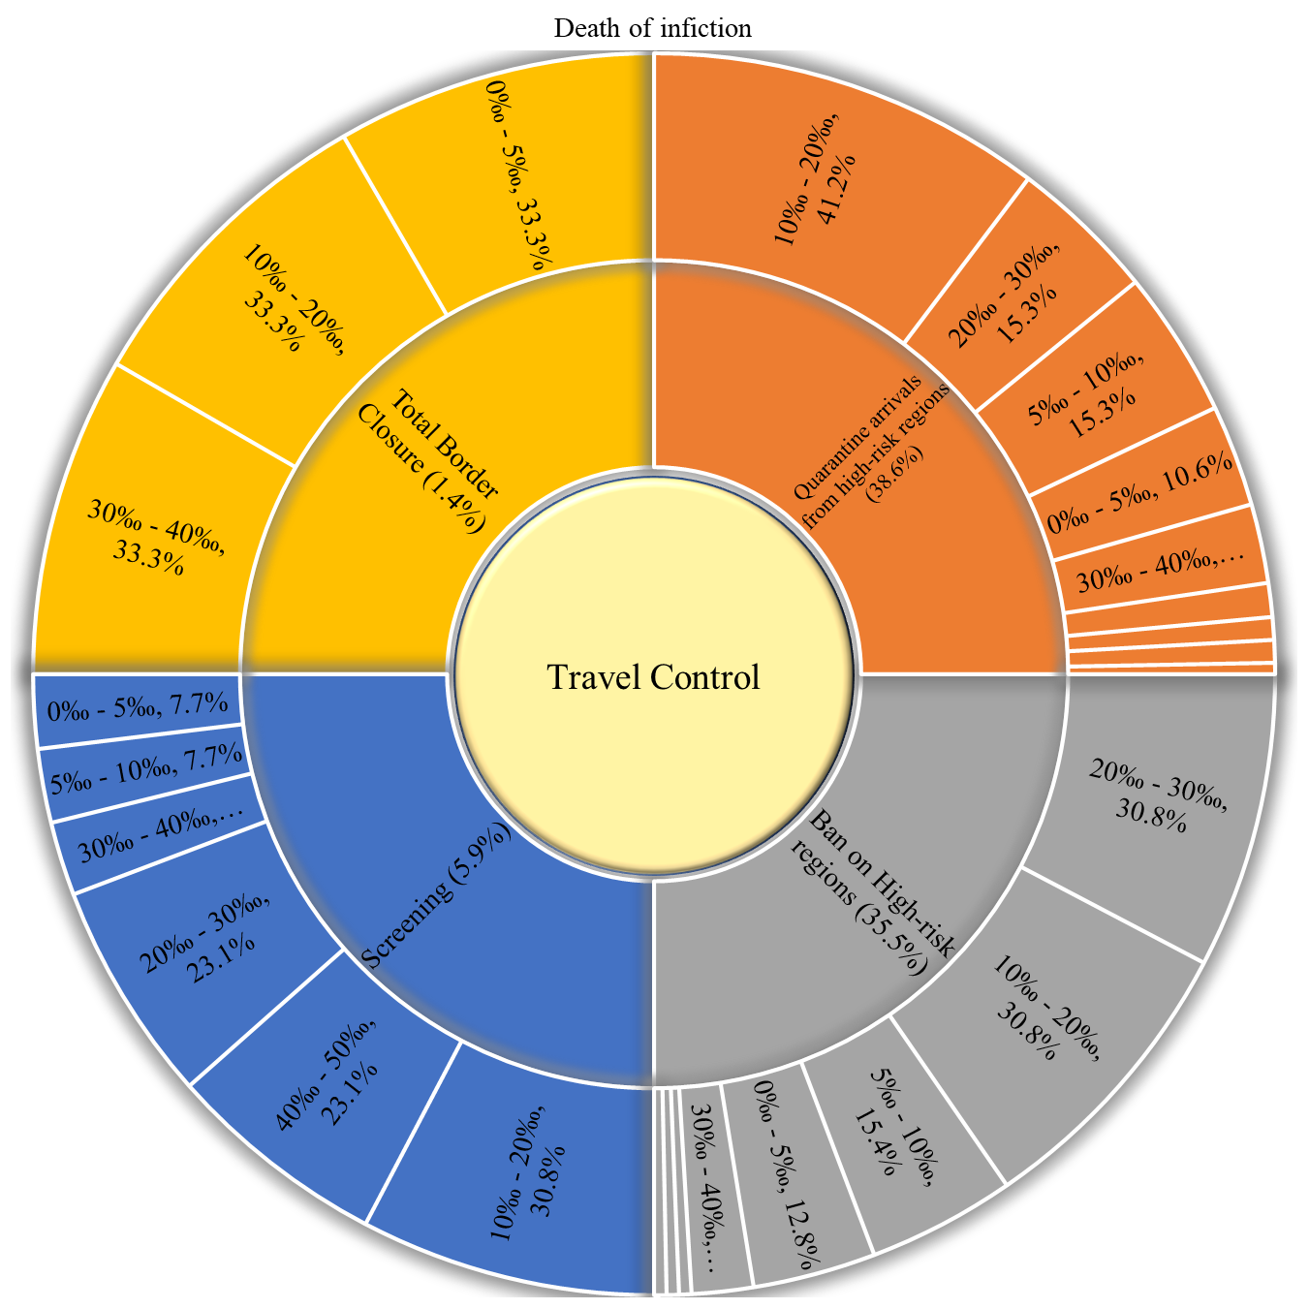
Figure 69. Covid-19 death of infection vs. international travel control policies.

Test of associations
The association (relationships) between the country related factors and Covid-19 dependent variables are studied in this section. The tests of associations are divided into two groups.
- Associations of Covid-19 dependent variables and categorical variables.
- Associations of Covid-19 dependent variables and scale variables.
Considering that all variables failed to follow the Normal distribution as detailed in section ‎2.2.4, the non-parametric tests are to be used. The associations between the variables in category 1 are performed using:
- The Kruskal-Wallis H test for variables that have three or more groups.
- The Mann-Whitney test for variables that have only two groups.
Both Kruskal-Wallis and Mann-Whitney tests examine the null hypothesis that the groups of the studied variable have the same median. When the test is significant, this means that the mean ranks of the groups are different, and the association (relationship) is significant. Hence, a comparison between the mean rank of the groups is to be done to determine the groups with higher or lower effects. The mean rank of the groups with a single entry will be the same as its actual rank. Therefore, when it has the highest or the lowest rank, the comparison with the other entries will be meaningless. Hence, any group with a single entry will be considered in the test of association, however, will be removed from the comparisons with other entries in case of a significant test.
The associations between the variables in category 2 are performed by calculating the Spearman correlation coefficient (R). Spearman correlation is a non-parametric test that is used to find correlations between non-normally distributed variables. The spearman correlation coefficient describes the power of the correlation and the direction of the relationship as well. A positive correlation coefficient indicates a direct relationship between the variables. On the contrary, a negative coefficient indicates an inverse relationship. The power of the relationship is interpreted as follows:
- R is between 0 – 0.4 indicates a low correlation.
- R is between 0.4 – 0.7 indicates a medium correlation.
- R is between 0.7 – 1 indicates a high correlation.

Country related variables
The effects of country related variables on Covid-19 variables are detailed in Table 74 and Table 75.
Table 74. Climate test of association.
Climate | Mean Rank
 | Cumulative cases | Cumulative deaths | Population Positive cases | Population COVID deaths | Death of infection
Tropical | 121.2 | 121.4 | 126.4 | 126.5 | 116.5
Dry | 90.1 | 81.8 | 82.0 | 69.4 | 82.2
Temperate | 102.1 | 103.2 | 99.1 | 102.2 | 110.9
Cold/Continental | 123.3 | 123.9 | 113.7 | 114.8 | 108.4
Polar | 134.0 | 135.0 | 63.0 | 69.0 | 104.0
Mix climate | 101.3 | 104.7 | 99.1 | 102.9 | 111.8
Z | 7.4 | 9.4 | 14.6 | 18.4 | 5.7
Sig. | 0.194 | 0.096 | 0.012 | 0.002 | 0.334
Conclusion | Insignificant | Insignificant | Significant | Significant | Insignificant
- Polar climate is removed from the comparisons as it is a single entry.
- Climate has a significant effect on the population positive cases and population deaths. Countries with Tropical climate has the highest population positive cases/deaths, followed by a cold climate, Mix climate, and Temperate climate. Countries with Dry climate has the lowest population positive cases and deaths.
Table 75. Country factors correlation matrix.
Country Factor |  | Cumulative cases | Cumulative deaths | Population Positive cases | Population COVID deaths | Death of infection
Land Country area (km2) | R | 0.551** | 0.591** | -0.214** | 0.033 | 0.387**
 | Sig. | <0.001 | <0.001 | 0.001 | 0.618 | <0.001
Latitude | R | 0.328** | 0.319** | 0.500** | 0.445** | 0.047
 | Sig. | <0.001 | <0.001 | <0.001 | <0.001 | 0.480
Urbanization | R | 0.298** | 0.242** | 0.457** | 0.366** | -0.052
 | Sig. | <0.001 | <0.001 | <0.001 | <0.001 | 0.435
**. Correlation is significant.
- The land country area has a:
  - significant, medium, direct effect on cumulative cases.
  - significant, medium, direct effect on cumulative deaths.
  - Significant, low, inverse effect on population positive cases.
  - Significant, low, direct effect on the death of infection.
- Latitude has a:
  - significant, low, direct effect on cumulative cases.
  - significant, low, direct effect on cumulative deaths.
  - Significant, medium, direct effect on population positive cases.
  - Significant, medium, direct effect on population deaths.
- Urbanization has a:
  - significant, low, direct effect on cumulative cases.
  - significant, low, direct effect on cumulative deaths.
  - Significant, medium, direct effect on population positive cases.
  - Significant, low, direct effect on population deaths.

Politics related variables
The effects of politics related variables on Covid-19 variables are detailed in Table 76 to Table 81.
Table 76. Government type test of association.
 | Mean Rank (Order)
Government type | Cumulative cases |  | Cumulative deaths |  | Population Positive cases |  |  | Population COVID deaths |  | Death of infection
Full Presidential Republic | 120.27 | 3 | 122.53 | 3 |  | 90.93 | 7 | 102.51 | 5 | 124.08 | 2
Semi-Presidential Republic | 103.36 | 5 | 100.54 | 4 |  | 113.16 | 5 | 104.30 | 4 | 98.02 | 5
Parliamentary Republic | 135.53 | 2 | 137.30 | 2 |  | 129.20 | 4 | 136.55 | 2 | 127.29 | 1
Parliamentary Constitutional Monarchy | 156.79 | 1 | 150.68 | 1 |  | 139.93 | 2 | 140.18 | 1 | 111.89 | 4
Parliamentary Democracy | 46.82 | 8 | 48.03 | 8 |  | 107.25 | 6 | 90.88 | 7 | 82.24 | 7
Constitutional Monarchy | 102.75 | 6 | 84.13 | 7 |  | 148.38 | 1 | 113.81 | 3 | 48.69 | 8
Absolute Monarchy | 103.67 | 4 | 97.67 | 5 |  | 131.67 | 3 | 95.08 | 6 | 90.42 | 6
One Party State Dictatorship | 75.75 | 7 | 85.13 | 6 |  | 17.25 | 8 | 32.63 | 8 | 117.38 | 3
Z | 55.2 |  | 55.4 |  | 26.8 |  |  | 23.3 |  | 23.4
Sig. | <0.001 |  | <0.001 |  | <0.001 |  |  | 0.002 |  | 0.001
Conclusion | Significant |  | Significant |  | Significant |  |  | Significant |  | Significant
- Government type has a significant effect on:
  - Cumulative cases. Parliamentary Constitutional Monarchy countries have the highest cumulative cases. Followed by, Parliamentary Republic, Full Presidential Republic, Full Presidential Republic, Absolute Monarchy, Semi-Presidential Republic, Constitutional Monarchy, and One-Party State/Dictatorship. Parliamentary Democracy countries have the lowest cases.
  - Cumulative deaths. Parliamentary Constitutional Monarchy countries have the highest cumulative deaths. Followed by, Parliamentary Republic, Full Presidential Republic, Presidential Republic, Absolute Monarchy, One Party State/Dictatorship, and Constitutional Monarchy. Parliamentary Democracy countries have the lowest deaths.
  - Population Positive cases. Constitutional Monarchy countries have the highest population positive cases. Followed by Parliamentary Constitutional Monarchy, Absolute Monarchy, Parliamentary Republic, Semi-Presidential Republic, Parliamentary Democracy, and Full Presidential Republic. One Party State/Dictatorship countries have the lowest cases.
  - Population COVID deaths. Parliamentary Constitutional Monarchy countries have the highest Population COVID deaths. Followed by Parliamentary Republic, Constitutional Monarchy, Semi-Presidential Republic, Full Presidential Republic, Absolute Monarchy, and Parliamentary Democracy. One Party State Dictatorship has the lowest deaths.
  - Death of infection. The Parliamentary Republic countries have the highest Death of infection rate. Followed by the Full Presidential Republic, One Party State Dictatorship, Parliamentary Constitutional Monarchy, Semi-Presidential Republic, Absolute Monarchy, and Parliamentary Democracy. Constitutional Monarchy countries have the lowest death rate.

Table 77. Leader education test of association.
 | Mean Rank
Leader Education (University degree) | Cumulative cases | Cumulative deaths | Population Positive cases | Population COVID deaths | Death of infection
Bachelor | 115.19 | 118.13 | 112.04 | 116.69 | 124.79
Masters | 105.53 | 99.67 | 130.04 | 117.39 | 89.82
Doctorate | 119.67 | 122.14 | 114.27 | 119.55 | 119.45
None | 111.80 | 114.34 | 86.43 | 97.91 | 120.34
Unknown | 80.91 | 74.38 | 82.69 | 64.44 | 64.88
Z | 4.931 | 9.124 | 13.218 | 11.835 | 19.512
Sig. | 0.294 | 0.058 | 0.010 | 0.019 | 0.001
Conclusion | Insignificant | Insignificant | Significant | Significant | Significant

- Leader Education (University degree) has a significant effect on:
  - Population Positive cases. Countries with its leader holding a Masters degree have the highest population positive cases. Followed by countries with leaders holding Doctorate, and Bachelor degree. Countries with leaders that have no degree have the lowest cases.
  - Population COVID deaths. Countries with its leader holding a Doctorate degree have the highest population positive cases. Followed by countries with leaders holding Masters degree and Bachelor degree. Countries with leaders that have no degree have the lowest deaths.
  - Death of infection. Countries with its leader holding a Bachelor degree have the highest death of infection rate. Followed by countries with leaders holding no degree and Doctorate degree. Countries with leaders that have Masters degree have the lowest rate.

Table 78. Leader employment type test of association.
 | Mean Rank (Order)
Leader Employment | Cumulative cases |  | Cumulative deaths |  | Population Positive cases |  | Population COVID deaths |  | Death of infection
Administration | 50.00 | 11 | 46.00 | 11 | 52.75 | 11 | 43.00 | 11 | 30.75 | 12
Arts | 54.75 | 10 | 50.63 | 10 | 61.75 | 8 | 65.63 | 7 | 50.38 | 11
Business Administration | 64.57 | 6 | 67.43 | 6 | 59.00 | 9 | 63.86 | 9 | 82.00 | 4
Economics | 78.87 | 4 | 81.00 | 4 | 70.04 | 6 | 73.15 | 4 | 76.72 | 5
History | 55.44 | 9 | 56.11 | 9 | 80.11 | 2 | 69.33 | 6 | 59.67 | 9
Law | 89.87 | 2 | 90.61 | 2 | 88.58 | 1 | 93.39 | 1 | 83.32 | 3
Literature | 37.21 | 12 | 38.68 | 12 | 75.57 | 3 | 71.43 | 5 | 68.50 | 6
Medicine | 69.00 | 5 | 75.58 | 5 | 64.33 | 7 | 74.92 | 3 | 88.25 | 2
Military academy | 64.14 | 7 | 63.11 | 7 | 39.86 | 12 | 40.32 | 12 | 64.18 | 7
Philosophy Public affairs | 59.13 | 8 | 57.30 | 8 | 72.73 | 5 | 60.43 | 10 | 55.57 | 10
Politics | 98.50 | 1 | 91.30 | 1 | 74.10 | 4 | 74.95 | 2 | 62.05 | 8
Public Administration | 84.00 | 3 | 81.13 | 3 | 57.00 | 10 | 64.50 | 8 | 96.75 | 1
Z | 26.829 |  | 26.061 |  | 16.838 |  | 20.726 |  | 15.115
Sig. | 0.005 |  | 0.006 |  | 0.113 |  | 0.036 |  | 0.177
Conclusion | Significant |  | Significant |  | Insignificant |  | Significant |  | Insignificant

- Leader Employment has a significant effect on:
  - Population Positive cases. Countries with leaders employed in Politics have the highest cumulative cases. Followed by countries with leaders employed in Law and Public Administration. Countries with leaders employed in Literature have the lowest cumulative cases.
  - Cumulative deaths. The order of effecting groups is similar to the cumulative cases variable.
  - Population COVID deaths. Countries with leaders employed in Law have the highest population Covid deaths. Followed by countries with leaders employed in Politics and medicine. Countries with leaders employed in the Military academy have the lowest cumulative cases.
Table 79. Leader gender test of association (Mann-Whitney test)
 | Mean Rank
Leader Sex | Cumulative cases | Cumulative deaths | Population Positive cases | Population COVID deaths | Death of infection
Male | 109.46 | 109.81 | 109.17 | 109.53 | 111.86
Female | 125.86 | 120.71 | 130.14 | 124.75 | 90.46
Z | 1227.0 | 1299.0 | 1167.0 | 1242.5 | 1161.5
Sig. | 0.351 | 0.535 | 0.233 | 0.386 | 0.223
Conclusion | Insignificant | Insignificant | Insignificant | Insignificant | Insignificant
- Leader sex has an insignificant effect on all Covid-19 variables.

Table 80. Leader age correlation matrix
 |  | Cumulative cases | Cumulative deaths | Population Positive cases | Population COVID deaths | Death of infection
Leader Age (years) | R | 0.082 | 0.085 | -0.237** | -0.178** | 0.024
 | Sig. | 0.223 | 0.207 | <0.001 | 0.008 | 0.723
**. Correlation is significant.
*. Correlation is significant at the 0.05 level (2-tailed).
- Leader Age has a:
  - Significant, low, inverse effect on population positive cases.
  - Significant, low, inverse effect on population Covid-19 deaths.

Table 81. War conflict test of association (Mann-Whitney test)
 | Mean Rank
War conflict | Cumulative cases | Cumulative deaths | Population Positive cases | Population COVID deaths | Death of infection
No | 97.63 | 94.19 | 123.21 | 113.67 | 92.91
Yes | 131.33 | 136.90 | 89.92 | 105.38 | 138.98
Z | 3962.000 | 3494.500 | 3983.000 | 5281.500 | 3319.500
Sig. | <0.001 | <0.001 | <0.001 | 0.348 | <0.001
Conclusion | Significant | Significant | Significant | Insignificant | Significant
- War conflict has a significant effect on:
  - Cumulative cases, cumulative deaths, and death of infection. Countries suffering from any type of war conflict have higher cases.
  - Countries without war conflicts have higher population positive cases.

Economics related variables
The effects of economics variables on Covid-19 variables are detailed in Table 82.
Table 82. Economics factors correlation matrix.
Economics factor |  | Cumulative cases | Cumulative deaths | Population Positive cases | Population COVID deaths | Death of infection
GDP (billion) | R | 0.851** | 0.832** | 0.192** | 0.366** | 0.352**
 | Sig. | <0.001 | <0.001 | 0.004 | <0.001 | <0.001
GDP per capita ($) | R | 0.260** | 0.191** | 0.556** | 0.486** | -0.034
 | Sig. | <0.001 | 0.004 | <0.001 | <0.001 | 0.614
Population Growth (%) | R | -0.105 | -0.084 | -0.473** | -0.365** | 0.063
 | Sig. | 0.120 | 0.214 | <0.001 | <0.001 | 0.352
**. Correlation is significant.
*. Correlation is significant at the 0.05 level (2-tailed).
- GDP (billion) has a:
  - significant, high, direct effect on cumulative cases.
  - significant, high, direct effect on cumulative deaths.
  - Significant, low, direct effect on population positive cases.
  - Significant, low, direct effect on Population COVID deaths.
  - Significant, low, direct effect on Death of infection.
- GDP per capita has a:
  - significant, low, direct effect on cumulative cases.
  - significant, low, direct effect on cumulative deaths.
  - Significant, medium, direct effect on population positive cases.
  - Significant, medium, direct effect on Population COVID deaths.
- Population Growth has a:
  - Significant, medium, inverse effect on population positive cases.
  - Significant, low, inverse effect on Population COVID deaths.

Demographic related variables
The effects of demographic related variables on Covid-19 variables are detailed in Table 83, Table 84, and Table 85.
Table 83. Religion test of association.
Religion | Mean Rank
 | Cumulative cases | Cumulative deaths | Population Positive cases | Population COVID deaths | Death of infection
Christianity | 105.47 | 106.74 | 119.14 | 120.12 | 112.34
Islam | 128.71 | 129.98 | 98.33 | 104.06 | 124.39
Judaism | 188.00 | 171.00 | 200.00 | 159.00 | 54.00
Hinduism | 145.00 | 137.50 | 84.33 | 89.33 | 96.00
Buddhism | 78.00 | 54.69 | 46.38 | 32.63 | 40.88
Unspecified | 78.50 | 78.08 | 111.83 | 62.42 | 65.92
None/Atheist | 111.20 | 108.50 | 90.00 | 88.60 | 102.20
Shintoism | 179.00 | 172.00 | 74.00 | 80.00 | 101.00
Z | 12.2 | 15.4 | 16.0 | 21.0 | 16.1
Sig. | 0.094 | 0.031 | 0.025 | 0.004 | 0.024
Conclusion | Insignificant | Significant | Significant | Significant | Significant

- Judaism and Shintoism are single entries and were removed from the comparisons.
- Religion has a significant effect on:
  - Cumulative deaths. Hinduism countries have the highest death rates. Followed by, Islam, Atheist, and Christianity. Buddhism has the lowest deaths.
  - Population Positive cases. Christianity has the highest effect. Followed by Islam, Atheist, and Hinduism. Buddhism has the lowest cases.
  - Population COVID deaths. Christianity has the highest effect. Followed by Islam, Hinduism, and Atheist. Buddhism has the lowest deaths.
  - Death of infection. Islam has the highest effect. Followed by, Christianity, Atheist, and Hinduism. Buddhism has the lowest death rate.
It is noteworthy that the Religion variable is a combined variable of the first three religions in a certain country. However, the second and third religions are reported as unknown for most countries. Therefore, only the first religion was considered for the between groups comparison.

Table 84. Age group test of association.
Age distribution |  | Mean Rank
 |  | Cumulative cases | Cumulative deaths | Population Positive cases | Population COVID deaths | Death of infection
1 | [0-14], [25-54], [15-24] | 110.45 | 108.45 | 102.45 | 105.11 | 107.89
2 | [25-54], [0-14], [15-24] | 108.06 | 109.16 | 106.84 | 108.53 | 109.03
3 | [25-54], [0-14], [55-64] | 112.83 | 115.42 | 123.00 | 131.83 | 113.17
4 | [25-54], [0-14], [65- ] | 85.84 | 82.63 | 95.95 | 84.58 | 77.53
5 | [25-54], [15-24], [0-14] | 126.33 | 134.33 | 137.67 | 152.00 | 150.33
6 | [25-54], [65- ], [0-14] | 86.06 | 87.02 | 95.13 | 89.72 | 95.28
7 | [25-54], [65- ], [55-64] | 113.11 | 110.89 | 94.56 | 99.89 | 101.44
8 | [65- ], [25-54], [55-64] | 169.00 | 153.00 | 198.00 | 172.00 | 72.00
 | Z | 7.5 | 7.7 | 5.5 | 9.0 | 7.5
 | Sig. | 0.383 | 0.358 | 0.596 | 0.256 | 0.380
 | Conclusion | Insignificant | Insignificant | Insignificant | Insignificant | Insignificant

- Age distribution has an insignificant effect on all Covid-19 variables.

Table 85. Demographic factors correlation matrix.
Demographic factor |  | Cumulative cases | Cumulative deaths | Population Positive cases | Population COVID deaths | Death of infection
Literacy | R | 0.323** | 0.276** | 0.493** | 0.436** | 0
 | Sig. | <0.001 | <0.001 | <0.001 | <0.001 | 0.997
Life Expectancy | R | 0.213** | 0.169* | 0.511** | 0.423** | -0.045
 | Sig. | 0.001 | 0.012 | <0.001 | <0.001 | 0.511
Population density | R | -0.044 | -0.089 | 0.186** | 0.066 | -0.134*
 | Sig. | 0.514 | 0.190 | 0.006 | 0.331 | 0.046
Population | R | 0.701** | 0.728** | -0.143* | 0.109 | 0.426**
 | Sig. | <0.001 | <0.001 | 0.035 | 0.107 | <0.001
Males (%) | R | 0.178** | 0.173* | -0.224** | -0.135* | 0.077
 | Sig. | 0.008 | 0.010 | 0.001 | 0.046 | 0.256
Females (%) | R | 0.441** | 0.448** | 0.105 | 0.275** | 0.273**
 | Sig. | <0.001 | <0.001 | 0.122 | <0.001 | <0.001
**. Correlation is significant.
*. Correlation is significant at the 0.05 level (2-tailed).

- Literacy has a:
  - significant, low, direct effect on cumulative cases.
  - significant, low, direct effect on cumulative deaths.
  - Significant, medium, direct effect on population positive cases.
  - Significant, medium, direct effect on Population COVID deaths.
- Life Expectancy has a:
  - significant, low, direct effect on cumulative cases.
  - significant, low, direct effect on cumulative deaths.
  - Significant, medium, direct effect on population positive cases.
  - Significant, medium, direct effect on Population COVID deaths.
- Population density has a:
  - Significant, low, direct effect on population positive cases.
  - Significant, low, inverse effect on Death of infection.
- Population has a:
  - significant, high, direct effect on cumulative cases.
  - significant, high, direct effect on cumulative deaths.
  - Significant, low, inverse effect on population positive cases.
  - Significant, medium, direct effect on Death of infection.
- The male percentage has a:
  - significant, low, direct effect on cumulative cases.
  - significant, low, direct effect on cumulative deaths.
  - Significant, low, inverse effect on population positive cases.
  - Significant, low, inverse effect on Population COVID deaths.
- The female percentage has a:
  - significant, medium, direct effect on cumulative cases.
  - significant, medium, direct effect on cumulative deaths.
  - Significant, low, direct effect on Population COVID deaths.
  - Significant, low, direct effect on Death of infection.

Health care related variables
The effects of health care variables on Covid-19 variables are detailed in Table 86.
Table 86. Health care factors correlation matrix.
Health care factor |  | Cumulative cases | Cumulative deaths | Population Positive cases | Population COVID deaths | Death of infection
Health expenditure | R | 0.512** | 0.505** | 0.360** | 0.412** | 0.176**
 | Sig. | <0.001 | <0.001 | <0.001 | <0.001 | 0.009
Hospital beds per 1000 | R | 0.363** | 0.322** | 0.292** | 0.303** | 0.028
 | Sig. | <0.001 | <0.001 | <0.001 | <0.001 | 0.681
Physicians per 1000 | R | 0.543** | 0.494** | 0.473** | 0.490** | 0.080
 | Sig. | <0.001 | <0.001 | <0.001 | <0.001 | 0.237
Nurses per 1000 | R | 0.508** | 0.454** | 0.347** | 0.372** | 0.063
 | Sig. | <0.001 | <0.001 | <0.001 | <0.001 | 0.355
Infant mortality per 1000 births | R | 0.007 | 0.055 | -0.578** | -0.378** | 0.184**
 | Sig. | 0.912 | 0.414 | <0.001 | <0.001 | 0.006
**. Correlation is significant.
*. Correlation is significant at the 0.05 level (2-tailed).

- Health expenditure has a:
  - significant, medium, direct effect on cumulative cases.
  - significant, medium, direct effect on cumulative deaths.
  - Significant, low, direct effect on population positive cases.
  - Significant, medium, direct effect on Population COVID deaths.
  - Significant, low, direct effect on Death of infection.
- Hospital beds/1000 has a:
  - significant, low, direct effect on cumulative cases.
  - significant, low, direct effect on cumulative deaths.
  - Significant, low, direct effect on population positive cases.
  - Significant, low, direct effect on Population COVID deaths.
- Physicians/1000 has a:
  - significant, medium, direct effect on cumulative cases.
  - significant, medium, direct effect on cumulative deaths.
  - Significant, medium, direct effect on population positive cases.
  - Significant, medium, direct effect on Population COVID deaths.

- Nurses/1000 has a:
  - significant, medium, direct effect on cumulative cases.
  - significant, medium, direct effect on cumulative deaths.
  - Significant, low, direct effect on population positive cases.
  - Significant, low, direct effect on Population COVID deaths.
- Infant mortality/1000 has a
  - Significant, medium, inverse effect on population positive cases.
  - Significant, low, inverse effect on Population COVID deaths.
  - Significant, low, direct effect on Death of infection.

Precautions related variables
The effects of precautions related variables on Covid-19 variables are detailed in Table 87 to Table 92.
Table 87. Stay at home test of association.
 | Mean Rank
Stay at home | Cumulative cases | Cumulative deaths | Population Positive cases | Population COVID deaths | Death of infection
No measures | 79.02 | 77.74 | 82.68 | 80.18 | 90.21
Recommend not leaving house | 137.81 | 137.31 | 118.74 | 125.22 | 125.40
Require not leaving house except for necessity | 146.89 | 151.09 | 109.25 | 122.32 | 133.50
Unknown | 46.10 | 45.83 | 117.10 | 94.01 | 76.30
Z | 82.2 | 85.0 | 10.1 | 18.9 | 26.0
Sig. | 0.000 | 0.000 | 0.018 | 0.000 | 0.000
Conclusion | Significant | Significant | Significant | Significant | Significant

- Stay at home policies has a significant effect on:
  - Cumulative cases and cumulative deaths. Countries that require not leaving the house have the highest cumulative cases. Followed by countries that recommend not leaving the house. Countries with no measures have the lowest cases.
  - Population positive cases and population Covid deaths. Countries that recommend not leaving the house have the highest cases. Followed by countries that require not leaving the house. Countries with no measures have the least cases.
  - Death of infection. Countries that require not leaving the house have the highest death of infection rate. Followed by countries that recommend not leaving the house. Countries with no measures have the lowest rate.
Table 88. Facial covering policy test of association
Facial Covering Policies | Cumulative cases | Cumulative deaths | Population Positive cases | Population COVID deaths | Death of infection
No Policy | 81.27 | 93.64 | 68.45 | 77.05 | 112.14
Required (all levels) | 120.14 | 118.32 | 119.84 | 120.66 | 112.07
Required in some specified shared/public spaces outside the home | 127.04 | 127.39 | 107.48 | 114.22 | 121.39
Required in all specified shared/public spaces outside the home | 164.71 | 160.97 | 113.59 | 123.29 | 129.76
Required outside the home at all times regardless of location | 15.00 | 12.50 | 2.00 | 12.50 | 12.50
Unknown | 46.27 | 45.96 | 118.80 | 94.94 | 76.21
Z | 66.502 | 63.805 | 9.764 | 10.196 | 18.790
Sig. | 0.000 | 0.000 | 0.082 | 0.070 | 0.002
Conclusion | Significant | Significant | Insignificant | Insignificant | Significant

- “Required outside the home at all times regardless of location” is removed from comparisons as being a single entry.
- Facial Covering Policies has a significant effect on:
  - Cumulative cases. Countries that require facial covering in “all specified shared/public spaces outside the home” have the highest cases. Followed by countries that require facial covering in “some specified shared/public spaces outside the home” and in “all levels”. Countries with no facial covering policies have the lowest cases.
  - Cumulative deaths. The order of effecting groups is similar to the cumulative cases variable.
  - Death of infection. Countries that require facial covering in “all specified shared/public spaces outside the home” have the highest death rate. Followed by countries that require facial covering in “some specified shared/public spaces outside the home” and “no covering policy”. Countries with “Required at all levels” policy have the lowest death rate.
Table 89. Restriction on gathering policy test of association.
 | Mean Rank
Restrictions on Gatherings | Cumulative cases | Cumulative deaths | Population Positive cases | Population COVID deaths | Death of infection
No Restrictions | 87.00 | 96.67 | 48.67 | 64.58 | 101.75
Restrictions on gatherings of more than 1000 people | 93.76 | 96.94 | 62.65 | 71.21 | 114.68
Restrictions on gatherings between 100-1000 people | 111.00 | 109.79 | 100.88 | 104.92 | 112.08
Restrictions on gatherings between 10-100 people | 147.62 | 147.03 | 132.99 | 137.83 | 125.22
Restrictions on gatherings of less than 10 people | 143.00 | 178.00 | 9.00 | 32.00 | 211.00
No Data | 45.85 | 45.61 | 114.80 | 91.50 | 75.67
Z | 72.091 | 71.571 | 29.801 | 30.319 | 19.355
Sig. | 0.000 | 0.000 | 0.000 | 0.000 | 0.002
Conclusion | Significant | Significant | Significant | Significant | Significant

- “Restrictions on gatherings of less than 10 people” is removed from comparisons as being a single entry.
- Restrictions on Gatherings policy has a significant effect on:
  - Cumulative cases. Countries that force restrictions on “gatherings between 10-100 people” have the highest cases. Followed by countries that force a restriction on “gatherings between 100-1000 people” and “gatherings of more than 1000 people”. Countries that have no restriction on gathering policy have the lowest cases.
  - Cumulative deaths. The order of effecting groups is similar to the cumulative cases variable.
  - Population positive cases. The order of effecting groups is similar to the cumulative cases variable.
  - Population Covid deaths. Countries that force restrictions on “gatherings between 10-100 people” have the highest deaths. Followed by countries that force a restriction on “gatherings between 100-1000 people” and “no restriction policy”. Countries that have restrictions on “gatherings of more than 1000 people “have the lowest deaths.
  - Death of infection. Countries that force restrictions on “gatherings between 10-100 people” have the highest death rates. Followed by countries that force a restriction on “gatherings of more than 1000 people” and “gatherings between 100-1000 people”. Countries that have no restriction on gathering policy have the lowest rates.

Table 90. School closure test of association.
 | Mean Rank
School Closure | Cumulative cases | Cumulative deaths | Population Positive cases | Population COVID deaths | Death of infection
No Measures | 90.00 | 76.75 | 93.17 | 69.33 | 44.00
Recommend closing | 92.59 | 87.10 | 90.79 | 88.41 | 93.13
Required in some categories (just highschool or just public schools) | 136.22 | 138.71 | 115.17 | 124.46 | 129.82
Required (all levels) | 162.00 | 134.00 | 185.00 | 141.00 | 46.00
Unknown | 45.85 | 45.61 | 114.80 | 91.50 | 75.67
Z | 68.366 | 75.926 | 6.457 | 17.511 | 35.049
Sig. | 0.000 | 0.000 | 0.168 | 0.002 | 0.000
Conclusion | Significant | Significant | Insignificant | Significant | Significant

- “School closure required at all levels” is removed from the comparisons as being a single entry.
- School closure policies have a significant effect on:
  - Cumulative cases. Countries that require school closure in “some categories (just high school or just public schools)” have the highest cases. Followed by countries that “recommend closing”. Countries that have no closure policy have the lowest cases.
  - Cumulative deaths. The order of effecting groups is similar to the cumulative cases variable.
  - Population Covid deaths. The order of effecting groups is similar to the cumulative cases variable.
  - Death of infection. The order of effecting groups is similar to the cumulative cases variable.
Table 91. Testing type test of association
 | Mean Rank
Testing policies | Cumulative cases | Cumulative deaths | Population Positive cases | Population COVID deaths | Death of infection
No testing policy | 32.00 | 62.50 | 7.00 | 36.17 | 145.83
Symptoms and key groups | 115.67 | 120.11 | 92.08 | 106.26 | 129.18
Anyone with symptoms | 136.23 | 131.39 | 126.37 | 123.89 | 108.64
Open public testing (including asymptomatic) | 136.20 | 143.80 | 98.80 | 106.20 | 127.60
Unknown | 46.10 | 45.83 | 117.10 | 94.01 | 76.30
Z | 64.242 | 58.353 | 20.762 | 11.446 | 20.066
Sig. | 0.000 | 0.000 | 0.000 | 0.022 | 0.000
Conclusion | Significant | Significant | Significant | Significant | Significant

- Testing policies have a significant effect on:
  - Cumulative cases. Countries that perform testing for “Anyone with symptoms” have the highest cases. Followed by countries performing “Open public testing” and countries perform testing for individuals with “Symptoms and key groups”. Countries with no testing policy have the lowest cases.
  - Cumulative deaths. The order of effecting groups is similar to the cumulative cases variable.
  - Population positive cases. The order of effecting groups is similar to the cumulative cases variable.
  - Population Covid deaths. The order of effecting groups is similar to the cumulative cases variable.
  - Death of infection. Countries that have no testing policy have the highest cases. Followed by countries performing “Symptoms and key groups” and countries perform testing for individuals with “Open public testing”. Countries “Anyone with symptoms” have the lowest cases.
Table 92. International travel control test of association.
 | Mean Rank
International travel controls | Cumulative cases | Cumulative deaths | Population Positive cases | Population COVID deaths | Death of infection
Screening | 112.00 | 114.73 | 142.69 | 142.81 | 132.19
Quarantine arrivals from high-risk regions | 120.74 | 122.18 | 102.91 | 109.24 | 116.71
Ban on High-risk regions | 134.55 | 132.92 | 113.90 | 118.98 | 118.89
Total Border Closure | 72.00 | 65.33 | 39.00 | 45.50 | 98.50
Unknown | 45.85 | 45.61 | 114.80 | 91.50 | 75.67
Z | 56.731 | 56.787 | 8.730 | 11.564 | 16.076
Sig. | 0.000 | 0.000 | 0.068 | 0.021 | 0.003
Conclusion | Significant | Significant | Insignificant | Significant | Significant
- International travel controls have a significant effect on:
  - Cumulative cases. Countries that perform a “Ban on High-risk regions” have the highest cases. Followed by countries that perform “Quarantine arrivals from high-risk regions” and countries with a “screening” policy. The countries with “Total border closure” have the lowest cases.
  - Cumulative deaths. The order of effecting groups is similar to the cumulative cases variable.
  - Population Covid deaths. Countries that perform a “screening” policy have the highest deaths. Followed by countries that perform “Ban on High-risk regions” and countries with “Quarantine arrivals from high-risk regions” policy. The countries with “Total border closure” have the lowest deaths.
  - Death of infection. The order of effecting groups is similar to the Population Covid deaths variable.

Summary
The relationships between all factors and the Covid-19 dependent variables are summarized in Table 93.
Table 93. Test of association summary.
 | Factor | Cumulative cases | Cumulative deaths | Population Positive cases | Population COVID deaths | Death of infection
Country | Climate
 | Land Area
 | Latitude
 | Urbanization
Politics | Government Type
 | Leader Education
 | Leader Employment
 | Leader Sex
 | Leader Age
 | War conflict
Economics | GDP (billion)
 | GDP per capita
 | Population Growth
Demographics | Religion
 | Age distribution
 | Literacy
 | Life Expectancy
 | Population Density
 | Population
 | Males (%)
 | Females (%)
Health | Health expenditure
 | Hospital beds/1000
 | Physicians/1000
 | Nurses/1000
 | Infant mortality/1000
Precautions | Stay at home
 | Facial Covering
 | Restrictions on Gatherings
 | School Closure
 | Testing policies
 | International travel controls
. Significant relationship.
. Insignificant relationship.

